***Dear Parents and Carers.***

***Hello and Happy New Year! Welcome to the new term and to our Spring 1 Curriculum Newsletter.***

*Throughout the term, each child will work on their personalised learning outcomes in core subjects English and Maths as well as across all our cross-curricular lessons.*

 



*****Diary dates:***

*Enrichment day: Tue 7th February*

*End of half term: Fri 10th February*

*School reopens: Mon 20th February*

*Parents Evening: Mon 27th February (Details to follow)*

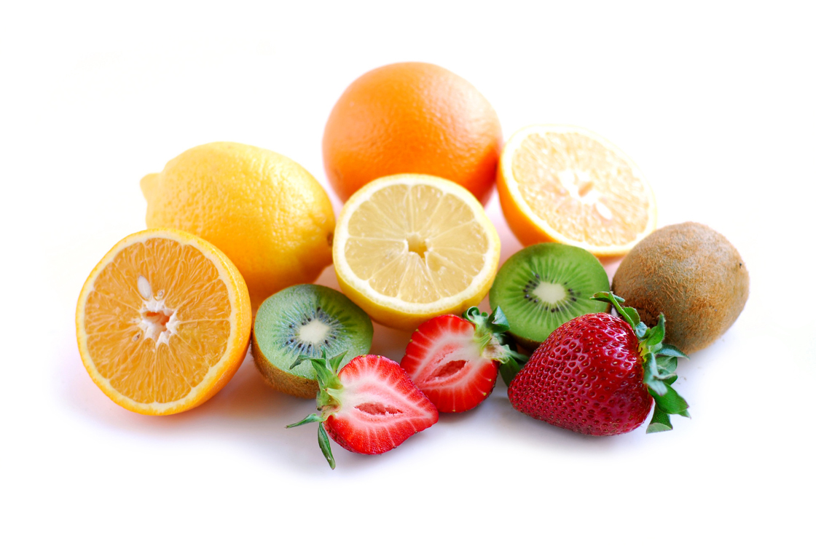

*May we remind you that the snacks, cooking and sensory play are a very important part of our children’s school life and that they can only be provided if we have the necessary means to do so? Therefore, could you please send in £1 per week (£5.00 for the half term) to cover their cost?*

*If you have any photos which we can use for our topic, we would love to look at them.*

*Key Stage 2 Teachers*

**KS2 Curriculum Newsletter Spring 1 2017** 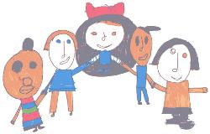

This half term our topic is *‘keeping healthy’.* Throughout the topic we will focus onhealthy eating and exploring food which is good for us. We will also look at ways to keep fit and take part in a variety of exercise sessions to develop our body awareness. 

We will also develop our awareness of personal hygiene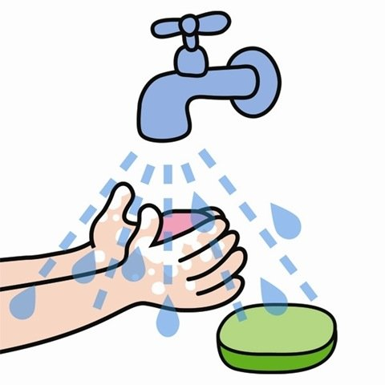 and how to stay safe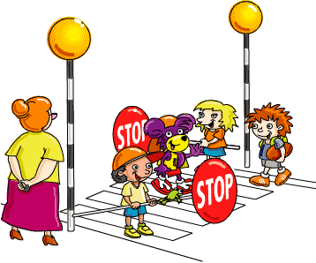 , identifying the important people that help us to keep healthy. 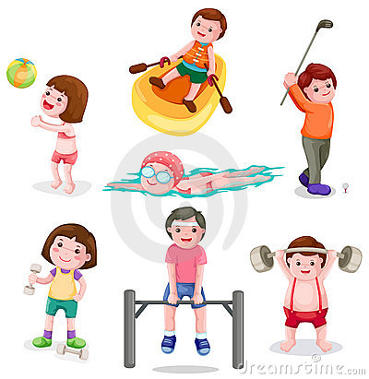

Our main focus in **English** is Comprehension. We will be reading stories and

developing our skills and understanding.

In **Maths** we are concentrating on measurement, mass and weight. We will learn to identify light and heavy objects and compare them, using and exploring various scales and weighing devices. 