Our topic for this half term is ***Minibeasts.***

We will start by looking at the many familiar insects living underground. 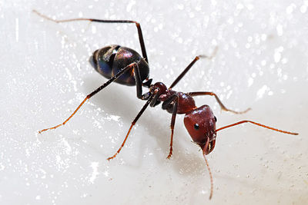 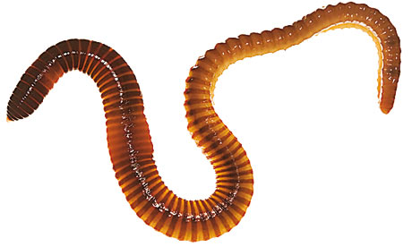

We will then extend our observations to those minibeasts living in or around water 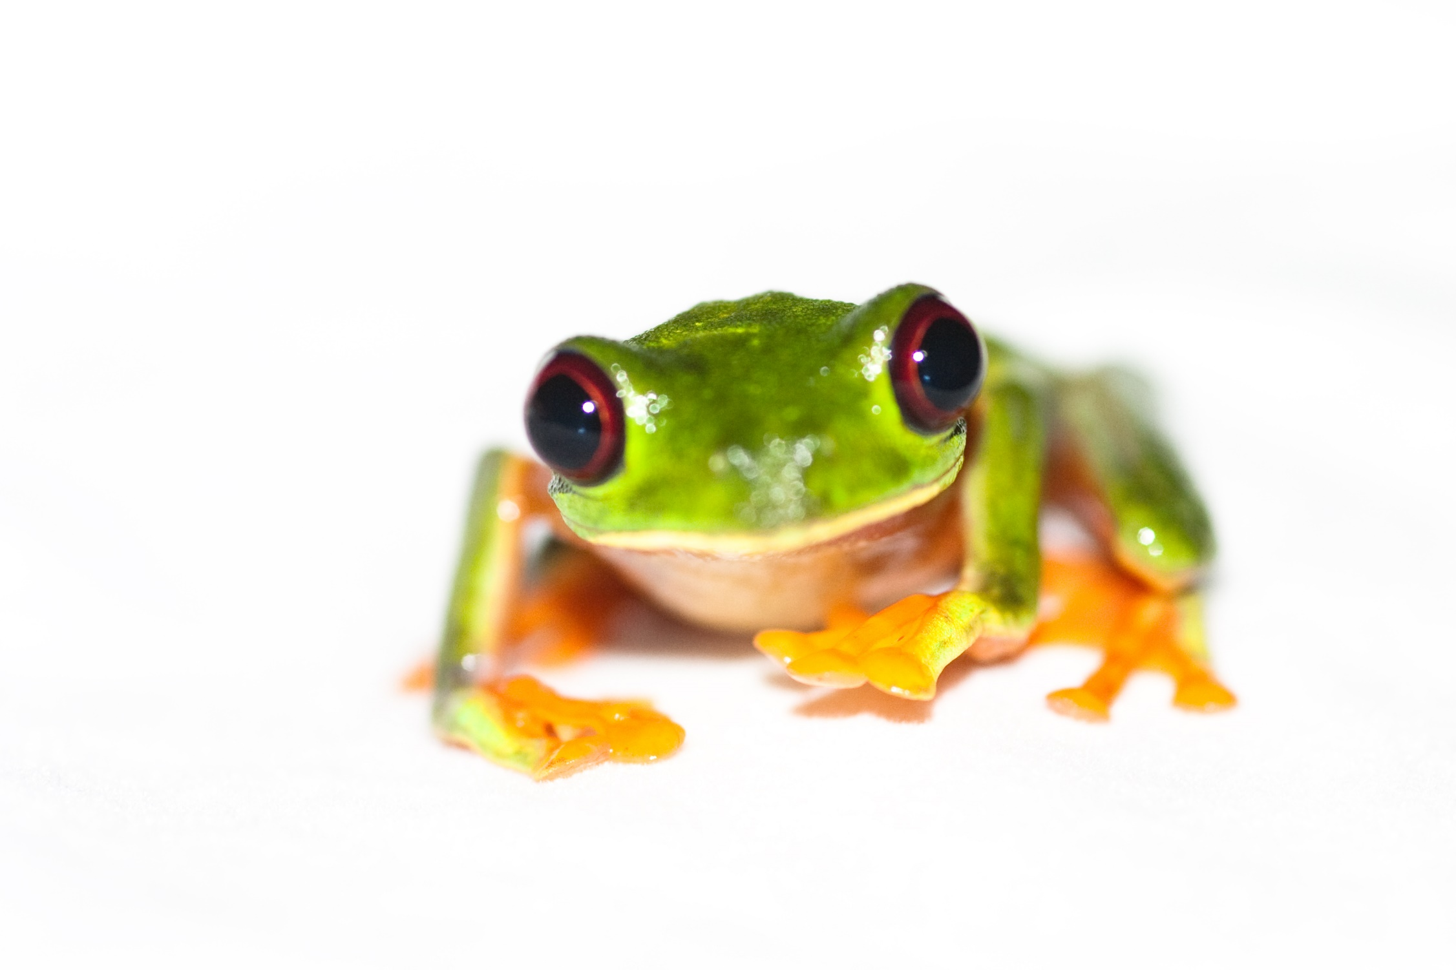before exploring the exotic range of flying minibeasts. 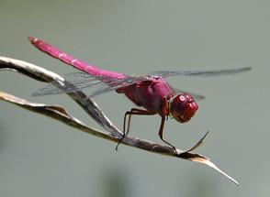 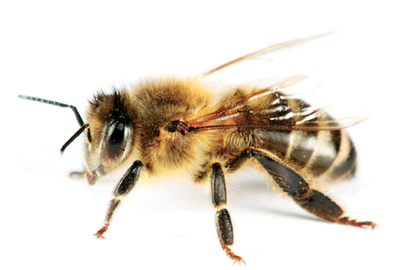

We will explore this exciting world through activities in the classroom but we will also expand our learning during trips to the allotment and various parks and outdoor spaces, 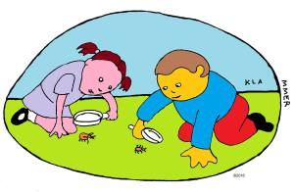 observing minibeasts in their habitat and developing new skills when using scientific tools.  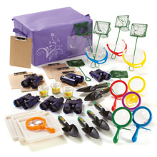

To compliment our learning the focus for our ‘*Let’s see what happens when…*’ Enrichment Day will be on Science. 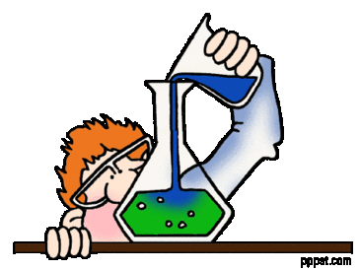

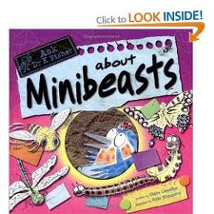

***Dear parents and carers,***

***We hope you had a very good holiday and we welcome you to our Summer 1 curriculum newsletter.***

 

***This term, each child will work on their updated Personalised Learning Outcomes in the core subjects and in our varied cross-curricular lessons, focusing on non-fiction in English and on Shape in Maths.***

**

*Diary dates:*

*Bank Holiday (school closed):*

*Monday 1 May*

*Enrichment day:*

*Tuesday May 23rd*

*End of half term:*

*Friday May 26th*

**

*May we remind you that snacks, cooking and sensory play are a very important part of our children’s school life and that they can only be provided if we have the necessary means to do so. Therefore, we ask for a voluntary contribution of £1 per week (£6.00 for the half term), unless you have kindly already done so to cover the cost. Many thanks.*

*Key Stage 2 Teachers*

**KS2 Curriculum Newsletter – Summer 1 2017** 