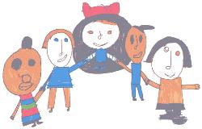
Updated September 2017

Li Bennett School INTERGRATED WORKING

COMMUNICATION GUIDELINES

Contents

Rationale 4
Evaluation 4
Communication guidelines……………………………………………………………………………………………………………………………………………………………………………………………………………….5
Section One: A Definition of Communication 6
Section Two: Our Aims and Commitment 7
The Communication Aims at Lindon Bennett School 7
The School’s Commitment 7
Baseline Assessment and Tracking Progress 8
Documenting and Recording Progress 8
Review 8
Section Three: A Common Language to Describe Student’s Expressive and Receptive Communication at Lindon Bennett School 9
- Expressive Communication Stages: 9
- Receptive Communication Stages 10
Section Four: What Communication System Should the Pupil Use? 14
Section Five: Glossary of Terms 15
Alternative, Augmentative Communication (AAC) 15
Communication environment 16
Cues 17
Touch Cues (See Below) 17
Intensive Interaction 18
Why Intensive Interaction? 18
Some Fundamentals of Communication 19
How do children learn to communicate and relate? 19
Makaton 23
Sensory Cues 24
Picture Exchange Communication System (PECS) 28
Tobi True Object Based Icons.............................................................................................................................................................................................................30
Spoken language 31
E-Tram frame …………………………………………………………………………………………………………………………………………………………………………………………………………………………….32
Touch Cues …………………………………………………………………………………………………………………………………………………………………………………………………………………………33
Voice Output Communication Aids (VOCAs) 40
Choosing a VOCA 41
SIMPLE MESSAGE DEVICES 42
MULTI-MESSAGE/MULTI-LEVEL MESSAGE DEVICES 43
DO’S AND DON’TS FOR TALKING WITH PEOPLE WHO USE VOICE OUTPUT COMMUNICATION AIDS (VOCAs) 46
References 47
Appendix ……………………………………………………………………………………………………………………………………………………………………………………………………………………………………….48

“For some *…+ people the journey on the communication road will bring them far towards advanced goals, for others the road will be rather short. As you always travel with a partner, you might discover that together you can make the road broad and full of shared experiences.”
(Rodbroe and Souriau, 1999 p 120)

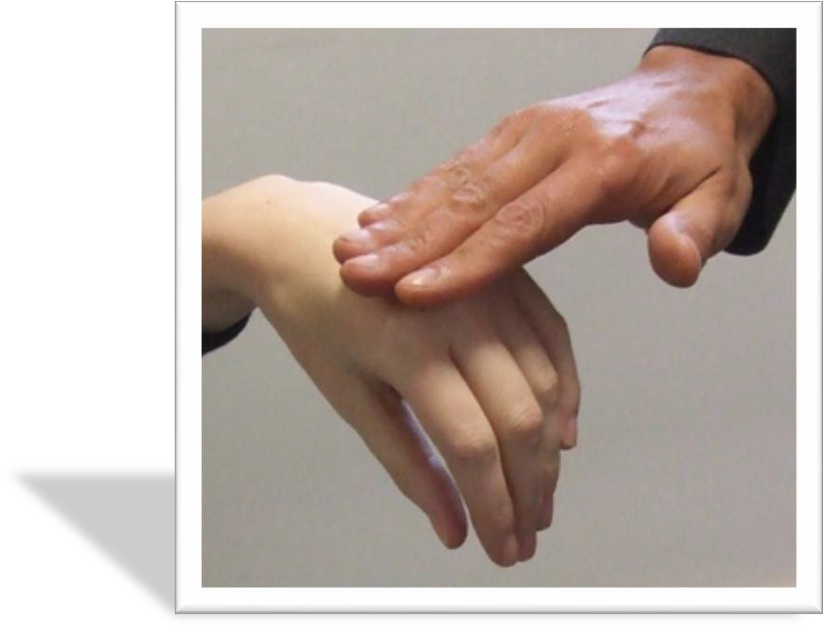
Rationale
The Communication Guidelines provide everyone at Lindon Bennett school a shared language when discussing, assessing and supporting students’ communication. They have not been developed as a prescriptive document but as a guidance of good practice in education both for teaching and learning.

Evaluation
These guidelines will be reviewed at regular intervals as new information and research becomes available.

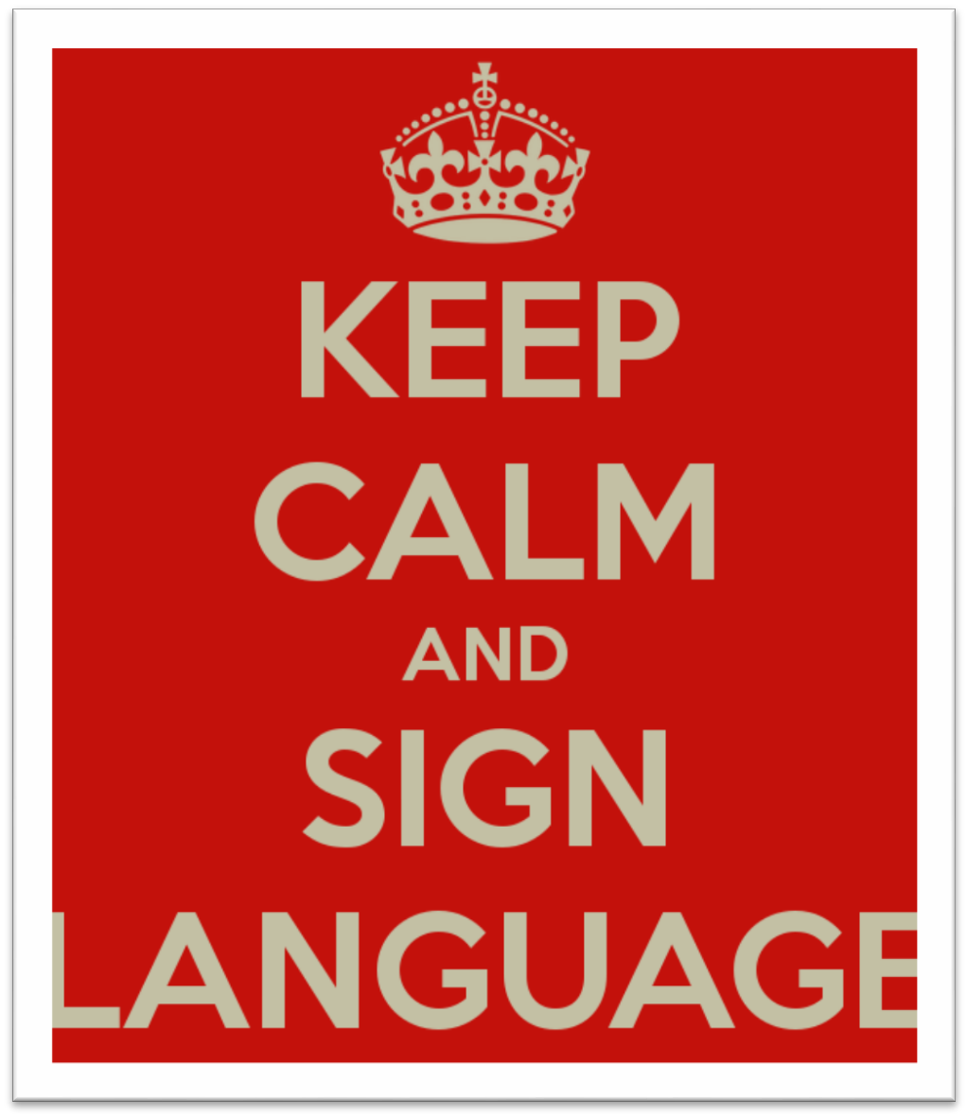
Communication Guidelines:
This document was born out of on-going discussions between teachers and speech and language therapists working at Lindon Bennett School when trying to find a common language to talk about, assess and support the student’s communicative development both for expressive and receptive purposes.

All students at Lindon Bennett School have a difficulty with language and communication. We aim to provide an environment where the child’s potential communication skills can be achieved.

This document suggests stages of development, methods/modes of communication appropriate for the different stages and includes the adult’s role to support students.

We have added a glossary of terms to eliminate any possible difficulties with the terms used. This is a document for everyone to use in their planning and discussions.

Section One: A Definition of Communication. Communication is more than being able to speak or being able to put words together in the proper order. It is the ability to let someone know that you want or don’t want something, to tell
someone about an event, to describe an action and to acknowledge
another person’s presence. This can be done either verbally or non- verbally. It can be accomplished through gestures, vocalisations, sensory cues, signs, symbols or words.

Communication also implies a social situation between two or more individuals, sending or initiating the message and listening, to receive and respond. In communication exchanges, the role of the initiator and listener switches backward and forward. To be fully competent in these skills the pupil needs opportunities to practice them.

Our job is to provide pupils reasons and opportunities to communicate using a range of different strategies.

Communication Guidelines Page 6

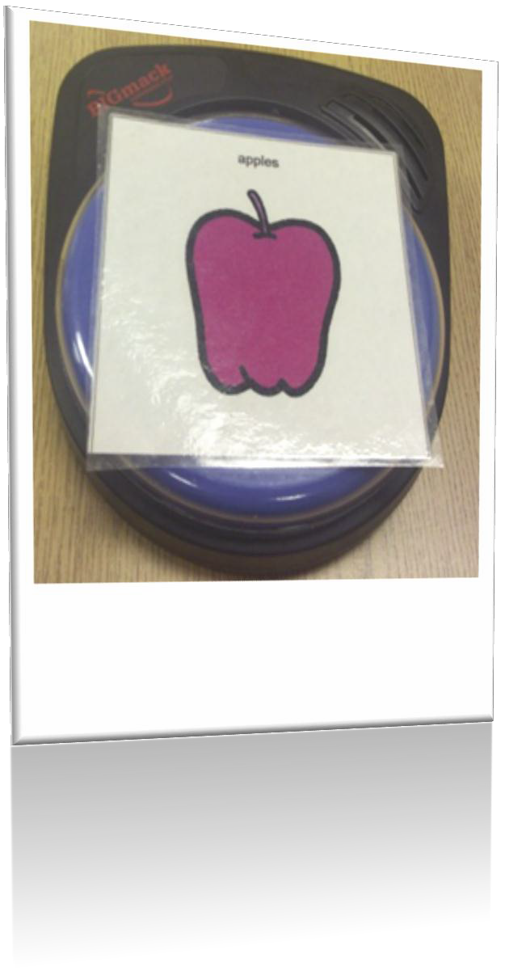
Section Two: Our Aims and Commitment

The Communication Aims at Lindon Bennett School

- To work in close co-operation with the speech and language therapy team and, where appropriate, the wider health team.
- To assess each pupil and use with them the most appropriate forms of communication.
- To provide communication strategies other than speech for those pupils who need them.
  - To give pupils a means of active participation in motivating social situations.
  - To work closely with the pupil’s family.

The School’s Commitment

At Lindon Bennett School we are committed to provide an appropriate provision for pupils who need to use a means of communication other than speech, including switches, voice output communication aids, sign, symbols or cues.

Pupil experiences

  - All pupils should experience a Total Communication environment. From touch cues, sensory cues to signs, photographs, symbols and switches to speech
  - All staff should use appropriate communication strategies that are relevant for individual pupils. Staffing and Resources
  - All members of staff are responsible for Communication across the curriculum with support from the Integrated Working Team.
  - Class teams should prepare and acquire resources needed throughout the school year. (e.g. PECs, Makaton signs, symbols, VOCAs (see glossary))

Communication Guidelines Page 7

Baseline Assessment and Tracking Progress
- The school currently uses B-squared to assess and track progress. CASPA is used to predict achievements over time.

Documenting and Recording Progress
Progress should be recorded by the class teacher by the use of our ‘communication information sheets’. The class teacher and the Speech and language therapist will collate their reports every term. Records should contain information about:

- Spontaneous or functional use of language and context. Developing communication skills.
- Any use of AAC to support other communication, e.g. signing or PECs use, this information should be provided on the communication information sheet displayed in each classroom.

Use this information when sharing information, planning targets and recording progress.
The school uses B-squared to track progress of the children and identifies those children who are not making expected progress through CASPA.

Review
Reviews take place each term and inform future plans for the pupil’s IEP or potential learning outcomes. Classroom communication sheets should be up dated every term.

Section Three:

A Common Language to Describe Student’s Expressive and Receptive Communication at Lindon Bennett School

Expressive Communication Stages:

Pre-symbolic communication
Stages | Description | Modes/Methods of communication | Adults role
Level one – pre- intentional actions | Unintentional or reflexive actions that expresses the state of the subject. State (e.g. hungry, wet) is interpreted by observer. | We would expect to see unintentional actions in the child such as body movements, facial expressions and sounds developing, eventually, into intentional actions  Reflexive responses would be the communication  methods used here by the child. Reflexive responses are not under the control of the child. | At this level there is only room for the child and the communication partner. Objects, the world outside, are not relevant in the interaction at this stage.  Place or object cues can be used by adults to routinely represent activities for the child (although this does not mean that the child necessarily understands the cues as such). I would add to these the fundamental principles of intensive interaction and use them consistently with the child. Children at this communicative stage should, therefore, be treated as intentional communicators
Level two - intentional actions | Actions are intentional, but not  intentionally communicative. Actions function to affect observer since observer infers intent. | Signals, when/if they appear, are intentional  actions although not intentionally communicative.
Level three - non conventional pre- symbolic actions | Non-conventional gestures are used with the intent of affecting observer's actions. | Level 3 marks the beginning of intentional communication with pre-symbolic unconventional communication. At this level, the child might start using the object cues both for receptive and for expressive communication and, eventually, using them together with conventional pre-symbolic communication (level 4) such as pointing or nodding. | Objects, the world, are introduced in the interaction and becoming the focus of the communicative act. This stage starts with reference to objects present in the interaction and it develops into conversations about objects not present. This later communicative development is possible when joint attention on the same experiences have occurred in the interaction that are remembered by both partners and can be recalled back into the interaction.
Level four - conventional pre-symbolic actions | I.e. pointing or nodding. From this point, the object cues might, then, develop into objects of reference and, then, to pictures or tactile symbols for those children with a severe visual impairment (level 5, concrete symbols). | Conventional gestures are used with the intent of affecting another's actions.
Symbolic Communication
Stages | Description | Modes/Methods of communication | Adults role
Level five - concrete symbolic communicatio | Limited use of concrete (iconic)  symbols to represent environmental entities - one to one correspondence between symbol and referent. | Objects of reference, pictures or tactile symbols for  those children with a severe visual impairment . | Eventually, the joint attention can relate to elements that have not  been shared in the interaction before. Communication can, then, become increasingly more symbolic with the use of body language such as pointing, objects of reference, symbols, etc.
Level six - abstract symbolic communica | Limited use of abstract (arbitrary) symbols to represent environmental entities. Symbols are used singly. | The methods used at these levels (6 and 7) are abstract visual or tactile symbols , sign language, speech, finger spelling and the use of technology.
Level seven - formal symbolic communication (language) | Rule bound use of arbitrary symbol system. Ordered combinations of two or more symbols according to syntactic rules.

2.Receptive Communication Stages

Pre-symbolic communication
Stage | Descriptor/summary | I need
1 | Reacts to touch  Quietens or responds to voices I respond to the environment through reflexes | Routine and structure  Consistent adults working with me Consistent Temperature (room and body)  Consistent Lighting – (avoid strip lighting, which can flash) Avoid surprises  I need you to monitor my reflexive reactions
Minimal speech
All attempts at communication (vocalising, eye contact, gestures, shiver, cough, laugh….) should be responded to immediately
using any sense that the child can understand either by using touch, movement, verbalizing, commenting on what has happened or copying sounds, actions, etc.
2 | Inconsistent/emerging skill:  Anticipates, reacts, shows awareness and searches for sounds  Reacts to known noises e.g. microwave bell | Interactions should be person to person  You can introduce things, but follow the child’s lead and let them lead the play Repetition  Intensive interaction Structured routine Familiar adults Touch cues  Object cues (meaningful personal object always used for individual child; object used during activity)  Consistent Person Identifiers e.g. how you smell be aware of strong smells like perfume and cigarette smoke, hair, bracelets so that I understand who I am with.  Consistency of cues – not too many cues Minimal speech at ALL times
3 | Contextual understanding in  familiar environment: Aware of familiar routines,  shows awareness of different people.  E.g. INTENSIVE INTERACTION | As for #2  Makaton signs (core 5 signs) – don’t expect child to understand  Continue to interpret child’s communication as intentional  Consider introducing objects of reference  Create structured pauses and anticipation to see what the child can do  Allow child time to process and respond (after 10 seconds) | Create a predictable daily routine repeated throughout the week, e.g.  insert one different activity per day such as Swimming on Friday, Music on Tuesday and Rebound on Wednesday  Limit activities; learning is in the routine/interactions
4 | Responds to simple commands, visual cues and objects. Shows awareness of 2 objects going together or how they are used  E.g. cup and spoon. | As above plus:  Practice of functional skills and play e.g. brushing doll’s hair, dressing  Introduce objects and shared play in intensive interaction e.g. looking in a mirror together. | Modelling of very simple language associated with play e.g. “look baby drinking”, “washing hands”  Respond consistently to all attempts of expressive communication Use of consistent visual support. Use simple visual timetables. Continue to model

Symbolic Communication
5 | Gives an object when asked to  and relates photos or pictures to real objects.  Knows 3 body parts.  E.g. can point to them when you name them |  | Simple commands. E.g. “find shoes” “where’s the ball?”  Visual timetabes  Modelling of simple language Makaton signing  Problem solving activities – finding things, which things go together
6 | Responds to 2 step instructions  Can predict cause and effect and use past experience and imagination to problem solve.  E.g. understands that electric  appliances need to be switched on.

Section 4: What Communication System Should the Pupil Use?

The choice of a communication system.

The communication system should be:

- Appropriate for the pupil’s current
- language skills
- cognitive abilities
- access (e.g. eye pointing or hand/finger pointing)
  - Flexible and allow for growth
  - Acceptable to and understood by the pupil and the listener
  - Functional and appropriate for the pupil’s educational and social needs.

All parts of the communication system should go with the pupils all the time, enabling them to participate and interact, ask and answer questions, comment, direct, explain and report, and practice their use of language in a natural and immediate way.

Section 5: Glossary of Terms

Alternative, Augmentative Communication (AAC)

In general, “alternative” is used to refer to methods of communication that replace speech, such as sign language or picture based systems.

“Augmentative” refers to enhancements of a pupil’s current communication skills, such as by using visual signals to help remind the pupil about the choices that are available in a particular situation or pictures to enhance speech that is difficult to understand. Communication is described as success in conveying one’s meaning to others.

Therefore Alternative, Augmentative Communication can be defined as any means which replaces speech and/or enhances an individual’s ability to successfully convey meaning to others.
Who Can Benefit from Acquiring an AAC?

- An alternative method of communication needs to be considered for any pupil who cannot:

- Use words or intelligible approximations to request favourite items.

- Use words or intelligible approximations to comment about interesting things.

- Initiate, imitate and respond to simple questions.

- Understand much of what others say, especially about retrieving simple items, following simple instructions and responding to social signals.

- If the pupil cannot accomplish these communicative functions via speech, then we must consider using an alternative or augmentative communication system.

Total Communication

Students should be encouraged to use every available form of communication. This includes the informal methods of facial expression, body language, gesture and vocalisation, together with formal communicative methods of words, signs, symbols and voice output communication aids (VOCAs).

Communication environment

Siegel-Causey and Guess (1989) give the following as the main environmental aspects that should to be observed when trying to create typical learning conditions:

  - Developing nurturance. Students developing a sense of well-being from their interactions with adults.

  - Enhancing sensitivity. Giving meaning to student’s actions, reading their communicative gestures and responding to their interactions. Also adults being sensitive about their communication with the children.

  - Increasing opportunities to communicate. Adults need to plan numerous opportunities for interaction where different communicative functions are used and where the communication is functional.

  - Sequencing experiences. Building routines and structures for activities and parts of the day to make them predictable.

  - Utilising movement. Interpreting any action from the child as intentionally communicative.

Other elements could be suggested such as collaborative partnership involving therapists and parents

Receptive language means the ability to understand or comprehend language heard or read.

Expressive language means being able to put thoughts into words and sentences, in a way that makes sense and is grammatically accurate.

If children have a speech and language impairment, it might affect their expressive language or their receptive language, or both, to a greater or lesser degree.

Intensive Interaction

For more information please talk to Iwona who is our Intensive interaction coordinator.

Why Intensive Interaction?
Human beings communicate with others in complex ways. We have many languages that use speech, but communication is also possible with signs, facial expression, gestures, body language, eye contact, physical contact…
Some children have very limited understanding of communication and probably have a lifestyle where they look
lonely, relating only for short periods with the people around them. This is why Intensive Interaction has been developed.
Intensive Interaction is a practical way of teaching communication by spending time with the students and having
fun together.

Some Fundamentals of Communication
The fundamentals of communication are the basic foundations for all communication to develop. Most of us use them without thinking much about them. And we use them all the time.
The learning of these Fundamentals of Communication starts at birth.
It is necessary to become skilled at them before learning to use any language.
The fundamentals of Communication and language are the building blocks of everything else that a person learns.
If a person does not learn these fundamental things, it will not only affect their communication but it will make it more difficult to learn anything else.

To use and understand eye contact To use facial expressions
Learning to “read” facial expressions
Learning to enjoy giving attention to another person Taking turns
To use and understand physical contact To use and understand gestures Learning to “read” body language Learning about personal space

Learning to concentrate and attend
With Intensive Interaction we are trying to help students to learn some or all of these important abilities. Other things will probably happen too:
Challenging behaviours may generally improve and the students may become easier to be with. The children may simply become happier.
It may be easier to get their attention in order to do anything.
It may be possible to involve the child in more new activities.
Your students may seek your attention and other people’s company, even when this is inconvenient! They may start to be more comfortable as a member of a group.
Basic care activities such as washing and dressing may become easier, with the students taking more interest and participating more.

How do babies learn to communicate and relate?
Babies learn a huge amount in their first year. What do the adults do in order to help the baby?
  - Adults are available.
It is not possible for adults simple to demand that a three month old baby gives them attention. We have to win that attention. We have to make sure that everything that we do in a conversation with a three month old is interesting and enjoyable to that person. We make sure that what we do is understandable for a three month old.
We make ourselves available to a baby frequently. We give them plenty of time and attention. We get our face in the right place.
We are joining the baby in their world.
  - Enjoyment.
For an interaction between an adult and a baby to be truly successful, both people need to enjoy themselves. This means that both baby and adult will want to come back for more!
  - Let the baby lead.
The adult is an “activity centre” for the baby. Adults respond to things that the baby does.
  - Responding.
The baby tries out new noises and movements or facial expressions, and the adult respond, often by doing it again, imitating or joining in. This is very pleasing and rewarding for the baby, and it makes it more likely that the baby will do the same thing again.

  - Creating and repeating familiar activities.
The parents and the baby build up a range of things that they can do together. They create a sort of catalogue of these activities, which they repeat many times in order to enjoy each other frequently and to have what feels like a conversation. Having these experiences enables the baby to learn and rehearse crucial skills like attending, exploring and interpreting facial expressions.
  - Extending.
While parents and babies are repeating these familiar interactions, new things happen as well. Games last longer. The creation of turn taking is an important aspect of the development of the interactions in the first year.
  - Pausing.
Parents allow pauses during the interaction. The baby simply goes quiet, takes a rest. Demanding that the baby keep going doesn’t work and it is likely to have the opposite effect.

By the end of the first year, if everything has been working well, a baby has considerable abilities to communicate and do all sort of things. The principles of parent-baby interaction provide a guide for how to interact in Intensive Interaction.
Getting started
  - Don’t be in a rush. Relax, respond and enjoy.
  - Start where the pupil is more comfortable. If he/she + prefers a certain corner of the room and likes to be left alone to sit and rocking and twiddling.
  - Position yourself so that your eye level is below theirs. This may mean being prepared to spend a lot of time on the floor or crouching. The pupil cannot learn to look at your face if your face is up in the sky.
  - “I am here for you, on your terms, I will go away as soon as you have had enough of me.”
  - Respond instantly to signals of negativity. If the pupil does anything which you suspect is telling you to go, or he/she does not like something, then you need to go, or stop the activity instantly. Trying to keep going when they have had enough may leave them with a negative memory of the experience and make it less likely they will want to do it again.
  - Tuning in. Respond to any signals that the pupil gives to you. (This can be hard but not impossible).
  - Respond to vocalisations and other noises made with the mouth, slapping or tapping parts of the body, slapping or tapping furniture or walls, clapping, hand rubbing, etc. Body Movements; facial expressions; physical contact such as pats, taps, reaching to hold you, etc.

  - Find behaviours to celebrate/respond to. Try out responses to the pupil’s behaviours: laugh, imitate sounds, tickle him or her, say something, be dramatic, smile, wide eyes, anything to do with your face, etc. Did it cause interest? You are experimenting with your responses to things that your child does. You are looking for any sign of interest or engagement.
  - There may be things that your child does that you may not feel comfortable about and certainly would not wish to imitate or join in with. That’s fine.
  - Try not to bombard. Have pauses when the child needs them.

With your responses you are doing two things:
Respond to anything you think the pupil did that was an attempt to communicate with you.
Respond to something the pupil did not for communicative reason as if it was communicative. By doing this, you are helping them to realise that they can have an effect and cause you to respond.

Equipment

The best piece of equipment, the most flexible, sensitive, intelligent and creative piece of equipment that can be offered to the pupil is another human being that is responsive.
It is you!

Interactive Games
Some examples:

“I am going to get you” A game in which the interactive partner threatens in an exaggerated and playful way, with wide-eyed expression and dramatic hand- poising to pounce and tickle. This usually brings laughter in response.
“Walking fingers” A game in which “the adult” walks his or her fingers spider-like up the child’s body, again often culminating in laughter. “So big” A game involving stretching the pupil’s arms upward as if to make him or her taller and commenting “so big”, etc.
“Pat-a-cake” A rhyme with clapping action.
“Peek-a-boo” The classic hide and appear again with anticipation and climax. “Round the garden”
“Row your boat”
etc. Remember to make your own. Whatever the pupil likes is good.
See appendix 5 for Intensive Interaction principles.

Makaton- For more information

please talk to Helen our Local Makaton trainer.

Lindon Bennett School uses the Makaton Vocabulary to support the production and understanding of speech.
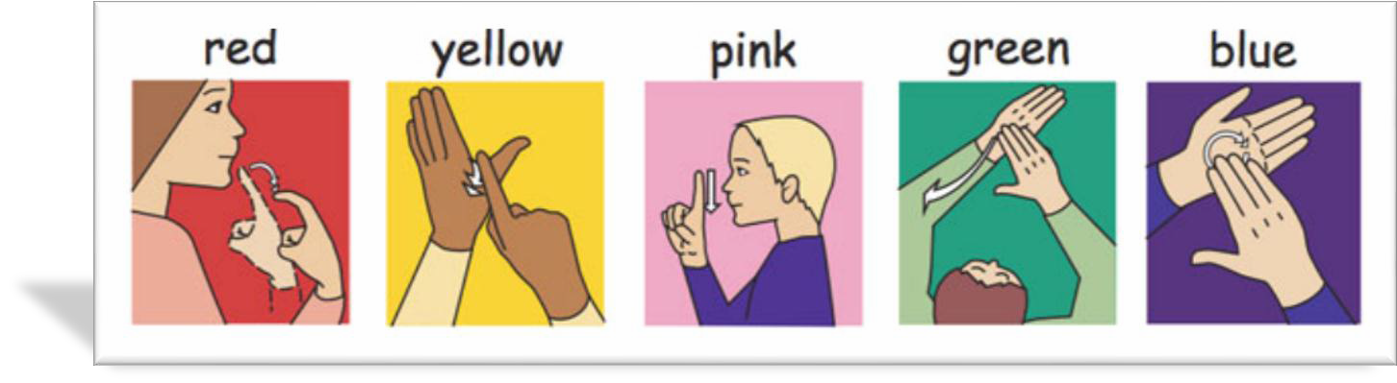

Makaton Vocabulary

The Makaton vocabulary consist of:

a core vocabulary (approximately 350 items)
- the national curriculum (approximately 600 items)
- Animals, Transport and Vehicles (approximately 400 items)
- People, Buildings and Places (approximately 700 items)
- Growth and Development, Emotions, Feelings and Relationships (approximately 1200 items)

Sensory Cues
Definition of Sensory Cues:
An object or part of an object used to refer to a, place or activity
Purpose of sensory Cues :
To provide a concrete means of supporting conversational interactions and language development.

Educational components of Sensory Cues system:

To develop anticipatory skills.
To reduce confusion and apprehension.
To develop early ‘emergent’ communication skills. To develop cognitive/early thinking skills.
To work towards the pupil being able to express preferences, communicate needs, make
choices, make decisions and choose options that other people act on and respect. To promote self-advocacy or the use of a range of systems of supported advocacy. To prepare pupils for an adult life in which they have the greatest possible degree of autonomy.
To increase the pupil’s awareness and understanding of his/her environment and of the world.

At Lindon Bennett we have developed a ‘bank’ of objects for our Sensory Cues there are at least two items for each educational activity or lesson which include an item to touch (texture), music and where possible a smell.
Please see appendix 1 for a complete list of sensory cues.
- Staff should always accompany the presentation of a Sensory Cues with simple language and sign where applicable. Encourage the pupil to interact with the Sensory Cues. If the pupil has physical problems in interacting, staff may assist with this process by, for example, gently rubbing the Sensory Cues on the pupil’s skin (where the tactile aspect of the Sensory Cues is seen as important).
- Where possible, especially with ambulant pupils, staff should allow the pupil to lead the way to the activity/ lesson on presentation of the Sensory Cues. Does the pupil demonstrate an understanding of where s/he is going? If the pupil is obviously ‘lost’ then the staff member should guide the pupil to the activity/ lesson allowing the pupil to lead taking the final few steps into the room.
- At the activity/ lesson entrance (where the activity/ lesson has a marked entrance) staff should encourage the pupil to match the Sensory Cue with the Sensory Cue on the door. This is best achieved by removing the door marker from its housing and holding it next to the Sensory Cues together in a position that the pupil can easily see.
- When the activity/ lesson are reached, the pupil should return the Sensory Cues of reference to the bag.
- Pupil’s must never return from an activity/ lesson clutching the Sensory Cues for the activity/ lesson as this presents a very confusing message.
- REMEMBER- It may only be after many thousands of presentations that a pupil may begin to make an association between the Sensory Cues and the activity/ lesson. We must be consistent and diligent in our efforts with Sensory Cues!!!!!!

Staff responsibilities
- At the beginning of each day a designated member of the team should check the contents of the Sensory Cues bag before presenting it to the pupil to ensure that the appropriate items are present (a list should be contained in each bag). If an item is missing or damaged, the team member should seek a replacement from Adele Mears- Assistant Head. Likewise, if ‘alien’ Sensory Cue has somehow found its way into the Sensory Cue bag, it should be removed immediately. .
- Staff should present the Sensory Cues consistently at every appropriate opportunity. Staff should never declare unilaterally that they consider the Sensory Cues to be inappropriate and decide not to go ahead with the presentation. Should staff feel strongly that a particular pupil’s needs are not being properly met with any Sensory Cues then it is the individual staff member’s responsibility to raise this matter and a meeting can be held to discuss whether a change should be made
- Where possible, the Sensory Cues may itself be labeled with the symbol for the activity/ lesson. While there should be no focus on the symbol when presenting the Sensory Cue to the pupil, the fact that the two are paired allows every opportunity for future progression.
- When pupils indicate a need for their Sensory Cue bag or present a Sensory Cue to a member of staff, staff should immediately react to this presentation as if it were intentional. That is, they should move to the activity/ lesson or provide the requested object or event. The Sensory Cues should then be returned to the bag, as is normal procedure.
- At the end of the day, the staff member designated to check Sensory Cues bags should ensure that the bag is removed before the pupil leaves for home.

Stages of Sensory Cue development:
While Stages of Development are outlined in the table below, it is expected that:
  - Development will not be commensurate for each object in the set. That is, development may be faster on some objects than on others.
  - Not all pupils will enter at Stage One and leave at Stage Five. Some pupils may enter the scheme at Stage Two or even Stage Three. Some pupils may never reach Stage Five. Some pupils may leave the scheme before they reach Stage Five because they are ready for symbol use and Sensory Cues is no longer seen as appropriate.
  - Pupils will develop at different rates.
Stage | Descriptors | Characterised by
Stage 1 | Intolerant  Difficult to reach Dependent Meaningless | Individual shows little tolerance of Sensory Cues.  Ignores, drops, or throws it
Stage 2 | Tolerant  Hard to reach Dependent Meaningless | Holds/carries Sensory Cues but demonstrates little  understanding
Stage 3 | Tolerant  Receptive Dependent  More Meaningful | Individual begins to show understanding of  meaning of one or more sensory Cues
Stage 4 | Tolerant  Expressive Dependent Meaningful | Individual will begin to understand what is happening next and respond accordingly to a range of sensory cues
Stage 5 | Independent  Meaningful | Individual will be able to identify the sensory cue and manage transition with minimal adult support.

Picture Exchange Communication System (PECS)

Please see appendix 4, Rules and reminders.

For more information please talk to Steph our PECS implementer

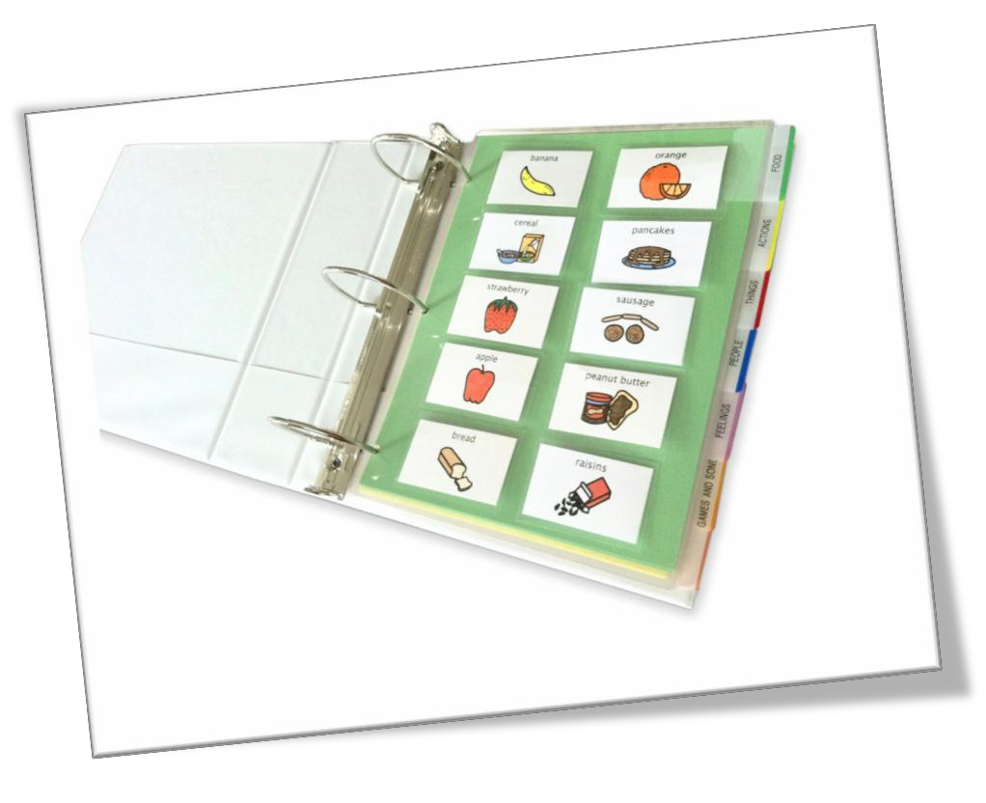

The following information is taken from Frost & Bondy (1994) ‘PECS Training Manual’.
PECS “…is a unique AAC training package developed for use with young students with autism and other social-communication deficits.” (p1)
PECS was initially developed for use with an early year’s student who had autism. Frost and Bondy describe these student as those who do not speak, who are echolalic or speak in a ‘self-stimulatory’ manner. They continue by describing the communicative disabilities of these students as being “socially-related in that they do not routinely approach others to communicate, actively avoid interaction with others or only communicate in response to a direct verbal cue to do so.” (p2).
There are six phases in a PECS programme and it is recommended by Frost and Bondy that the pupil should progress through all six phases.

Phase 1 Objective: on seeing a desired item, the pupil will pick up a symbol and give it to an appropriate person:
This can require two adults, one to stimulate the pupil by holding the target item and the other to physically help the pupil pick up and exchange the picture/symbol for the desired object.

Phase 2
Objective: Pupil to find communication board, pull picture off and to find the appropriate adult to give the symbol to. The pupil is able to independently pick up the picture/symbol and exchange it for the target item without additional adult input.

Phase 3
Objective: pupil will request desired items by going to communication board (developing distance between the pictures/symbols and the target item) selecting the appropriate picture from an array, going to a communication partner and giving the picture.

Phase 4
Objective: the pupil requests present and non-present items using a multi-word phrase by going to the book. This includes using the phrase ‘I want’ + picture/symbol and exchanges this for a target item. For example, the process would include:
- picking up a picture/symbol of ‘I want’,
- putting it on a sentence strip,
- picking out the picture of what is wanted,
- putting it on the sentence strip,
- removing the strip from the communication board,
- approaching the communicative partner
- and giving the sentence strip top him/her
By the end of this phase, the pupil has 20-50 pictures on a communication board and is communicating with a wide variety of partners.
Phase 5
Objective: the pupil can spontaneously request a variety of items and can answer the questions “What do you want?”

Phase 6
Objective: The pupil appropriately answers the above questions and similar questions when these questions are asked randomly.
Introducing Additional Language Concepts
Objective: The pupil uses a wide range of vocabulary concepts in a variety of communicative functions.

The important points in PECS include:
- Working from the individual’s motivators i.e. favourite toys/objects. You need to assess which are the most to least motivating items for the individual.
- Teach the staff, parents and pupil how to use the system before expecting any symbol discrimination
- You will need to engineer situations to encourage the pupil to request
- You should work through the PECS stages .

Please see appendix 2 for additional information.

Tobi- True Object Based Icons

'TOBI’s' (True Object Based Icons) are made by cutting around the outline of a photograph of the object. This should be large enough for the child to recognise the shape of the object. Photographs try not to include unnecessary details in the background of the photograph. They can presented to the children on a raised black background.

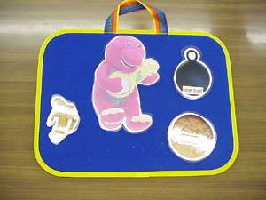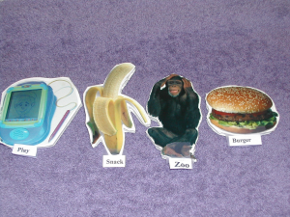

Spoken language

What are speech, language and communication?
Speech refers to:
• Saying sounds accurately and
in the right places in words
• The sounds people use to
communicate words
• Speaking fluently, without
hesitating, or prolonging or
repeating words or sounds
• Speaking with expression
with a clear voice, using
pitch, volume and intonation
to support meaning.

Language refers to speaking
and understanding
language:
• Using words to build up
sentences, sentences to build
up conversations and longer
stretches of spoken language
• Understanding and making
sense of what people say

Communication refers
to how we interact with
others:
• Language is used to
represent concepts and
thoughts.

• Using language in different
ways; to question, clarify,
describe etc.

• Non-verbal rules of
communication; good
listening, looking at people
when in a conversation,
knowing how to talk to
others and take turns, how to
change language use to suit
the situation or the person
being spoken to the wider context.

• Many children and young
people communicate
successfully using non-verbal
means such as signing,
gestures, communication
books or electronic

• The ability to take into
account other peoples’
perspectives, intentions and the wider context.

• The ability to take into
account other peoples’
perspectives and intentions.

E-Tran frame
Some people who have communication difficulties also have physical difficulties and find it difficult to point to a book or chart or to handle communication cards. People with good control over their eyes may be able to use an ETRAN frame. This is a sheet of stiff, transparent plastic (Perspex) onto which symbols or words can be stuck with Blu-Tack or Velcro.
- 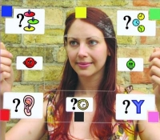
The communication partner faces the user and holds the chart up between them. The user gazes at the letter, symbol, or word they want to say. Initially one symbol or word will be placed at each corner. As the user and communication partner become more skilled, symbols can be added in the middle of each side.
The method can be developed using colour or number coding systems so that more items can be accessed. (Other methods of accessing symbols, words and phrases available to people without well-controlled hand movement are discussed in the access section.)

Text-based communication
Some very skilled users use a transparent letter board and spell out messages by eye gazing letter by letter. The communication partner requires skill to identify and remember which letter is being looked at. Some communication pairs are extremely fast and efficient communicators.
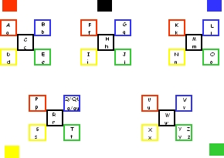

Touch cues

Introduction
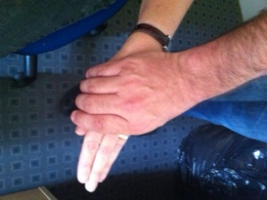

What are Touch Cues?
Touch cues are physical prompts made in a consistent manner directly on the body to support RECEPTIVE communication.

How can they help?
Touch cues provide an early and simple means of receptive communication for learners with significant visual impairment and multiple disabilities who may not understand words.

Touch cues signal the communicator’s intent and may reduce a learner’s startle reflex or other behaviours caused by sudden or confusing interactions. Used consistently during everyday activities Touch Cues will help the learner to anticipate and recognise what it about to happen.

Although Touch Cues are limited in the types of communication messages that they can convey (for example letting the learner know what is about to happen) the content of the message may vary.

Introducing Touch Cues
Touch cues should be used consistently by communication partners to convey specific messages to an individual. If not, people may use these tactile signals in different ways, and this variation will confuse the learner.

Touch cues should be produced so that they are clear, emphatic, but gentle tactile signals (that is, that the learner can easily discriminate them from other physical contact)

When considering Touch Cues the type and placement of touch must be carefully selected. In most cases a Touch Cue that is firm tends to be more acceptable to a child than a light stroke.
Begin by selecting a few (3-5) Touch Cues that are very easy to discriminate because they are made on different parts of the body. Use speech to support the Touch Cues
Touch Cues can be individualised for each learner.

Points to Remember:
- Be respectful
- Touch the learner on his or her body where it is socially acceptable and age appropriate
- Provide clear touch cues that are easy to discriminate
- Use Touch Cues consistently

Hello 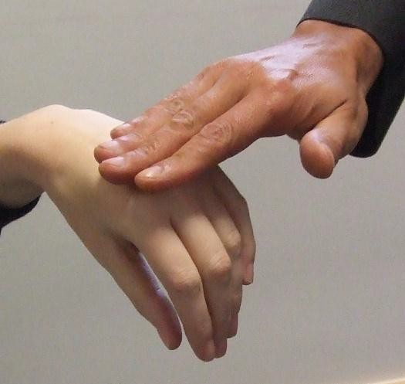 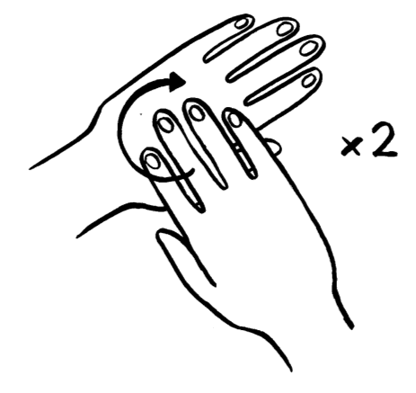

Firmly rub back of hand in a circular clockwise motion two times

Leaving

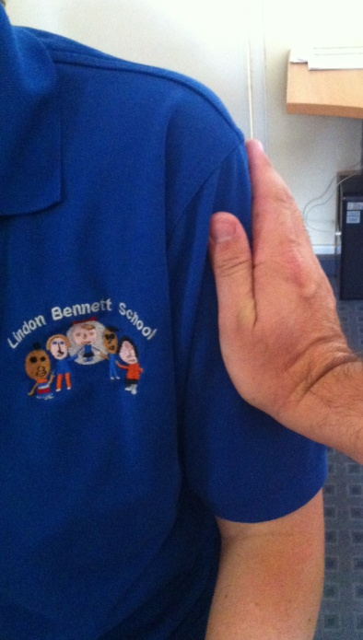

Slowly and gently squeeze upper forearm

Finished 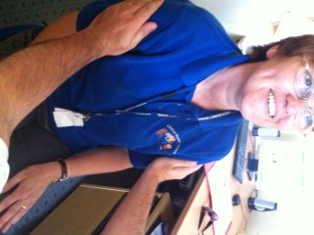 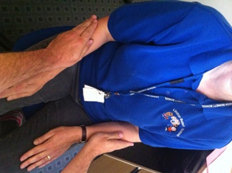 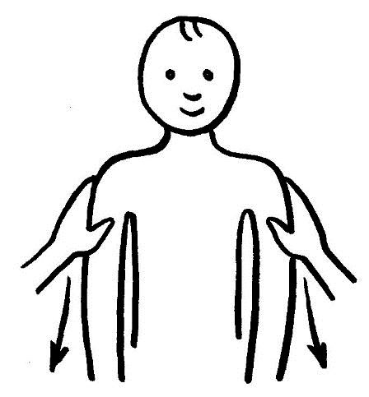

Brush open palms downwards on both arms

Moving Up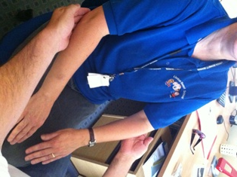

Apply pressure under elbows with an upward movement

Moving Down 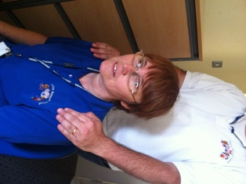 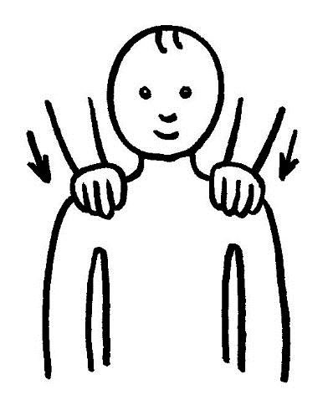
Apply firm pressure down on shoulders

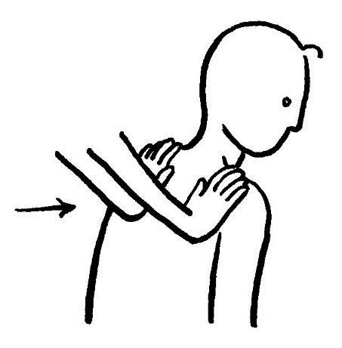
Moving Forwards 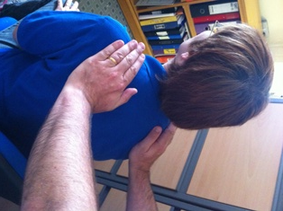

Press slowly on back of shoulders in a forward movement

Moving Backwards 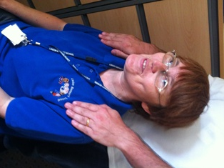 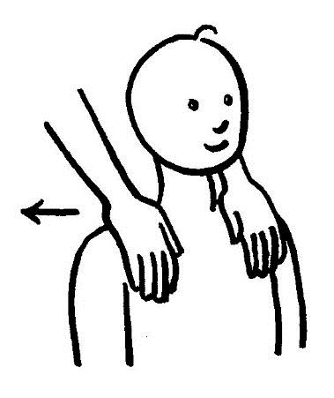

Pull slowly back on front of shoulders

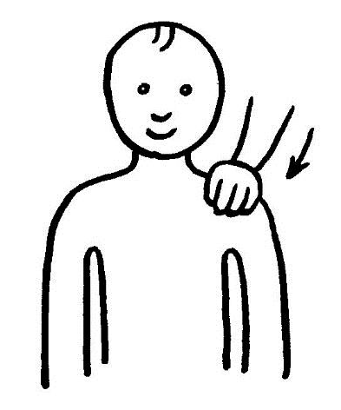
Moving Left 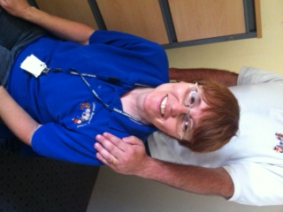

Apply firm pressure to left shoulder

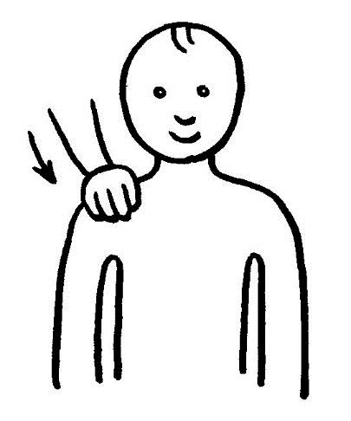
Moving Right 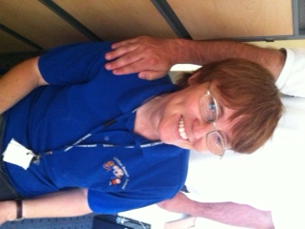

Apply gentle pressure to right shoulder

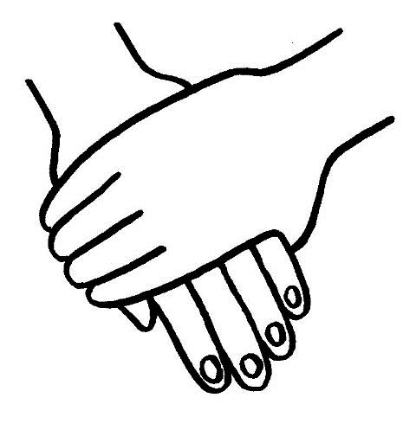
Goodbye

Squeeze gently on hand.

Voice Output Communication Aids (VOCAs)

A number of switches and voice output communication aids (VOCAs) of varying complexity are owned by the school. The SLT team is responsible for storing and allocating the VOCAs and switches to classes and pupils within the school.

The VOCAs and switches are for trialling with pupils to determine if a VOCA is suitable to support the pupils total communication system. The SLT may also contact specialist AAC assessment centres to assess the pupil for a specific VOCA.

If the trial is successful, the VOCA will be purchased for the pupil by other funds. There is a wide range of electronic communication aids available:
- Simple message devices (digitised speech)
- Multi-message / multi-level message device (digitised speech)
- Complex devices (synthesised speech) and the vocabularies available for them.

Digitised speech refers to the use of human recorded speech which can be changed at any point.
Synthesised speech refers to artificial, machine generated speech. The quality of this is improving all the time.

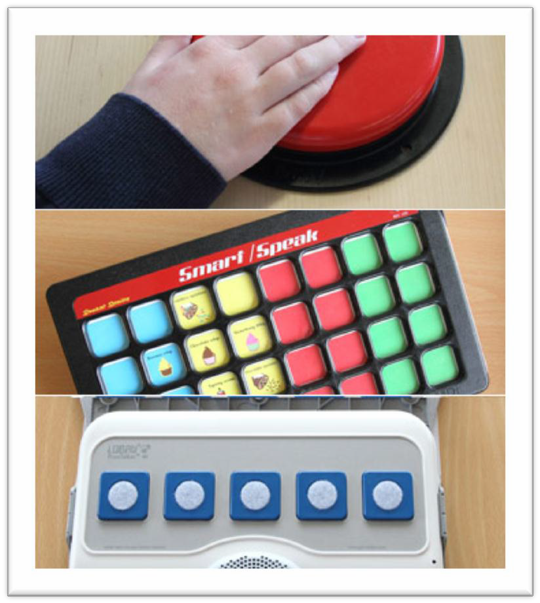
Choosing a VOCA
The choice of a VOCA is not a simple decision. It is essential that both professionals and parents are involved with the individual in the decision making process and if required, further advice should be sought from a centre specialising in the assessment and use of VOCAs (e.g. communication aids centres, ACE Centres).

When choosing a VOCA, consider:
      - What is the device to be used for? e.g. is it to be used as a main or additional means of communication, for attracting attention, all of these functions as well as writing and accessing the curriculum?
      - Who will take responsibility for co-ordinating the use of the device?
      - Who will take responsibility for programming the device? e.g. adding new vocabulary -
      - Is the individual ambulant or does s/he use a wheelchair or variety of seats? This affects the weight of the communication aid that will be possible – heavy communication aids are difficult to carry around but can be attached to a wheelchair – as well as raising the issues of mounting the device.
      - What is the individual’s level of language and cognitive ability?
      - Is auditory scanning required to support the individual’s visual skills?
      - How is the individual going to access the device (keyboard, optical head-pointer, switches, joystick etc.)?
              - Which type of speech output (digitised or synthesised) will be most easily understood by the user?

  - Are languages other than English spoken in the individual’s environment? If so, this may affect choice of device as digitised speech may be required in order to record speech in the user’s first language.
  - Should graphic symbols or text be used on the VOCA? If graphic symbols are to be used, should these be the same as the user’s existing graphic symbol system or should other graphic symbols available with devices be used (e.g. Minsymbols, Dynasyms)?
  - Is the individual at the stage of pressing one location for a single message or will he be able to select several symbols to produce more complex and spontaneous messages? Can he/she combine icons and use a Minspeak based system or does he/she need a hierarchical system e.g. Dynavox, Personal Communicator (Symbols for Windows), MindExpress?
  - Where is training and support going to be available from?

SIMPLE MESSAGE DEVICES
- Simple single message devices: e.g. Big Mack, One Step Communicator, Talking Buddy Button, Chipper, Partner 1, One Talker These devices are useful classroom tools as they can be quickly and easily reprogrammed to suit any activity.

Some ideas for getting going:
  - Developing understanding of cause/effect (attached to Powerlink or similar to operate toys and/or electrical equipment).
  - Attracting attention (teacher’s name).
  - Greetings.
  - Asking the pupil in the class or family members to do silly things, such as jump up and down, make a silly noise etc.
  - Join in reading a story, if there is a repetitive phrase e.g. ‘What’s the time Mr Wolf?’
  - Reciting nursery rhymes, poems.
  - Join in a song where there is a chorus of repeated refrain, e.g. ‘there was an old woman who swallowed a fly, perhaps she’ll die.’
  - Taking news to and from home and school.
  - Playing Hide and Seek e.g. ‘you are getting closer’ or ‘you are getting further away’.
  - Taking messages in school e.g. finding out what is for lunch.
  - Controlling a game e.g. ‘build up the bricks’ or ‘knock them down’.
  - Taking part in a school play.
  - Placing an order in a café.

Some ideas for moving on:
  - Activities that involve using a message functionally and waiting for the appropriate time

  - Joining in class by having an answer to a question put into the single message device and having to press the switch to give the right answer in the right place.
  - Having a word or message that can be used in more than one situation e.g. ‘more please’ and learning to use it appropriately.

Issues:
  - Care should be taken to have an appropriate symbol or material on the device so that the user can know what the message is about.
  - If the message is changed too frequently a user at this developmental stage is unlikely to know what will happen when they press the device and it becomes a purely physical activity rather than a communicative one.

- Single message stepping devices: e.g. Little/Big Step-by-Step, Step-by-Step with levels.

These devices are identical to the single message devices except that a sequence of messages can be recorded and played back by repeated presses of the button.

Some suggested uses:
  - Fun activities such as participation in stories, songs, assemblies etc, when a pre-determined sequence of messages is required in a specific order.
  - Introductory activity for ‘auditory scanning’: a sequence of options is recorded on the device; the pupil presses switch repeatedly until s/he hears the required option; s/he then indicates the choice by smiling/vocalising etc.
- ‘2-message’ devices: e.g., iTalk2 Some suggested uses:
  - Pupil learns to distinguish between two switches (could begin with one ‘blank’ switch so that pupil finds switch with photo/symbol or other distinctive
marker to make something happen).
  - Pupil learns that each switch can have a different function/message.
  - Introduction of simple choices (drink, food activities etc).
  - Directing activities/games using two commands (go/stop, fast/slow, loud/quiet).
  - Participation in routines, games and activities as for single message VOCAs.

- ‘4-message’ devices:

Some suggested uses:
    - Choosing drinks, food, toys, activities etc.
    - Core vocabulary to use in different activities: (e.g. that’s great, yuck, more, help).
    - Directing others – (Pull a face, blow a raspberry, sing a song, jump up and down).
    - Games and activities –dressing up, face paints, art.
    - Songs/stories (using right word/phrase or line at appropriate time).
- Simple level devices:
Some suggested uses:
  - As with single-level, 4-message devices, except that vocabulary for different activities can be stored on different levels for re-use.

MULTI-MESSAGE/MULTI-LEVEL MESSAGE DEVICES
More than 8 messages can be programmed into these devices but the messages cannot be stored or backed up on a computer. Many of the ‘multi- message/multi-level’ devices can also be programmed with as few as 2 or 4 messages for pupils who need to start at a simple level, but are expected to progress quickly onto a larger display.

The devices have displays (sometimes quite small) from which the user selects items but they have several levels which can allow vocabulary to be programmed for different contexts. The simpler devices do not expect the user to change the level – it is anticipated that the level and the overlay appropriate to that level will be changed by the teacher/parent to suit the context in which it is to be used. Hence there will be, for example, a level (an appropriate overlay) for shopping vocabulary another for playing in the home corner, another for colours, and another for baking, and so on.

The more complex devices in this category have up to 128 locations and/or the facility for the user to move between 2-3 levels independently. They also have the facility to increase the number of messages available by storing messages under symbol sequences.

A wide range of devices is available in this category. They vary in shape, size, weight and complexity. Careful assessment of the pupil and detailed knowledge of the devices are required to ensure that a particular VOCA is the most appropriate for an individual.
- 8 – 10 message devices, e.g. MiniMessage Mate, TechTalk 8, TechScan 8, TechScan 8 Plus, Tash Ultimate, GoTalk 9,
- VoicePal Max.
- 16 – 20 message display devices, e.g.Chatbox, VocaFlex, adVOCAte, Message Mate 20.
- 32 message display devices, e.g.TechSpeak 32, TechScan 32, TechScan 32 Plus, Macaw 3, Macaw 3+.
- 40 – 64 message display devices, e.g. MessageMate 40, Portacom, Springboard, Digivox, Eclipse.

DO’S AND DON’TS FOR TALKING WITH PEOPLE WHO USE VOICE OUTPUT COMMUNICATION AIDS (VOCAs)
DO’S
- Do look at me, not my Talker.
- Do give me time to respond.
- Do ask me how I indicate ‘yes’ and ‘no’ if I don’t have my Talker.
- Do ‘read’ my facial expression and body language.
- Do ask me to expand/explain, rather than always asking questions to which I can only answer yes or no.
- Do check that I mean to say what I said, (check it wasn’t a mis-hit) and also that you have not misunderstood. Just ask “Did you mean ...”
- Do make sure that I can access my Talker:
  - is it switched on?
  - is my switch plugged fully in?
  - is the light reflecting on my screen?
  - is the light shining directly on the screen
  - is my head-pointer upside down!?
  - is the screen at a good angle?
- Do talk to me at my eye-level.
- Do tell me things; it’s boring just to be asked questions.
- Do tell me when you want to move my chair – I’m not a sack of potatoes!!

DON’TS
- Don’t ask a question and then answer it yourself, or immediately turn to someone else for the answer.
- Don’t talk about me in front of me without acknowledging that you are being rather rude – and apologizing.
- Don’t lean on my device or my wheelchair without my permission.
- Don’t anticipate what I’m going to say without asking “Can I have a guess at what you mean?”
- Don’t switch off my device because I’m being a pain or you disagree with me.
- Don’t laugh at my mistakes, it gets disheartening. When you did your best to speak French, would you like it if someone laughed at you?
- Don’t just ask me questions, tell me about yourself or talk about music, television, football, etc. 8 Don’t put me on the spot by asking me to demonstrate my Talker unless I have agreed in private. 9 Don’t stand behind me when I’m talking to you.

References

Frost & Bondy (1994) ‘PECS Training Manual

Rowland, C., and Stremel-Cambell, K. (1987) Share and share alike: Conventional gestures to emergent language for learners with sensory impairments. In L. Goetz, D. Guess and K. Stremel-Campbell (Eds) Innovative Program Design for Individuals with Dual Sensory Impairments Baltimore, Maryland, USA: Paul H. Brookes pg 52

Hewett D. and Nind M. (1998) Interaction in Action. London. David Fulton.

Nind M. and Hewett D. (2001) A Practical Guide to Intensive Interaction. Kidderminster. BILD

Rodbroe, I. and Souriau, J. (1999) Communication in McInnes, J.M.(Ed) A guide to planning and support for individuals who are deafblind Toronto: University of Toronto Press Incorporated

Siegel-Causey, E. and Guess, D. (1989) Enhancing Non-Symbolic Communication Interactions Among Learners With Severe Disabilities. Baltimore, Maryland, USA: Paul H. Brook

Appendix

- List of sensory Cues.

- Helpful handy hints- finding reinforces.

- PECs and critical communication skills objective.

- Rules and Reminders around PECs

- Principles of Intensive interaction

