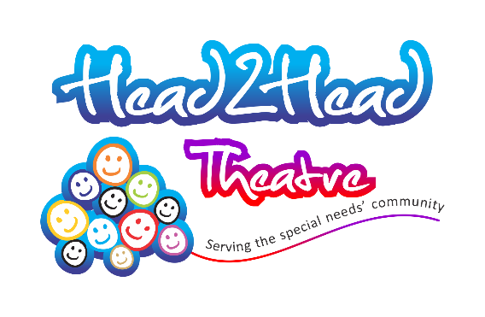
SPECIAL OFFER TO FAMILIES
Recommend a family to join our free membership and both families will receive 2 free places (worth £10) for
PETER PAN IN A PICKLE

FUN FOR ALL THE FAMILY Registered Charity No: 1161873
at Manor Mead School, Laleham Road, Shepperton TW17 8EL
FAMILIARISATION SESSION
for children with ASD/anxieties & their families
Quiet session with a small group exploring our sensory tent, craft & game activities. Please bring along a picnic.
[Please note there is no performance but you will get to explore the sensory props & meet some of the characters in the story]
Monday 22nd October … 12.00 – 2.00pm
£8 (family group of up to 4 persons)
Peter Pan in a Pickle
for children/young people with SEND & their families
Half-day session to include interactive, multi-sensory walkabout performance and lunchtime activities (12.45 – 2.00pm) with games, craft activities & sensory tent

Monday 22nd October … 2pm
Tuesday 23rd October … 11.15am or 2pm

£5 per person
Some free places available for families on Income Support or Income Related ESA

To book a place, please contact Head₂Head Theatre:
Tel/Fax: 01372 278021 Mobile: 07519 747 290
Email: office@head2headtheatre.co.uk
http://www.head2headtheatre.co.uk/families/walkabout-theatre
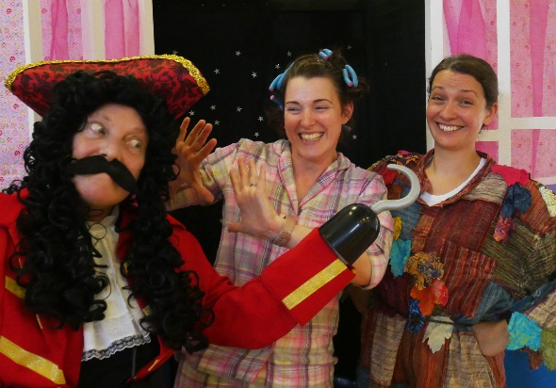
Video links plus full details of our touring dates on WEBSITE

Supported by:

Walton Leigh School Story based on J.M. Barrie’s
Manor Mead School ‘Peter & Wendy’

