LINDON BENNETT SCHOOL
SAFEGUARDING & CHILD PROTECTION POLICY

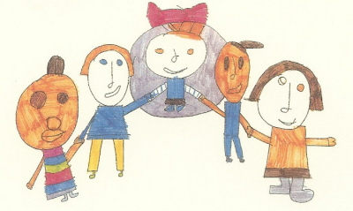
MY REQUESTS
Give me the dignity and respect I deserve
Always give me time to respond
Remember I like to make choices, please help me to do so
Always look out for me and keep me safe
Always remember to tell me what is happening next
Stay calm and be patient with me
Give me the opportunity and time to communicate for myself
Talk with me, not about me
Please take the time to understand what I am trying to tell you
Please don’t judge me

Reviewed & Updated: Spring 2020
Next update due: Spring 2021

CONTENTS
Introduction
Safeguarding and Child Protection Policy

School Commitment Aim of Policy

SECTION 1: Providing a Safe and Supportive Environment
- Safer Recruitment and Selection
- Safe Practice
- Safeguarding Information for Pupils
- Partnership with Parents
- Partnership with Others
- School Training and Staff Induction
- Support, Advice and Guidance for Staff
- Related School Policies (inc. Children Missing from Education)
- Pupil Information
- Roles and Responsibilities: Governing Body Headteacher
Designated Senior Person All Staff and Volunteers

SECTION 2: Identifying Children who are suffering or likely to suffer Significant Harm
Definitions

SECTION 3: Taking Action to Ensure that Children are Safe at School and at Home
- Staff will immediately report
- Responding to Disclosure
- Action by Designated Senior Person
- Action following a Child Protection referral
- Recording and Monitoring
- Supporting the Child and Partnership with Parents

SECTION 4: Allegations regarding person(s) working in or on behalf of school INTRODUCTION
The purpose of the Child Protection Policy

The school recognises that it has an explicit duty to safeguard and protect children from abuse as defined in the Children Act 2004 and the Education Act 2002. The overall intention and purpose behind the school’s child protection policy is underpinned by the fundamental principle of the Children Act 1989:

‘the welfare of the c hild is paramount’

Everyone in our school shares an objective to help keep children safe by:
- Providing a safe environment for children to learn in.
- Supporting children’s development in ways which will foster a sense of self
-esteem and independence
- Identifying and responding to children in need of support and/or protection The policy is in response to:
  - The Children’s Act 1989 and 2004
  - Sections 175 and 157 of the Education Act 2002, implemented in June 2004
  - Keeping Children Safe in Education (2018)
  - The Education (Pupil Information) (England) Regulations 2005

It is in line with:
Hounslow Safeguarding Board Safeguarding Procedures Working Together to Safeguard Children (March 2015)
What to do if you’re worried about a child being abused (March 2015) Multi-Agency Practice Guidelines: Female Genital Mutilation (2014)

This policy applies to all adults, including volunteers, working in or on behalf of the school.
Safeguarding and promoting the welfare of children is everyone’s responsibility. Everyone who comes into contact with children and their families has a role to play. In order to fulfil this responsibility effectively, all practitioners should make sure their approach is child-centred. This means that they should consider, at all times, what is in the best interests of the child.

All school and college staff have a responsibility to provide a safe environment in which children can learn.

All school and college staff have a responsibility to identify children who may be in need of extra help or who are suffering, or are likely to suffer, significant harm. All staff then have a responsibility to take appropriate action…’

‘Keeping Children Safe in Education’ (September 2019)

SCHOOL COMMITMENT
Lindon Bennett School is committed to Safeguarding and Promoting the Welfare of all of its pupils. Each pupil’s welfare is of paramount importance. We recognise that some of our children may be especially vulnerable to abuse because of their Special Educational Needs, especially those also living in adverse circumstances. We recognise that children who are abused or neglected may find it difficult to develop a sense of self worth and to view the world in a positive way. Whilst at school, their behaviour may be challenging. We recognise that some children who have experienced abuse may harm others. We will always take a considered and sensitive approach in order that we can support all of our pupils.

Aims
The aims of this policy are to:
  - support the child’s development in ways that will foster security, confidence and independence;
  - provide an environment in which children and young people feel safe, secure,
valued and respected, and feel confident, and know how to, approach adults if they are in difficulties believing they will be effectively listened to;
  - raise the awareness of all teaching and non-teaching staff of the need to safeguard children and of their responsibilities in identifying and reporting possible cases of abuse;
  - provide a systematic means of monitoring children known or thought to be at risk of harm, and ensure we, the school, contribute to assessments of need and support packages for those children;
  - emphasise the need for good levels of communication between all members of staff;
  - develop a structured procedure within the school which will be followed by all members of the school community in cases of suspected abuse;
  - develop and promote effective working relationships with other agencies, especially the Police and Social Services;
  - Wherever the word “staff” is used, it covers ALL staff on site, including ancillary and supply staff, and volunteers working with children
  - ensure that all adults within our school who have substantial access to children have been checked as to their suitability.

Procedures
We will follow the procedures set out by the Hounslow Local Safeguarding Children Board and take account of guidance issued by OFSTED and the Department of Education to:

- ensure we have a designated senior person (Clare Longhurst, Headteacher) and a deputy (Leonie Christou, Deputy Headteacher) who receive appropriate training and support for their role;
- ensure that we have a designated governor responsible for Safeguarding (Lorna Goodwin, Chair);
- ensure that every member of staff (including temporary staff, volunteers, supply staff etc) and the governing body knows who the designated senior person for Safeguarding is and their role;
- ensure that all staff and volunteers understand their responsibilities in being alert to the signs of abuse and responsibility for referring any concerns to the designated senior person responsible for Safeguarding;
- ensure that parents have an understanding of the responsibility placed on the school and staff for Safeguarding by setting out its obligations on the website and in school publications;
- notify Children’s Services if there is any absence of a pupil who is subject to a Safeguarding Plan;
- develop effective links with relevant agencies and co-operate as required with their enquiries regarding Safeguarding matters, including attendance at case conference and core group or networking meetings;

- keep written records of concerns about children, even when there is no need to refer the matter immediately;
- ensure that all written records are kept securely, either electronically or separate from the main pupil file, and in a locked location;
- follow procedures where an allegation is made against a member of staff or volunteer by contacting the Designated Officer and following her direction - Hetsie van Rooyen Tel: 020 8583 3066 for existing cases or SAAM Duty Desk 020 8583 5730 for new enquiries
- ensure that safer recruitment practices are always followed;
- maintain a single central record of all vetting and recruitment checks;
- ensure that all agencies who refer staff to us e.g. supply agencies, ITT institutions, LA staff, health staff etc are vetted;
- induct every adult and student who spend time in school ensuring their full awareness of our Safeguarding Policy, safety and any other relevant safeguarding policies and procedures;
- ensure that all staff receive regular training/briefing in Safeguarding to keep their knowledge and understanding fully up to date;
- ensure that the Governing Body are fully informed of the numbers of children subject to Safeguarding Plans, provision for vulnerable children, progress of identified groups etc and complete the annual audit requested by the LA.

Section 1: PROVIDING A SAFE AND SUPPORTIVE ENVIRONMENT

Safer Recruitment and Selection
The school pays full regard to DfES guidance ‘Keeping Children Safe in Education’ September 2018. We ensure that all appropriate measures are applied in relation to everyone who works in the school who is likely to be perceived by the children as a safe and trustworthy adult including e.g. volunteers and staff employed by contractors. Safer recruitment practice includes scrutinising applicants, verifying identity and academic or vocational qualifications, obtaining professional and character references, checking previous employment history and ensuring that a candidate has the health and physical capacity for the job. At least one member of the interview panel will have undertaken ‘Safer Recruitment’ training. It also includes undertaking interviews and, where appropriate, undertaking List 99 and Disclosure and Barring checks, as well as s128 prohibition checks on all Governors, the Head, members of SLT and department heads.

Statutory changes, underpinned by regulations, are that:
  - a DBS Enhanced Disclosure is obtained for all new paid appointments to the school’s workforce,
  - an identity check is carried out on all new paid appointments to the school’s workforce
  - a prohibition check is carried out on all new paid appointments to the school’s workforce
  - a disqualification and disqualification by association form is completed by all staff members
  - all professional qualifications will be checked as necessary
  - a DBS Enhanced Disclosure is obtained for all volunteers further to a written risk assessment considering the regularity, frequency, duration and nature of contact (see p.49 of above guidance)
  - school will ensure that any contracted staff have a DBS check where appropriate
  - schools must keep a single central record detailing a range of checks carried out on their staff
  - all new appointments to the school workforce who have lived outside the UK are subject to additional checks as appropriate
  - schools must receive confirmation in writing that any staff provided by any alternative provider have undergone the necessary checks
  - identity checks must be carried out on all appointments to the school workforce before the appointment is made

Clare Longhurst (Headteacher), Leonie Christou (Deputy Headteacher), Lindy Rourke, Adele Mears & Hayley Davidson (Assistant Headteachers), Mark Hutton (School Business Manager) and Lorna Goodwin (Chair of Governors) have all undertaken Safer Recruitment training. One or more will be involved in all staff and volunteer appointments and arrangements (including, where appropriate, contracted services).

Safe Practice
The school has adopted the DfE ‘Keeping Children Safe in Education’ September 2019 guidance and has undertaken Safe Practice training to ensure that staff are safe and aware of behaviours which should be avoided.

Safe working practice ensures that pupils are safe and that all staff:

  - are responsible for their own actions and behaviour and should avoid any conduct which would lead any reasonable person to question their motivation and intentions;
  - work in an open and transparent way;
  - discuss and/or take advice from school management over any incident which may give rise to concern;
  - record any incidents or decisions made;
  - apply the same professional standards regardless of gender or sexuality;
  - are aware that breaches of the law and other professional guidelines could result in criminal or disciplinary action being taken against them.

Safeguarding Information for pupils
We recognise that the school plays a significant part in the prevention of harm to our pupils by providing pupils with good lines of communication with trusted adults, supportive friends and an ethos of protection.

The school community will therefore:
- establish and maintain an ethos where children feel secure and are encouraged to communicate their feelings and are always listened to;
- include across the curriculum, including PSHE, opportunities which equip children with the skills they need to stay safe from harm and to know to whom they should turn for help.

Lindon Bennett School is committed to ensuring that pupils are as aware as they can be of behaviour towards them that is not acceptable and how they can keep themselves safe. When considering peer on peer abuse, whilst acknowledging that any such behaviour is most likely to be as a result of learning difficulties rather than being with any intent, all such incidents will be recorded using the school’s existing systems and addressed appropriately.

Partnership with Parents
The school shares a purpose with parents to keep children safe from harm and to have their welfare promoted.
We are committed to working with parents positively, openly and honestly. We ensure that all parents are treated with respect, dignity and courtesy. We respect parents’ rights to privacy and confidentiality and will not share sensitive information unless we have permission or it is necessary to do so in order to protect a child.
School will share with parents any concerns we may have about their child unless to do so may place a child at risk of harm (see Section 3: 3 Action by Senior Designated Person).
We encourage parents to discuss any concerns they may have with the class teacher, head teacher/designated safeguarding person.
We make parents aware of our policy through its availability on our website and parents are made aware that they can view this policy on request:

‘Lindon Bennett School is committed to ensuring the welfare and safety of all children in school. All Hounslow schools, including Lindon Bennett School, follow the Hounslow Local Safeguarding Children Board (LSCB) procedures. The school will, in most circumstances, endeavour to discuss all concerns with parents about their child/ren. However, there may be exceptional circumstances when the school will discuss concerns with Social Care and/or the Police without parental knowledge (in accordance with Child Protection procedures). The school will, of course, always aim to maintain a positive relationship with all parents. The school’s safeguarding policy is available on request.’

Partnerships with others
The school recognises that it is essential to establish positive and effective working relationships with other agencies.

As a school we will work together with our safeguarding partners:
- Local Authority (LA)
- Clinical commissioning group within the LA
- Chief office of Police within the LA

As a school we will follow new local safeguarding arrangements, as and when these are shared.

The school works closely with the Early Help Hounslow Team, their Educational Welfare Officer, Children’s Medical Examining Officer and Social Care.

School Training and Staff Induction
The school’s senior members of staff with designated responsibility for child protection as well as the 3 Assistant Headteachers have undertaken Level 3 child protection training, which is refreshed on a two year basis.
All school staff, including non teaching staff, undertake appropriate induction including the Behaviour Policy and information regarding processes for children missing from education; as well as training to equip them to carry out their responsibilities for child protection effectively, which is kept up to date by refresher training at yearly intervals.

All staff (including temporary staff and volunteers) are provided with the school’s child protection and safeguarding policies and informed of school’s child protection arrangements on induction.

Support, Advice and Guidance for Staff
Staff will be supported by the head teacher and referral to documentation held in school and http://www.hounslow.gov.uk/childprotection
The designated senior person will be supported by the governing body designated person. Staff are given clear procedures to follow if they are concerned about a child’s safety, and know to seek advice from the Child Protection Officer.

Related School Policies
‘Safeguarding covers more than the contribution made to child protection in relation to individual children. It also encompasses issues such as pupil health and safety and bullying and a range of other issues, for example, arrangements for meeting the medical needs of children, providing first aid, school security, drugs and substance misuse, etc. There may also be other safeguarding issues that are specific to the local area or population’

Working Together to Safeguard Children March 2015

The school’s Behaviour Policy and Written Statement of Behaviour Principles, as well as procedures for dealing with children missing from education are also of particular relevance.

Missing Children
Parents are aware that they must phone school if their child is absent. Admin staff phone every child on the first day of an absence if a parent doesn’t phone by 9am.

Any absence for child who is subject to a Safeguarding plan or is known to Children’s Services will have their absence reported to Children’s Services on the first day.

Education Welfare will be notified of absences for any children who have a referral to EWO or who have been absent for more than 3 days with no notification from parents.
We will follow the School and Local Authority Off Roll Procedures (appendix 6). As well as informing Hounslow EWO we will add any missing children to the database. https://sa.education.gov.uk/idp/Authn/UserPassword
All school staff are aware of the possible link between Female Genital Mutilation and Forced Marriage and extended absence from school. Any concerns are raised with the Designated Safeguarding Lead (Clare Longhurst).

Confidentiality
We recognise that all matters relating to Safeguarding are confidential; however, a member of staff must never guarantee confidentiality to either a parent or a pupil.

Where there is a Safeguarding concern it will be passed immediately to the Designated Senior Person and/or to Children’s Social Care.

The Headteacher/Designated Senior Person will disclose personal information, including the level of involvement of other agencies, about a pupil to other members of staff only on a ‘need to know’ basis.

All staff must be aware that they have a professional responsibility to share information with other agencies in order to safeguard children

Pupil Information
In order to keep children safe and provide appropriate care for them the school requires accurate and up to date information regarding:
- Names ( including any previous names), address and date of birth of child
- Names and contact details of persons with whom the child normally lives
- Names and contact details of all persons with parental responsibility (if different from above)
- Emergency contact details for at least 2 different people (if different from above)
- Details of any persons authorised to collect the child from school (if different from above)
- Any relevant court orders in place including those which affect any person’s access to the child (e.g. Residence Order, Contact Order, Care Order, Injunctions etc.)
- If the child has a Child Protection Plan
- Name and contact detail of key persons in other agencies, including GP

- Any other factors which may impact on the safety and welfare of the child
The school will collate, store and agree access to this information. It will be held centrally on the school premises.

Roles and Responsibilities
The Governing Body is responsible for ensuring that:
  - the school has a safeguarding policy and procedures in place that are in accordance with local authority guidance and locally agreed inter-agency procedures, and the policy is made available to parents on request;
  - the school operates safe recruitment procedures and makes sure that all appropriate checks are carried out on staff and volunteers who work with children;
  - the school has procedures for dealing with allegations of abuse against staff and volunteers that comply with guidance from the local authority and locally agreed inter-agency procedures;
  - a senior member of the school’s leadership team is designated to take lead responsibility for child protection (and deputy);
  - staff undertake appropriate child protection training;
  - they remedy, without delay, any deficiencies or weaknesses regarding child protection arrangements;
  - a governor is nominated to be responsible for liaising with the LA and /or partner agencies in the event of allegations of abuse being made against the head teacher
  - where services or activities are provided on the school premises by another body, the body concerned has appropriate policies and procedures in place in regard to safeguarding children and child protection and liaises with the school on these matters where appropriate.
  - they review their policies and procedures annually and provide information to the LA about them and about how the above duties have been discharged

Headteacher is responsible for ensuring that:
    - the policies and procedures adopted by the Governing Body or Proprietor are fully implemented, and followed by all staff;
    - we will ensure that we now carry out section 128 checks on all of our non-associate Governors
    - sufficient resources and time are allocated to enable the designated person and other staff to discharge their responsibilities; and
all staff and volunteers feel able to raise concerns about poor or unsafe practice in regard to children, and such concerns are addressed sensitively and effectively in a timely manner in accordance with agreed whistle blowing policies.

The Senior Leader with Designated Responsibility for Child Protection is responsible for:

Referrals
      - Refer cases of suspected abuse or allegations to the relevant investigating agencies;
      - Act as a source of support , advice and expertise within the educational establishment;

Training
        - To recognise how to identify signs of abuse and when it is appropriate to make a referral;
        - Have a working knowledge of how LSCBs operate, the conduct of a child protection case conference and be able to attend and contribute to these;
        - Ensure that all staff have access to and understand the school’s child protection policy; and are aware of the school’s procedures for children missing from education;
        - Ensure that all staff have induction training;
        - Keep detailed accurate secure written or electronic records and/or concerns
        - Obtain access to resources and attend any relevant or refresher training courses at least every two years.

Raising Awareness
- Ensure the safeguarding policy is updated and reviewed annually and work with the governing body regarding this;
- Ensure parents are made aware of the safeguarding policy which alerts them to the fact that referrals may be made and the role of the establishment in this to avoid conflict later;
- Where a child leaves the establishment, ensure the child protection file is copied for the new establishment ASAP and transferred to the new school separately from the main pupil file. If a child goes missing or leaves to be educated at home, then the child protection file should be copied and the copy forwarded to the Principal Education Social Worker, London Borough of Hounslow, Hounslow House, 7 Bath Road, Hounslow, TW3 3EB

All staff and volunteers must:

  - fully comply with the school’s policies and procedures
  - attend appropriate training
  - inform the designated person of any concerns

Section 2: IDENTIFYING CHILDREN AND YOUNG PEOPLE WHO MAY BE SUFFERING SIGNIFICANT HARM

Teachers and other adults in school are well placed to observe any physical, emotional or behavioural signs which indicate that a child may be suffering significant harm. The relationships between staff, pupils, parents and the public which foster respect, confidence and trust can lead to disclosures of abuse, and/or school staff being alerted to concerns.

Definitions

As in the Children Acts 1989 and 2004, a child is anyone who has not yet reached his/her 18th birthday.
Harm means ill-treatment or impairment of health and development, including, for example, impairment suffered from seeing or hearing the ill-treatment of another; Development means physical, intellectual, emotional, social or behavioural development; Health includes physical and mental health; Ill-treatment includes sexual abuse and other forms of ill- treatment which are not physical.
Abuse and Neglect are forms of maltreatment. Somebody may abuse or neglect a child by inflicting harm or failing to act to prevent harm. Children may be abused in a family or in an institutional or community setting; by those known to them, or, more rarely, by a stranger. They may be abused by an adult or adults or another child or children.

Physical Abuse may involve hitting, shaking, throwing, poisoning, burning or scalding, drowning, suffocating or otherwise causing physical harm to a child. Physical harm may also be caused when a parent or carer fabricates the symptoms of or deliberately induces illness in a child.

Sexual Abuse involves forcing or enticing a child or young person to take part in sexual activities, not necessarily involving a high level of violence, whether or not the child is aware of what is happening. The activities may involve physical contact, including assault by penetration (for example, rape or oral sex) or non penetrative acts such as masturbation, kissing, rubbing and touching outside clothing.

They may also include non-contact activities, such as involving children in looking at or in the production of, sexual images, watching sexual activities, encouraging children to behave in sexually inappropriate ways, or grooming a child in preparation for abuse (including via the internet). Sexual abuse is not solely perpetrated by adult males. Women can commit acts of sexual abuse, as can other children.

Emotional Abuse is the persistent emotional maltreatment of a child such as to cause severe and persistent adverse effects on the child’s emotional development. It may involve conveying to children that they are worthless or unloved, inadequate, or valued only insofar as they meet the needs of another person. It may include not giving the child opportunities to express their views, deliberately silencing them or ‘making fun’ of what they say or how they communicate. It may feature age or developmentally inappropriate expectations being imposed on children. These may include interactions that are beyond the child’s developmental capability, as well as overprotection and limitation of exploration and learning, or preventing the child participating in normal social interaction. It may involve seeing or hearing the ill treatment of another. It may involve serious bullying (including cyber-bullying), causing children frequently to feel frightened or in danger, or the exploitation or corruption of children. Some level of emotional abuse is involved in all types of maltreatment of a child, though it may occur alone.

Neglect is the persistent failure to meet a child’s basic physical and/or psychological needs, likely to result in the serious impairment of the child’s health or development. Neglect may occur during pregnancy as a result of maternal substance abuse. Once a child is born, neglect may involve a parent or carer failing to:
- provide adequate food and clothing, shelter (including exclusion from home or abandonment)
- protect a child from physical and emotional harm or danger
- ensure adequate supervision (including the use of inadequate caretakers)
- ensure access to appropriate medical care or treatment.
It may also include neglect of, or unresponsiveness to, a child’s basic emotional needs.

Appendix 1 gives more information about likely signs of abuse (as explained by the NSPCC)

Appendix 7 gives more information about Female Genital Mutilation, referrals, Tracking and Monitoring.

Upskirting is now a form of peer-on-peer abuse, this is typically when a photograph is taken under a person’s clothing without them knowing, for sexually gratification or to cause the victim humiliation, distress or alarm. Whilst it is highly unlikely that this would ever happen within our school, staff are all aware that this is now a criminal offence.

Indicators that may signal that children are at risk from, or are involved with, serious violent crime include:
- Unexplained gifts or new possessions - these can indicate that children have been approached by or involved with individuals associated with criminal networks or gangs
- Increased absence from school
- Change in friendship or relationships with others or groups
- Significant decline in performance
- Signs of self-harm or significant change in wellbeing
- Signs of assault or unexplained injuries
Again it is highly unlikely that these would be relevant to the children attending Lindon Bennett School, but Staff are aware of both the indicators and the associated risks and understand the measures in place to manage them.

Section 3: TAKING ACTION TO ENSURE THAT CHILDREN ARE SAFE AT SCHOOL AND AT HOME

All staff follow the Hounslow LSCB Child Protection Procedures which are consistent with ‘Keeping Children Safe in Education’ September 2019 and ‘What To Do If You Are Worried A Child is Being Abused’ (Appendix A)

It is not the responsibility of the school staff to investigate welfare concerns or determine the truth of any disclosure or allegation. All staff, however, have a duty to recognise concerns and maintain an open mind. Accordingly all concerns regarding the welfare of pupils will be recorded and discussed with the designated senior person with responsibility for child protection (or another senior member of staff in the absence of the designated person) prior to any discussion with parents.

Staff must immediately report:
  - any suspicion that a child is injured, marked, or bruised in a way which is not readily attributable to the normal knocks or scrapes received in play
  - any explanation given which appears inconsistent or suspicious
  - any behaviours which give rise to suspicions that a child may have suffered harm
  - any concerns that a child may be suffering from inadequate care, ill treatment, or emotional maltreatment
  - any concerns that a child is presenting signs or symptoms of abuse or neglect
  - any significant changes in a child’s presentation, including non-attendance
  - any hint or disclosure of abuse from any person
  - any concerns regarding person(s) who may pose a risk to children (e.g. living in a household with children present)

Responding to Disclosure
Disclosures or information may be received from pupils, parents or other members of the public. School recognises that those who disclose such information may do so with difficulty, having chosen carefully to whom they will speak. Accordingly all staff will handle disclosures with sensitivity, providing appropriate support for those who have difficulty expressing themselves verbally.

Such information cannot remain confidential and staff will immediately communicate what they have been told to the designated person and make a contemporaneous record.

Staff will not investigate but will, wherever possible, elicit enough information to pass on to the designated person in order that s/he can make an informed decision of what to do next.

Staff will:

- listen to and take seriously any disclosure or information that a child may be at risk of harm
- try to ensure that the person disclosing does not have to speak to another member of school staff
- clarify the information
- try to keep questions to a minimum and of an ‘open’ nature e.g. ‘Can you tell me what happened ?’ rather than ‘Did x hit you?’
- try not to show signs of shock, horror or surprise
- not express feelings or judgements regarding any person alleged to have harmed the child
- explain sensitively to the person that they have a responsibility to refer the information to the senior designated person
- reassure and support the person as far as possible
- explain that only those who ‘need to know’ will be told
- explain what will happen next and that the person will be involved as appropriate

Action by the Designated Senior Person (or other senior person in their absence)

Following any information raising concern, the senior designated person will consider:

- any urgent medical needs of the child
- discussing the matter with other agencies involved with the family

- consulting with appropriate persons e.g. Education Welfare Officer service, Social Care
- the child‘s wishes Then decide:
- wherever possible, to talk to parents, unless to do so may place a child at risk of significant harm, impede any police investigation and/or place the member of staff or others at risk
- whether to make a child protection referral to social care because a child is suffering or is likely to suffer significant harm and if this needs to be undertaken immediately

OR
- not to make a referral at this stage
- if further monitoring is necessary
- if it would be appropriate to undertake an assessment (e.g. Common Assessment Framework) and/or make a referral for other services

All information and actions taken, including the reasons for any decisions made, will be fully documented. All referrals to social care will be accompanied by a standard referral form.

Action following a child protection referral

The designated senior person or other appropriate member of staff will:
- make regular contact with Social Care
- contribute to the Strategy Discussion and Initial Assessment
- provide a report for, attend and contribute to any subsequent Child Protection Conference
- if the child or children has a Child Protection Plan, contribute to the Child Protection Plan and attend Core Group/Network Meetings and Review Child Protection Conferences
- share all reports with parents prior to meetings
- where in disagreement with a decision made e.g. not to apply Child Protection Procedures or not to convene a Child Protection Conference, discuss this with the Education Safeguarding and Child Protection Manager
- where a child having a Child Protection Plan moves from the school or goes missing, immediately inform the key worker in Social Care

Recording and monitoring School will record:
- Information about the child : name (aka) address, d.o.b., those with parental
responsibility, primary carers, emergency contacts, names of persons authorised to collect from school, any court orders, if a child is or has been subject to a CP Plan (been on the CP Register)
- Key contacts in other agencies including GP details
- Any disclosures/accounts from child or others, including parents (and keep original notes)
- All concerns, discussions, decisions, actions taken (dated, timed and signed) and arrangements for monitoring/review

All records should be objective and include:
- Statements, facts and observable things (what was seen/heard)
- Diagram indicating position, size and colour of any injuries (not photograph)
- Words child uses, (not translated into ‘proper’ words)
- Non-verbal behaviours

All Child Protection documents will be retained in a ‘Child Protection’ file, separate from the child’s main file. This will be locked away and only accessible to the Headteacher and senior designated person. These records will be copied and transferred to any school or setting the child moves to, clearly marked ‘Child Protection, Confidential, for attention of Designated Senior Person Child Protection.’

If the child goes missing from education or is removed from roll to be educated at home then any Child Protection file should be copied and the copy sent to the Principal Education Social Worker, London Borough of Hounslow, Hounslow House, 7 Bath Road, Hounslow, TW3 3EB.We will retain all original copies of Child Protection files until the child’s 25th birthday.

School will monitor:
Any cause for concern including where there could be serious child welfare concerns:
- Injuries/marks
- Attendance
- Changes e.g. mood/ academic functioning
- Relationships
- Language
- Behaviour
- Demeanour and appearance
- Statements, comments
- Medicals
- Stories, ‘news’, drawings
- Response to P.E./Sport
- Family circumstances
- Parental behaviour/ care of child

The Designated Senior Person will review all monitoring arrangements in the timescale and manner determined by circumstances, recorded and clearly understood by all concerned.

- Supporting the Child and Partnership with Parents

- School recognises that the child’s welfare is paramount, however good, child protection practice and outcome relies on a positive, open and honest working partnership with parents

- Whilst we may, on occasion, need to make referrals without consultation with parents, we will make every effort to maintain a positive working relationship with them whilst fulfilling our duties to protect any child

- We will provide a secure, caring, supportive and protective relationship for the child

- Children will be given a proper explanation (appropriate to age & understanding) of what action is being taken on their behalf and why

- We will endeavour always to preserve the privacy, dignity and right to confidentiality of the child and parents. The Designated Senior Person will determine which members of staff “need to know” personal information and what they “need to know” for the purpose of supporting and protecting the child

Section 4: Allegations regarding person(s) working in or on behalf of school (including volunteers)
All school staff should take care not to place themselves in a vulnerable position with a child. It is always advisable for interviews or work with individual children or parents to be conducted in view of other adults.

All Staff should be aware of Hounslow’s Guidance on Behaviour Issues, and the school’s own Behaviour Management policy and Staff Code of Conduct.

Where an allegation is made against any person working in or on behalf of the school that he or she has:

- behaved in a way that has harmed a child or may have harmed a child
- possibly committed a criminal offence against or related to a child or
- has behaved towards a child or children in a way that indicates s/he is unsuitable to work with children.

We will apply the same principles as in the rest of this document.

We will always follow the Hounslow Local Safeguarding Children’s Board procedures http://www.hounslow.gov.uk/local_safeguarding_children_board_.htm

Detailed records will be made to include decisions, actions taken, and reasons for these. All records will be retained securely in a locked cupboard only accessible by the Headteacher and senior safeguarding person, or electronically on MyConcern.

Whilst we acknowledge such allegations, (as all others), may be false, malicious or misplaced, we also acknowledge they may be founded. It is, therefore, essential that all allegations are investigated properly and in line with agreed procedures.

Initial Action

  - The person who has received an allegation or witnessed an event will immediately inform the headteacher and make a record
  - In the event that an allegation is made against the headteacher the matter will be reported to the Chair of Governors who will proceed as the ‘headteacher’
  - The headteacher will take steps, where necessary, to secure the immediate safety of children and any urgent medical needs
  - The member of staff will not be approached at this stage unless it is necessary to address the immediate safety of children
  - The headteacher may need to clarify any information regarding the allegation, however no person will be interviewed at this stage
  - The headteacher will consult with Designated Officer (DO) in order to determine if it is appropriate for the allegation to be dealt with by school or if there needs to be a referral to social care and/or the police for investigation
  - Consideration will be given throughout to the support and information needs of pupils, parents and staff
  - The headteacher will inform the Chair of Governors of any allegation.

References

Training Materials
www.educareforeducation.co.uk

Websites
Hounslow LSCB
(CP Procedures and Training) http://www.hounslow.gov.uk/local_safeguarding_children_board_.htm
CAPE (Child Protection in Education) www.cape.org.uk

Keeping Children Safe
Internet Safety www.ceop.gov.uk
Cyberbullying www.digizen.org
Bullying & child abuse www.anti-bullyingalliance.org
www.kidscape.org.uk www.childline.org.uk
www.nspcc.org.uk
Domestic Violence www.thehideout.co.uk
Internet Safety www.ceop.org.uk/thinkuknow
www.childnet-int.org
Jenny’s story www.childnet-int.org/jenny

Documents
DCSF Document www.teachernet.gov.uk/childprotection Safeguarding Children and Safer Recruitment in Education
Extended Work Experience and Child Protection – Supplementary Guidance Working Together to Safeguard Children
“What to do if” and other docs www.everychildmatters.gov.uk/safeguarding Information Sharing www.ecm.gov.uk/deliveringservices/informationsharing Making it Happen www.everychildmatters.gov.uk/search/IG00130

Monitoring, Evaluating and Review

The Governing Body will review this policy annually (or sooner if legislation changes) and assess its implementation and effectiveness. The policy will be promoted and implemented throughout the school.

Appendix 1: definitions & signs of abuse
Appendix 2: body maps indicating likely accidental and non-accidental injury
Appendix 3: Missing children / Off roll procedures
Appendix 4: Female Genital Mutilation
Appendix 5: Forced Marriage
Appendix 6: Radicalisation

The Governing Body is regularly kept informed of Safeguarding incidents via the Designated Governor and the Headteacher’s reports presented at Full Governing Body meetings.

This Policy will be formally reviewed annually by the Full Governing Body

Review date: Spring 2021

FLOW CHART FOR RAISING SAFEGUARDING CONCERNS ABOUT A CHILD
The Local Authority
SAAM Duty Desk:
020 8583 5730

Designated Officer (DO):
Hetsie van Rooyen

Tel: 020 8583 3066

Decision made to refer the concern to social care
The Designated Safeguarding Person in this school is:

Clare Longhurst

The Deputy Designated Safeguarding person is:

Leonie Christou

The Link Governor for Safeguarding is:

Lorna Goodwin
Concern put in written on a MyConcern
Concern handed to:
Clare Longhurst
Designated Safeguarding Officer reviews concern form and makes a decision about next steps
Decision made to discuss the concern informally with the parents/carers
Decision made to monitor the concern.

Monitor
Class teacher asked to monitor child and feedback to the Designated Safeguarding Person within an agreed timescale
Refer

Close
Designated Safeguarding Person discusses decision with headteacher and both agree to refer to social care
Once discussed with parents Designated Safeguarding Person decides to close concern, monitor or refer to social care

Date published: Spring 2020
Designated Safeguarding Person closes concern, but keeps record in confidential safeguarding file.
Children’s Services Duty Desk
020 8583 6600/3200 Option 1

CSLL-socialcare-gcsx.gov.uk

Date for review: Spring 2021

Appendix 1 – Definitions and Signs of Abuse

Definitions

There are four types of child abuse. They are defined in the UK Government guidance Keeping children safe in education (September 2019)

- Physical abuse
- Emotional abuse
- Sexual abuse
- Neglect

Bullying is not defined as a form of abuse in Working Together but there is clear evidence that it is abusive and will include at least one, if not two, three or all four, of the defined categories of abuse. For this reason it has been included in this factsheet.

Signs of abuse

Recognising child abuse is not easy. It is not your responsibility to decide whether or not child abuse has taken place or if a child is at significant risk of harm from someone. You do however, have both a responsibility and duty, as set out in your organisation’s child protection procedures, to act in order that the appropriate agencies can investigate and take any necessary action to protect a child.

The following information should help you to be more alert to the signs of possible abuse.

Physical Abuse

Most children will collect cuts and bruises as part of the rough-and-tumble of daily life. Injuries should always be interpreted in the light of the child’s medical and social history, developmental stage and the explanation given.

Most accidental bruises are seen over bony parts of the body, e.g. elbows, knees, shins, and are often on the front of the body. Some children, however, will have bruising that is more than likely inflicted rather than accidental.

Important indicators of physical abuse are bruises or injuries that are either unexplained or inconsistent with the explanation given, or visible on the ‘soft’ parts of the body where accidental injuries are unlikely, e g, cheeks, abdomen, back and buttocks.

A delay in seeking medical treatment when it is obviously necessary is also a cause for concern, although this can be more complicated with burns, as these are often delayed in presentation due to blistering taking place sometime later.

The physical signs of abuse may include:

- unexplained bruising, marks or injuries on any part of the body
- multiple bruises- in clusters, often on the upper arm, outside of the thigh
- cigarette burns
- human bite marks
- broken bones
- scalds, with upward splash marks,
- multiple burns with a clearly demarcated edge.

Changes in behaviour that can also indicate physical abuse:

  - flinching when approached or touched
  - reluctance to get changed, for example in hot weather
  - depression
  - withdrawn behaviour
  - running away from home.

Emotional Abuse

Emotional abuse can be difficult to measure, as there are often no outward physical signs. There may be a developmental delay due to a failure to thrive and grow, although this will usually only be evident if the child puts on weight in other circumstances, for example when hospitalised or away from their parents’ care. Even so, children who appear well-cared for may nevertheless be emotionally abused by being taunted, put down or belittled. They may receive little or no love, affection or attention from their parents or carers. Emotional abuse can also take the form of children not being allowed to mix or play with other children.

Changes in behaviour which can indicate emotional abuse include:

  - neurotic behaviour e.g. sulking, hair twisting, rocking, being unable to play
  - fear of making mistakes
  - sudden speech disorders
  - self-harm
  - fear of parent being approached regarding their behaviour
  - developmental delay in terms of emotional progress

Sexual Abuse

Adults who use children to meet their own sexual needs abuse both girls and boys of all ages, including infants and toddlers. Usually, in cases of sexual abuse it is the child’s behaviour that may cause you to become concerned, although physical signs can also be present. In all cases, children who tell about sexual abuse do so because they want it to stop. It is important, therefore, that they are listened to and taken seriously.

It is also important to remember that it not just adult men who sexually abuse children – there are increasing numbers of allegations of sexual abuse of children against women and sexual abuse can also be perpetrated by other children or young people.

The physical signs of sexual abuse may include:

  - pain or itching in the genital area
  - bruising or bleeding near genital area
  - sexually transmitted disease
  - vaginal discharge or infection
  - stomach pains
  - discomfort when walking or sitting down
  - pregnancy

Changes in behaviour which can also indicate sexual abuse include:

  - sudden or unexplained changes in behaviour e.g. becoming aggressive or withdrawn fear of being left with a specific person or group of people
  - having nightmares
  - running away from home
  - sexual knowledge which is beyond their age, or developmental level
  - sexual drawings or language
  - bedwetting
  - eating problems such as overeating or anorexia self-harm or mutilation, sometimes leading to suicide attempts saying they have secrets they cannot tell anyone about
  - substance or drug abuse
  - suddenly having unexplained sources of money
  - acting in a sexually explicit way towards adults

Neglect

Neglect can be a difficult form of abuse to recognise, yet have some of the most lasting and damaging effects on children.

The physical signs of neglect may include:

  - constant hunger, sometimes stealing food from other children constantly
  - being dirty or ‘smelly’
  - loss of weight, or being constantly underweight
  - inappropriate clothing for the conditions.

Changes in behaviour which can also indicate neglect may include:

  - complaining of being tired all the time
  - not requesting medical assistance and/or failing to attend appointments
  - having few friends
  - mentioning being left alone or unsupervised.

Bullying

Bullying is not always easy to recognise as it can take a number of forms. A child may encounter bullying attacks that are:

  - physical: pushing, kicking, hitting, pinching and other forms of violence or threats
  - verbal: name-calling, sarcasm, spreading rumours, persistent teasing
  - emotional: excluding (sending to Coventry), tormenting, ridiculing, humiliating.

Persistent bullying can result in:

  - depression
  - low self-esteem
  - shyness
  - poor academic achievement
  - isolation
  - threatened or attempted suicide

Signs that a child may be being bullied can be:

  - coming home with cuts and bruises
  - torn clothes
  - asking for stolen possessions to be replaced
  - losing dinner money
  - falling out with previously good friends
  - being moody and bad tempered
  - wanting to avoid leaving their home
  - aggression with younger brothers and sisters
  - doing less well at school
  - sleep problems
  - anxiety
  - becoming quiet and withdrawn

These definitions and indicators are not meant to be definitive, but only serve as a guide to assist you. It is important too, to remember that many children may exhibit some of these indicators at some time, and that the presence of one or more should not be taken as proof that abuse is occurring. There may well be other reasons for changes in behaviour such as a death or the birth of a new baby in the family or relationship problems between parents/carers. In assessing whether indicators are related to abuse or not, the authorities will always want to understand them in relation to the child’s development and context.

Appendix 2 – Body Maps indicating likely accidental and non-accidental injury

Likely sites of accidental Injury

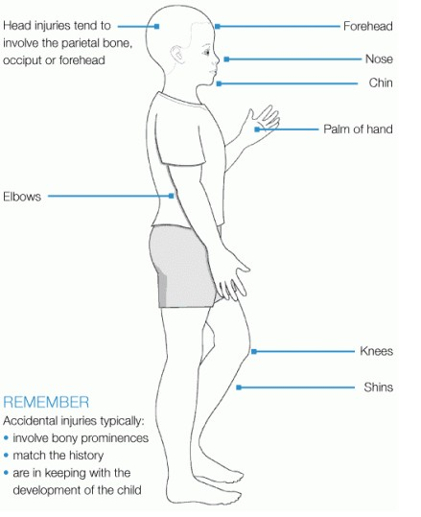

Likely sites of non-accidental injury

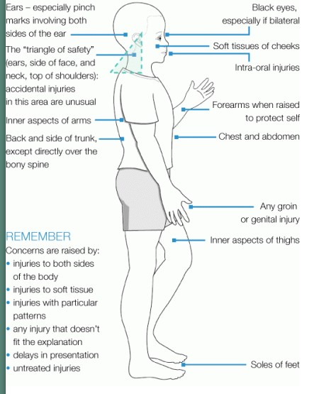

Appendix 3 – Missing/Children Off roll Procedures

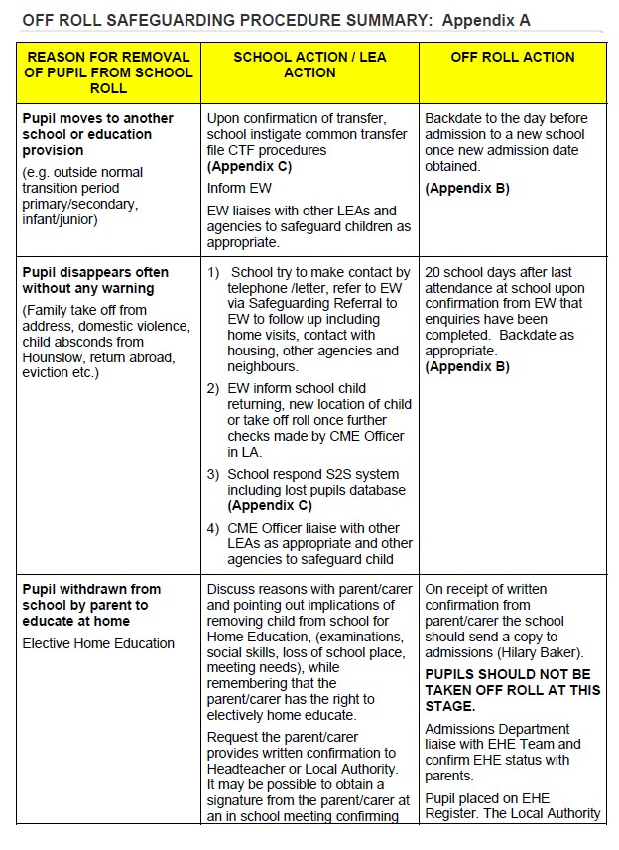

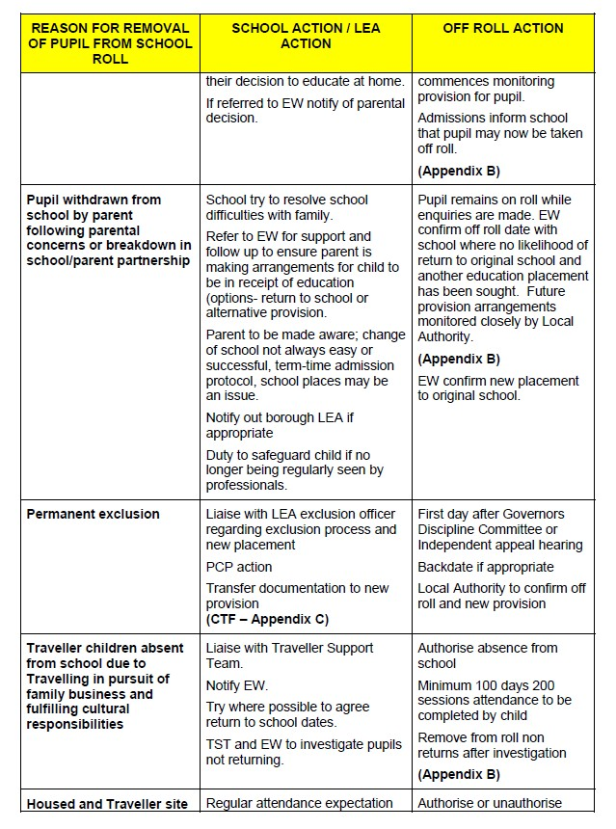

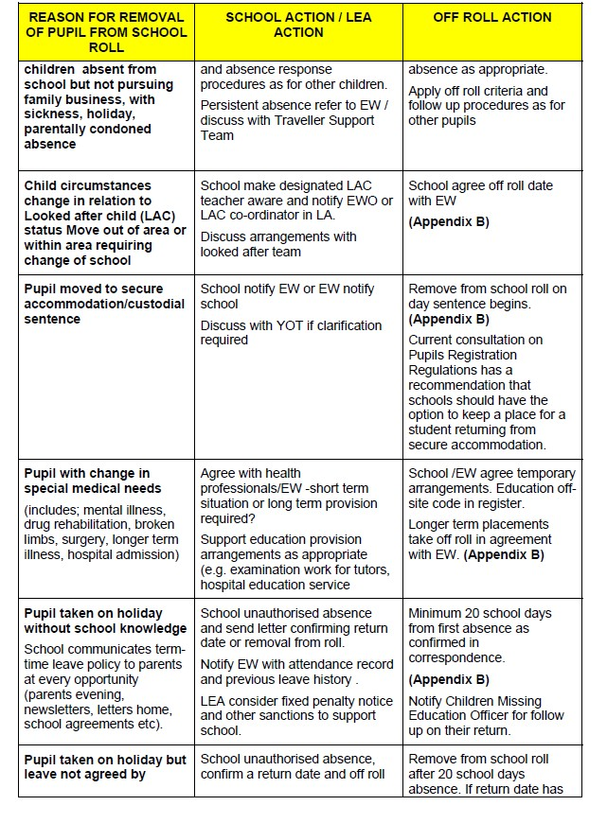

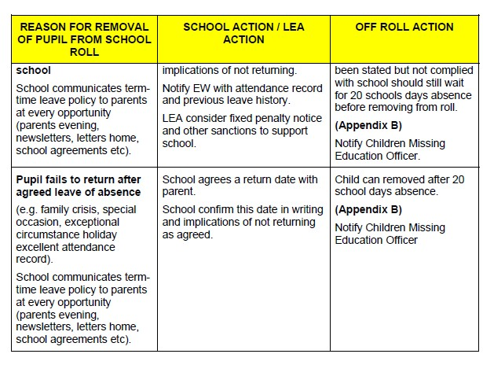

Appendix 4 – Female Genital Mutilation

Introduction

Female genital mutilation (FGM), sometimes referred to as female circumcision, refers to procedures that intentionally alter or cause injury to the female genital organs for non-medical reasons. The practice is illegal in the UK. It is also illegal to take a British national or permanent resident of the UK abroad for FGM. The maximum prison sentence for carrying out FGM or helping it to take place is 14 years,

It has been estimated that over 20,000 girls under the age of 15 are at risk of female genital mutilation (FGM) in the UK each year, and that 66,000 women in the UK are living with the consequences of FGM. However, the true extent is unknown, due to the "hidden" nature of the crime.

The girls may be taken to their countries of origin so that FGM can be carried out during the summer holidays, allowing them time to "heal" before they return to school. There are also worries that some girls may have FGM performed in the UK.
FGM is usually carried out on young girls between infancy and the age of 15, most commonly before puberty starts.
FGM is prevalent in Africa, the Middle East and Asia. In the UK, FGM tends to occur in areas with larger populations of communities with first-generation immigrants, refugees and asylum seekers. London has been identified as an area where FGM occurs.

Immediate effects
- severe pain
- shock
- bleeding
- wound infections, including tetanus and gangrene, as well as blood-borne viruses such as HIV, hepatitis B and hepatitis C
- inability to urinate
- injury to vulval tissues surrounding the entrance to the vagina
- damage to other organs nearby, such as the urethra (where urine passes) and the bowel
- FGM can sometimes cause death.

Long-term consequences
- chronic vaginal and pelvic infections
- abnormal periods
- difficulty passing urine, and persistent urine infections
- kidney impairment and possible kidney failure
- damage to the reproductive system, including infertility
- cysts and the formation of scar tissue
- complications in pregnancy and newborn deaths
- pain during sex and lack of pleasurable sensation
- psychological damage, including low libido, depression and anxiety (see below)
- flashbacks during pregnancy and childbirth
- the need for later surgery to open the lower vagina for sexual intercourse and childbirth

Psychological and mental health problems

Case histories and personal accounts taken from women indicate that FGM is an extremely traumatic experience for girls and women, which stays with them for the rest of their lives.

Young women, receiving psychological counselling in the UK report feelings of betrayal by parents, as well as regret and anger.

Signs of FGM that we look out for at Lindon Bennett School
  - Prolonged or repeated absences from school.
  - Difficulties walking, standing or sitting.
  - Changes in behaviour – withdrawn, anxious or depressed.
  - Drop in academic performance.
  - Spending prolonged amounts of time in the toilets.
  - Being aware of physical changes during personal care.
If any family informs the school about a prolonged trip abroad, the possibility of FGM is considered. The Headteacher and/or Deputy Headteacher will meet with the parents where there is an identified risk to ensure they are aware of the legal position.

In the event of a concern
If a member of staff suspects a child is at risk of, has already undergone, or receives a disclosure about FGM, they will be careful to respond in an appropriate and sensitive manner. Efforts should be made to establish the full facts from the child before any action is taken. The disclosure should be discussed with the school’s Designated Safeguarding Lead, Clare Longhurst. School staff will not attempt to investigate the case themselves or attempt to speak to the child’s parents as this may place the child at an increased risk of harm.
At Lindon Bennett School, FGM will be treated as a child protection concern and will be referred to Hounslow Children’s Services as outlined in the main body of the Child Protection Policy.
Useful Links
FGM helpline – 0800 028 3550
ChildLine – 0800 1111

Appendix 5 – Forced Marriage

Introduction

Forced Marriage is when someone faces physical pressure to marry (e.g. threats, physical or sexual violence) or emotional and psychological pressure (e.g. being made to feel they are bringing shame on the family).
Forced marriage should not be confused with arranged marriage, which is where the families of both spouses take a leading role in choosing the marriage partner but the choice whether or not to accept the arrangement remains with the young people.
Forced marriage for anyone under 18 is a child protection matter. While it is unlikely that a pupil attending Lindon Bennett School will be forced to marry, it is possible that an older sibling may be and/or a forced marriage may be discussed/planned for a later date.

Keeping Children Safe from Forced Marriage at Lindon Bennett School

- Staff at Lindon Bennett School know what forced marriage is and feel empowered to raise the subject with parents if and when they feel it is necessary. Any conversation of this nature will be reported to a member of the senior leadership team.

Acting on a disclosure

Forced marriage is a culturally sensitive area. It is important that staff are neither overly suspicious about cultural difference nor ignore worrying signs on the basis that that they might be thought racist for raising them.
If a member of staff becomes aware or concerned about a possible forced marriage for a pupil or a sibling of a pupil they should discuss their concerns with the Child Safeguarding lead, Clare Longhurst.

Further Guidance
Forced Marriage Unit – www.gov.uk/stop-forced-marriage Government advice – www.gov.uk/forced-marriage

Appendix 6 - Radicalisation

Statement to combat Radicalisation at Lindon Bennett School

Lindon Bennett School is fully committed to safeguarding and promoting the welfare of all its pupils. As a school we recognise that safeguarding against radicalisation is equally as important as safeguarding against any other vulnerability.

At Lindon Bennett School all staff are expected to uphold and promote the fundamental principles of British values and the UNCRC, including democracy, the rule of law, individual liberty and mutual respect, and tolerance of those with different faiths and beliefs. In formulating this statement the Governors have taken account of the guidance from the Department for Education (DfE) who have called for all public bodies to make explicit their preventative measures to minimise the threat of extremism in their setting.

Definitions and Indicators

Radicalisation is defined as the act or process of making a person more radical or favouring of extreme or fundamental changes in political, economic or social conditions, institutions or habits of the mind.

Extremism is defined as the holding of extreme political or religious views.
Extremism embraces a wide range of ideologies, and should not be seen as only in the context of Islam, or Black Power. Young people are equally at risk from white supremacism.
Lindon Bennett School recognises the responsibility to protect children and young people from extreme and intolerant views as these can foster an environment where radicalisation can flourish. The Governing Body will not tolerate extremist activities of any sort.

Aims and Principles

The main aims of this statement are to ensure that staff are fully engaged in being vigilant about radicalisation; that they overcome professional disbelief that such issues ‘could not happen here’ and ensure that school staff work alongside other professional bodies and agencies to ensure that our pupils are safe from harm.

The principle objectives are that:
  - All governors, teachers, teaching assistants and non-teaching staff will have an understanding of what radicalisation and extremism are and why we need to be vigilant in school.

  - All governors, teachers, teaching assistants and non-teaching staff will know what the school policy is on anti-radicalisation and extremism and will follow the procedures when issues arise.

  - All parents and pupils will know that the school has policies in place to keep pupils safe from harm and that the school regularly reviews its systems to ensure they are appropriate and effective.

  - Pupils are supported in making good choices right from when they join the school, so that they understand the impact and consequences of their actions on others.

The Role of the Curriculum

Our curriculum promotes respect, tolerance and diversity. Children are encouraged to express themselves appropriately. The R.E, PSHE (Personal, Social and Health Education), Citizenship and SMSC (Spiritual, Moral, Social and Cultural) provision is embedded across the curriculum, and underpins the ethos of the school.

It is recognised that children with low aspirations can often be more vulnerable to radicalisation and therefore we strive to equip our pupils with confidence, self-belief, respect and tolerance as well as setting high standards and expectations for them.

Our children are regularly taught about how to stay safe when using the internet, as appropriate to their level of understanding and are encouraged to recognise that people are not always who they say they are online. They are taught to seek adult help if they are upset or concerned about anything they read or see on the internet.

We will ensure that our online safety guidance for our children is in line with the Department of Education’s (DfE) new online safety guidance.

The school will continue to deliver the now mandatory areas of:
- Relationships education (for all primary schools)
- Health education (for all pupils in state-funded schools) as appropriate for the individual needs of our children.

Procedures for Referrals

Although serious incidents involving radicalisation have not occurred at Lindon Bennett School to date, it is important for us to be constantly vigilant and remain fully informed about the issues which affect the area in which we teach. Staff are reminded to suspend any professional disbelief that instances of radicalisation ‘could not happen here’ and to refer any concerns through the appropriate channels (currently through our Designated Safeguarding Officer – Clare Longhurst and in her absence Leonie Christou).

London Borough of Hounslow contacts:
Najeeb Ahmed – Prevent Co-ordinator Email: Najeeb.Ahmed@hounslow.gov.uk
020 8583 2185/07890 540 433 / 07792 494946
Mrs Joan Conlon | Community Inclusion and Participation Manager (Prevent Lead)
London Borough of Hounslow Office: 020 8583 2197 Email: joan.conlon@hounslow.gov.uk

If there is an immediate risk of extremism or an act of terrorism call 999 immediately

Staff Training

Through INSET opportunities in school, we will ensure that our staff are fully aware of the threats, risks and vulnerabilities that are linked to radicalisation; are aware of the process of radicalisation and how this might be identified early on

Review

This statement to combat radicalisation will be reviewed annually as part of the Safeguarding policy review.

Reference Documents:

Prevent Strategy HM Government June 2011
Channel: Protecting vulnerable people from being drawn into terrorism (A guide for local partnerships) HM Government October 2012

