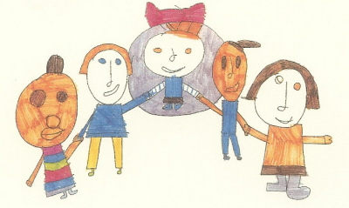
Lindon Bennett School
Main Street
Hanworth
Middlesex
TW13 6ST
Telephone 020 8898 0479
Fax 020 8893 4630
Email: office@lindonbennett.hounslow.sch.uk
Website: www.lindonbennettschool.co.uk
Clare Longhurst, Headteacher

25th February 2020

Dear Parents/Carers

This year World Book Day is taking place on Thursday 5th March 2020.

The pupils in EYFS and KS1 will be sharing different stories in their year groups. During the day they will be visiting classes for stories and to experience a range of activities linked to the different books.

We would like to invite parents/carers to dress their children as a famous book character for the day and staff at school will be dressing up as book characters too.

Thank you for your ongoing support.

Yours sincerely

Catherine Barker

Catherine Barker
KS1 Team Leader

