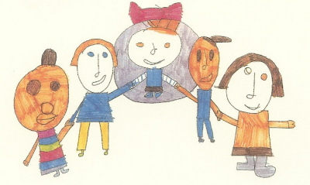
Lindon Bennett School
Main Street
Hanworth
Middlesex
TW13 6ST
Telephone 020 8898 0479
Fax 020 8893 4630
Email: office@lindonbennett.hounslow.sch.uk
Website: www.lindonbennettschool.co.uk
Clare Longhurst, Headteacher

25th February 2020

Dear Parents/Carers

This year World Book Day is taking place on Thursday 5th March 2020.

Key Stage 2 chosen topic this term is ‘Superheroes’ it would be great if those children who have any costumes at home came to school wearing them at any time throughout the term.

The children will have the opportunity to participate in a variety of exciting interactive stories, in their class and in other settings, before gathering in the hall in the afternoon for a fun assembly.

Thank you for your ongoing support.

Yours sincerely

François Cersosimo

François Cersosimo
KS2 Team Leader

