PE Activities EYFS & KS1
Dance with a scarf, balloon
play some funky music and let the child move freely with a scarf/balloon:
fast, slow, up, down, throw, catch, pass from hand to hand, pass from han to hand between legs...
Encourage stretching up/ down, sideways, to each leg, to the ceiling...

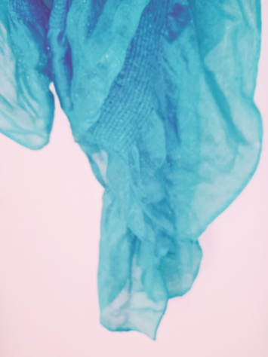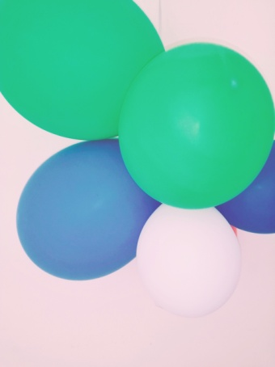

Aiming skills
Put cups randomly on a floor/table.
Get a round object and roll/throw/push at the cups.
Count the points. Set it all back up.
Build a tower out of cups.
Throw at the tower to destroy it.
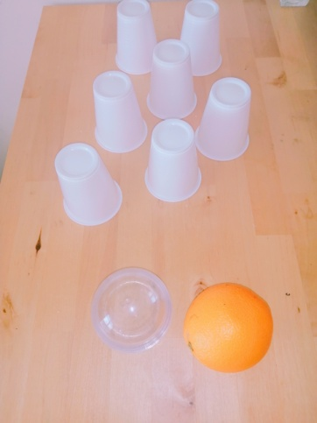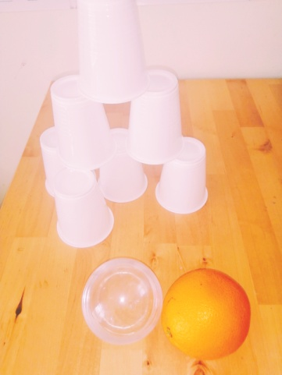

Bowling Skills
Set up any bottles or tall objects.
Throw/kick/roll/push a ball (or any round object) to knock the bottles down.
Count the points.
Set them back up.
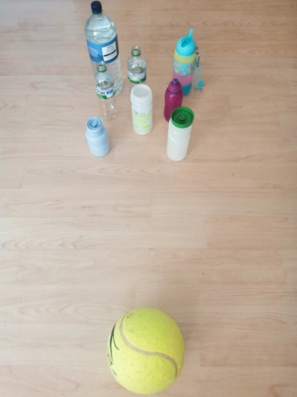
Throwing skills
Get any containers (big and small).
Get any objects, even folded socks, ant throw them into containers.
Put containers closer/further to challenge.
Can you match socks colours with containers?
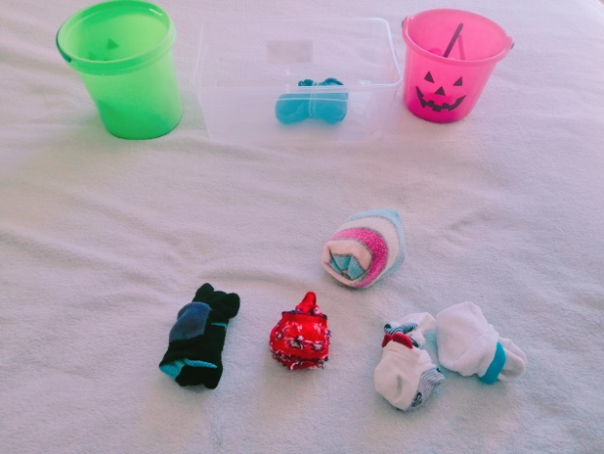

Exploring objects
Make a glove balloon.
Throw it, catch it, balance it on any lid.
Put water/flour in a balloon.
Manipulate it, squeeze it, throw, catch, aim at targets (frying pans, containers, boxes...).
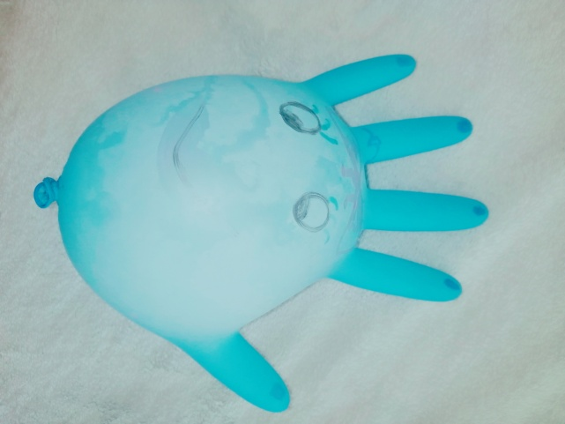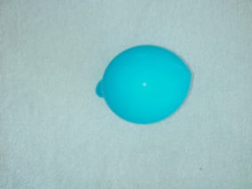

ONLINE YOGA/MOVEMENT/Stretches

YOGA ON THE FARM
https://youtu.be/YKmRB2Z3g2s

MOVE AND FREEZE ACTION SONG
https://youtu.be/388Q44ReOWE

COSMIC YOGA
https://youtu.be/2aje33UPixE

ANIMAL YOGA
https://youtu.be/4ffsxj4T8DI

INSECTS YOGA
https://youtu.be/oYI0TPJOuGk

JUNGLE YOGA
https://youtu.be/C4CaR0syf1g

JUNGLE ADVENTURE
https://youtu.be/FOgHL7Of3js

STRETCHING CARDS
https://www.twinkl.co.uk/resource/t-mov-339-twinkl-move-pe-ks1-stretches-cards

