PE Activities PMLD
Movement ideas
encourage child to roll sideways
put object to each side and encourage rolling
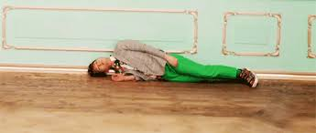
Roll together with a child to each side
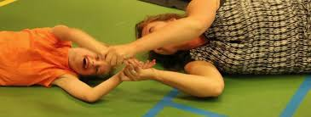

Give child a stick/mop/broom
Encourage pushing/hitting objects
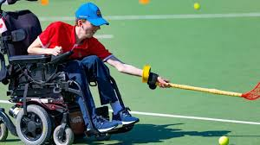

Play row a boat
pull gently forwards, backwards, sideways
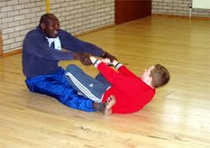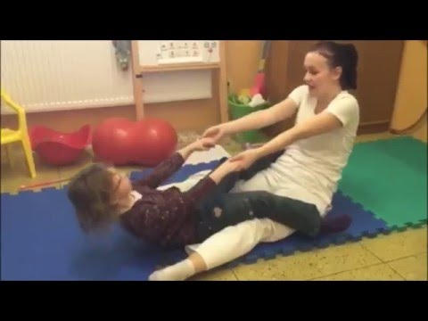

Sit behind child and play airplane
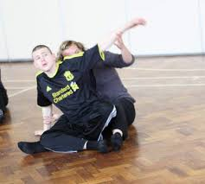
Put child on a blanket, bed sheet
pull around/along the floor
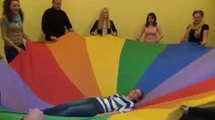

Child lies on a tummy
Encourage reaching for ball/scarf/object
imitate swimming
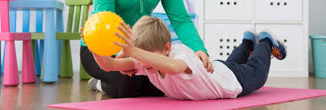
Encourage stretches up/down/sideways/to each leg
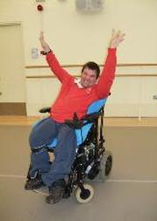

Press gently on child's legs/rotate them/draw circles in the air
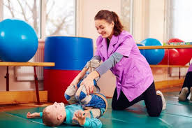

STRETCHING CARDS
https://www.twinkl.co.uk/resource/t-mov-339-twinkl-move-pe-ks1-stretches-cards

Sherbourne Movement (physio on the floor)
https://youtu.be/2ZuQheTXnv8
https://youtu.be/9w71ngLBjYI
https://www.youtube.com/watch?v=d1RCZeW2wXE&list=PLiufJbZZSgKYkbZkg8nsEULUFAeCsfkrx&index=12&t=0s
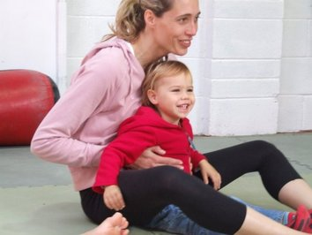

Exploring/manipulating objects (fine motor skills)
Encourage child to hold a cup in each hand
pass a cup between hands
shake objects inside to make noise
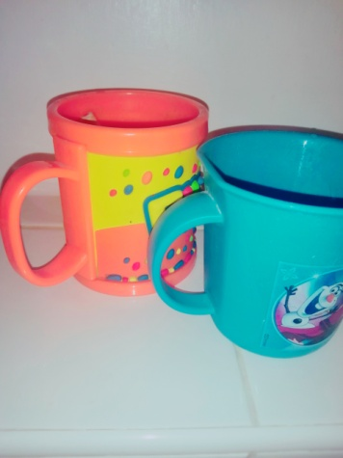
Use objects with a zip (travel bag, jacket)
ask child to zip/unzip
Hide things inside
ask child to get object out of it
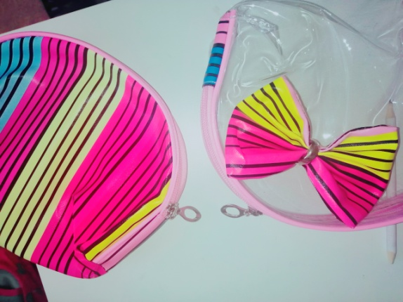 U

use sponges/socks to squeeze
wet them, ask child to squeeze the water out
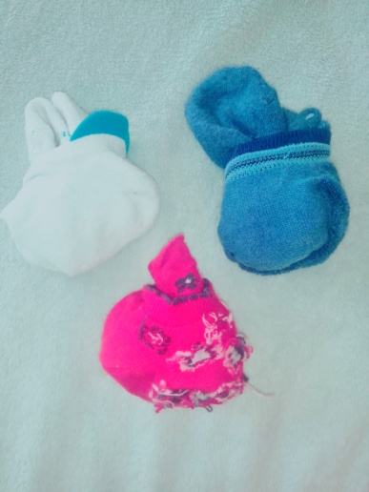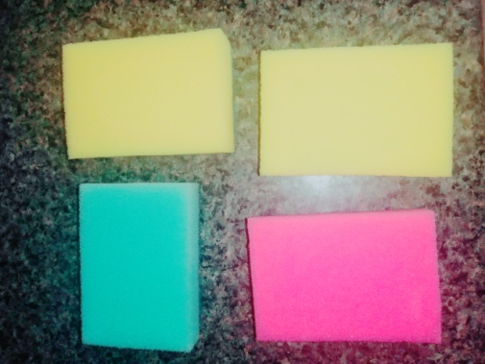

Dance with a scarf, balloon
play some funky music and let the child move freely with a scarf/balloon:
fast, slow, up, down, throw, catch, pass from hand to hand, pass from hand to hand between legs...
Encourage stretching up/ down, sideways, to each leg, to the ceiling...
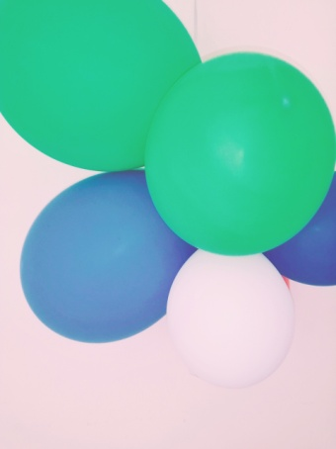

Aiming skills
Put cups/bottles randomly on a floor/table.
Get a round object and roll/throw/push at the cups.
Count the points. Set it all back up.
Build a tower out of cups.
Throw at the tower to destroy it.
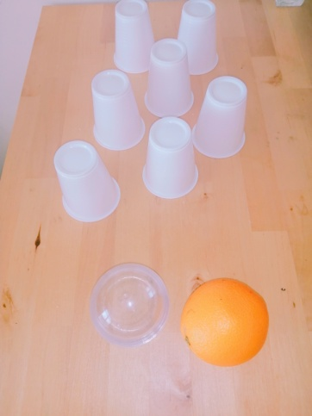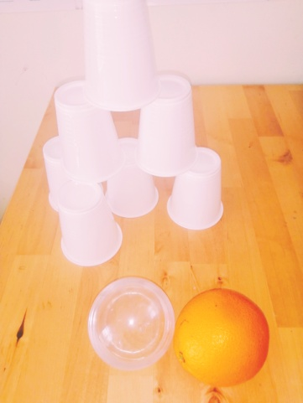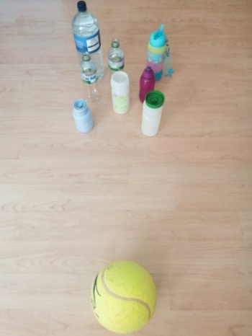

ONLINE YOGA/MOVEMENT
COSMIC YOGA
https://youtu.be/2aje33UPixE

ANIMAL YOGA
https://youtu.be/4ffsxj4T8DI

INSECTS YOGA
https://youtu.be/oYI0TPJOuGk

JUNGLE YOGA
https://youtu.be/C4CaR0syf1g

