Activities to keep your children active

Games for hand / eye coordination

Balloon Volleyball
Equipment | How to play
Balloon  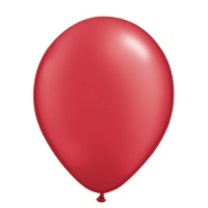  String / rope – to create a net | Try to keep the balloon off the floor – see how many times with a partner you keep the balloon in the air  Try to ground the balloon on the floor on the floor of your oppositions side of the net

Target practice

Equipment | How to play
Washing basket  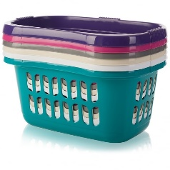  Rolled up socks | Aim at the basket and see how many rolled up pairs of socks you can get in the basket  Increase the distance of the basket to make more difficult

Equipment | How to play
Empty cereal boxes, tea bag boxes and any other boxes  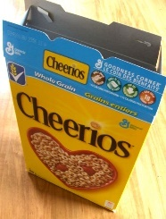 | Stack the boxes to make a tower  Knock them over by rolling a ball or rolled up socks

Using pegs

Equipment | How to play
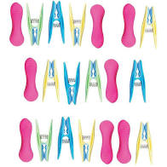  Pegs  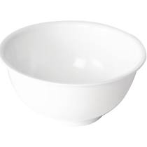  Saucepan / mixing bowl | See how many pegs you can attach to the bowl in a timed period.  See how many pegs you can take off the side of the bowl in a timed period.

Tong pick up

Equipment | How to play
Pair of tongs, bowl ,rolled up socks  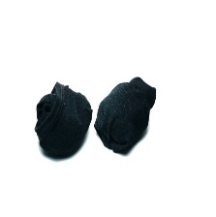  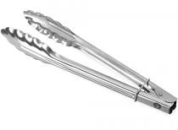 | Pick up different size objects (light in weight) and drop into bowl  See how many items you can drop into the bowl in a timed period.

Pass the egg

Equipment | How to play
Empty egg carton x 2  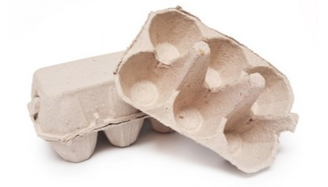  Hard boiled eggs / tomatoes/ ping pong balls | Transfer eggs / tomatoes/ ping pong balls from one container to the other.  Use a timer to see how quickly you can do it.  Try it with your non dominant hand too if you are able to.

Tube target

Equipment | How to play
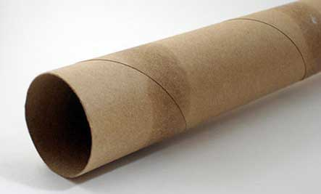  Kitchen roll tube  Bowl  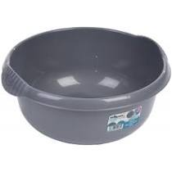  Table tennis balls  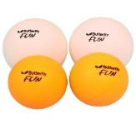 | Pick up the table tennis ball or small object ( that can fit in a kitchen roll tube)  Aim the tube at the bowl and release ball/ object down the tube into the bowl for a goal  Count how many you can get out of 5.  Try your non dominant hand too

GoNoodle

Equipment | How to play
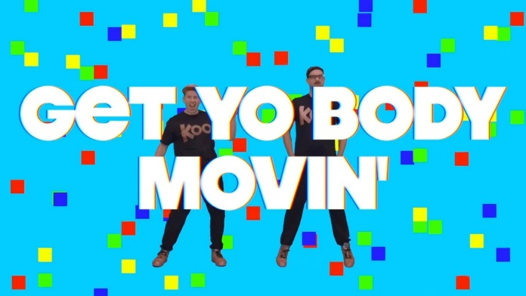 | Go to You tube and type in GoNoodle “Get yo body movin”  It’s a fun action song for all to join in with

Exercise, Rhyme and freeze- Jack Hartman

Equipment | How to play
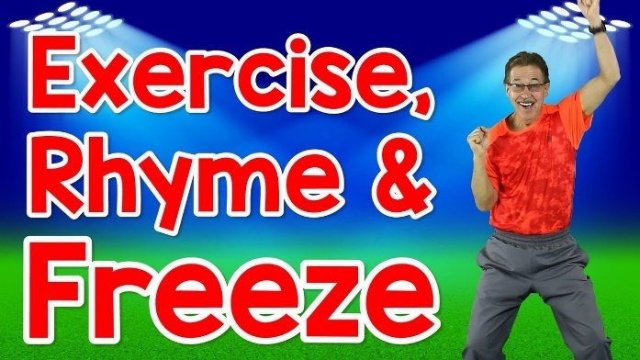 | Go to You tube and type in  “Exercise, Rhyme and freeze” Jack Hartman  This is a fun action song that also helps learn rhyming words.

