**Fine Motor Skills ideas**

**Hand Strengthening**

Activities to develop your child’s hand strength and ability to control fine finger movements.

* Using playdough or modelling clay:
* squeezing in the hand, so it comes out between your fingers
* pinching and pulling between your thumb and index finger
* Bursting bubble wrap by pinching it between the thumb and index finger
* Typing on a keyboard or a typewriter (which requires more force)
* Cooking activities - shelling peas, using tongs, mixing with a spoon, kneading dough, cutting out dough shapes, etc
* Paper football – rip a sheet of paper into small pieces, scrunch the paper into small balls using only one hand, and use different fingers to attempt to flick them between goal posts
* Helping clean! Using squeezing sponges.

BD06529_

**In-hand manipulation**

In-hand manipulation is the ability to move objects around in your hand.

* Wringing out the flannel when washing hands and face.
* Rolling out playdoh/plastercine - rolling out a sausage, roll into a ball. Roll out with a rolling pin.
* Baking/kneading pastry/dough
* Take the lid off a jar/tub and hold in palm whilst taking out contents.
* Gluing and sticking – use glue stick if unhappy with glue texture
* Lego and construction games – building and pulling bricks apart.
* Squeeze football - using any “squeezy” bottle to blow air onto a ping-pong ball (or similar) across a table into a partners goal.

**Pincer Grasp/Isolating index finger**

Activities to develop your child’s ability to Finger painting – use thickened paint if texture is a problem initially; fill as much space as possible; move on to crayons. Then imitate and copy tracking between 2 lines, pre-writing patterns / letters etc.

* Blowing bubbles and popping with index finger.
* Pointing at objects in books – identify colours, favourite objects, animals etc.
* Posting coins – moving onto pushing button through hole; then pulling back through.
* 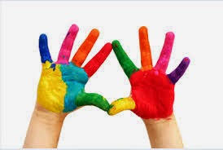Tiddlywinks.
* Filling peg boards with small pegs.

**Bilateral Integration**

Bilateral integration is the ability to co-ordinate use of both hands together. This is an important skill to refine fine motor skills

* Rolling/Catching/ throwing large ball using both hands
* Windmills with arms in the same direction
* Marching with arms swinging both arms together.
* Drumming
* Pat head and rub tummy
* Threading games
* Screwing nuts and bolts
* Spreading butter onto bread/toast

**Play Activities – Textured - Feeling**

**Foil**

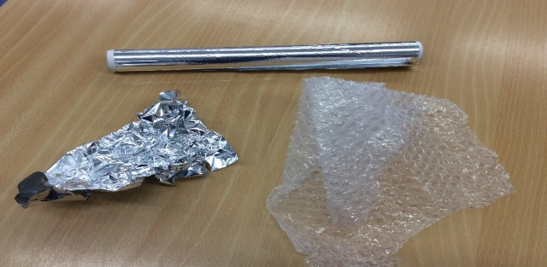

* Foil – scrunch up the foil near the child so they can hear it, help them pick up the foil and scrunch it in their hand.
* Place a torch or light up hand toy over or under the foil to see the different patterns.

**Bubble wrap**

* Bubble wrap – scrunch the wrap in their hand, pop the bubble wrap near the child so that they can hear the pop.
* If you have a large piece of wrap lay it on the floor and wheel the child across it. Hear it pop – make up a story or song about the leaves crunching or fireworks crackling.

**Brushes**

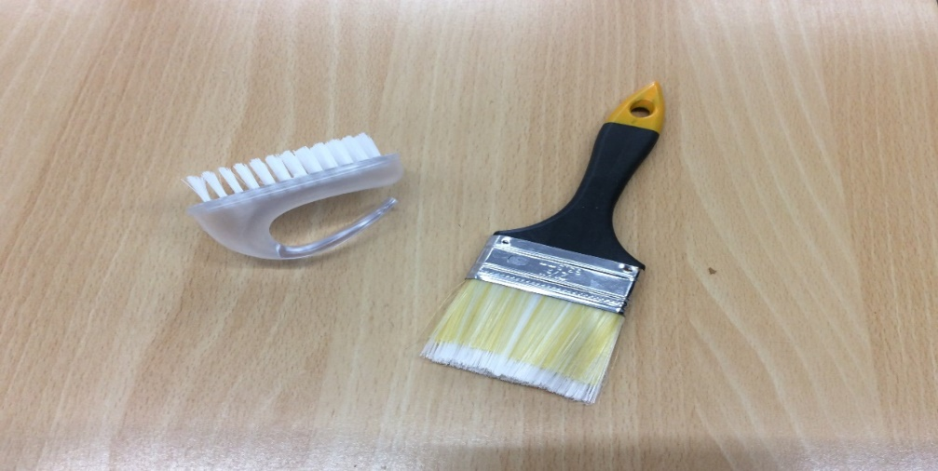

* Brushes – Hard and soft brushes, gently stroke across the hand and body fast and slow movements to music.
* You could stop brushing and wait for the child to respond vocally or physically letting you know to continue, repeat the activity. (pause and response)