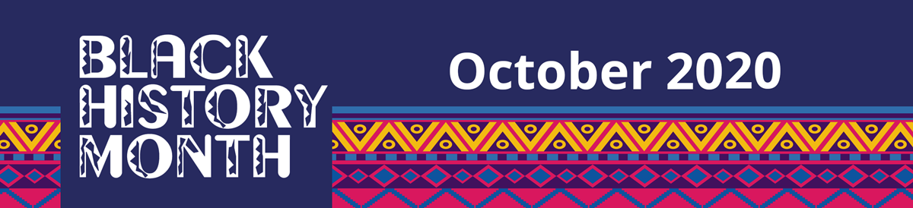

**Celebration Day**

On Tuesday 13th October Key Stage 1 celebrated Black History Month. We had a whole day of fun activities which we all really enjoyed. Our curriculum focus included links to Personal, Social and Emotional Development– Making Relationships and Understanding The World.

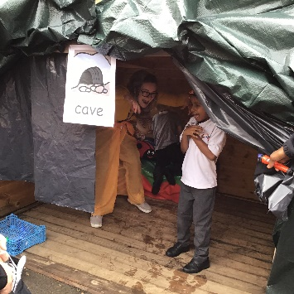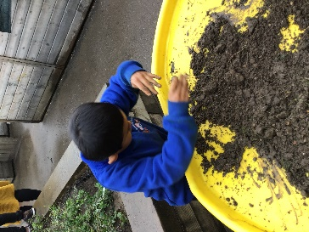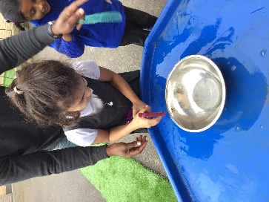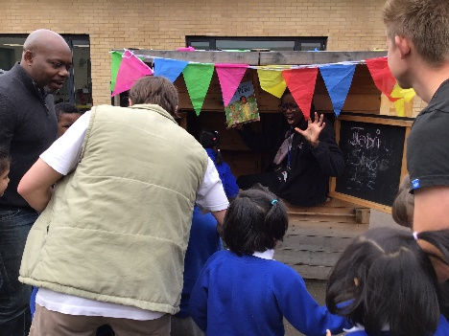We listened to the story ‘We’re Going on a Lion Hunt’ in the Key Stage 1 playground. We role played the story by exploring sensory areas and found a scary lion hiding in a cave!

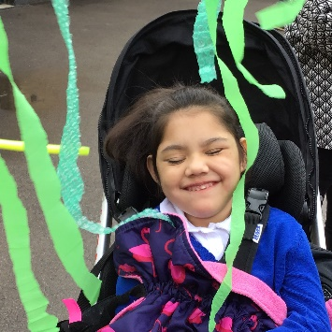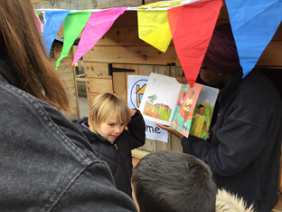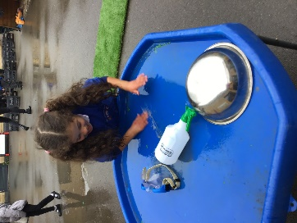

In class we took part in fun and creative activities!

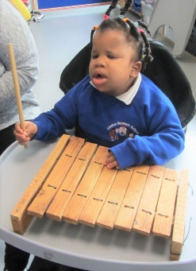

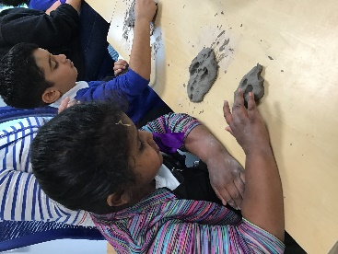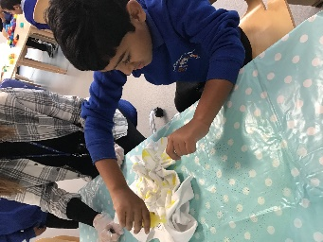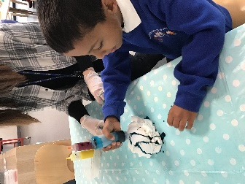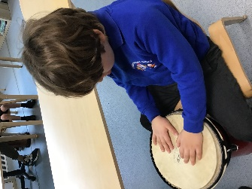

klhk

Jbkjb

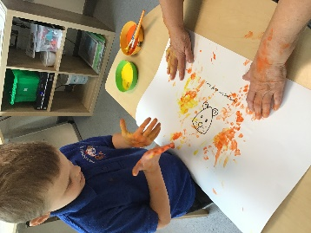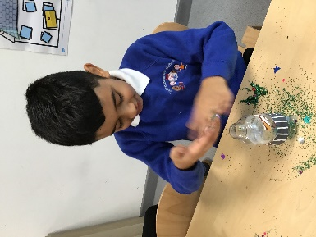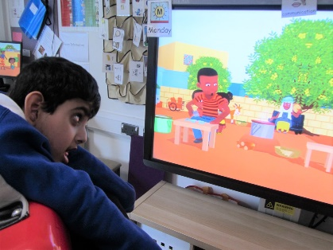

Hand print lions

Making sensory bottles

Listening to songs

Making clay masks

Tie dyeing t-shirts

Playing African music