**‘People Who Help Us’ Stories**

**Week 1 People Who Help Us at Home**

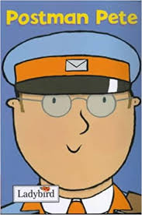Postman Pete

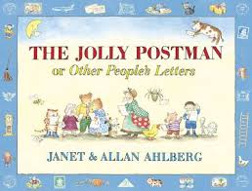

Jolly Postman

**Week 2 People Who Help us at School**

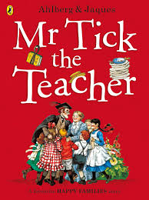Mr Tick the Teacher

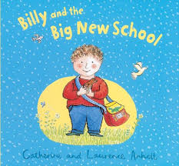Billy and the Big New School

**Week 3 People Who Keep us Safe**

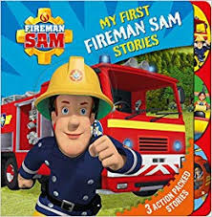Fireman Sam Stories

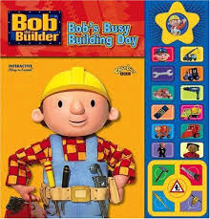Bob the Builder Stories

**Week 4 People Who Help Keep us Healthy**

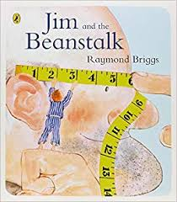 Jim and the Beanstalk

**Week 5 People Who Provide our Food**

C:\Users\aboast6.313\AppData\Local\Microsoft\Windows\INetCache\Content.MSO\2F436B6D.tmpThe Shopping Basket

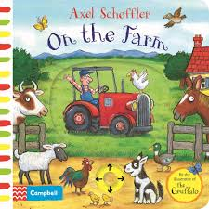

On the Farm

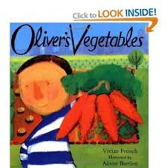**Week 6 People Who Make our Food**

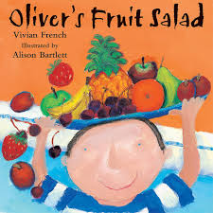Oliver’s Vegetables

Oliver’s Fruit Salad