Action songs
https://www.youtube.com/watch?v=s-8CSs7XnIo
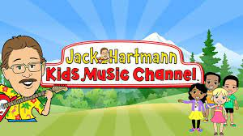

https://www.youtube.com/watch?v=1gUbdNbu6ak
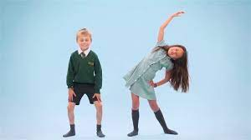

https://www.youtube.com/watch?v=NwT5oX_mqS0
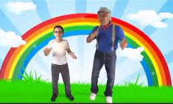

https://www.youtube.com/watch?v=JoF_d5sgGgc
