Art ideas for Growth topic

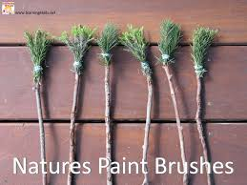
Nature’s paintbrushes
Collect leaves and tie/stick them to the end of a stick. Dip them in paint and create some lovely pictures.

Natural material pictures
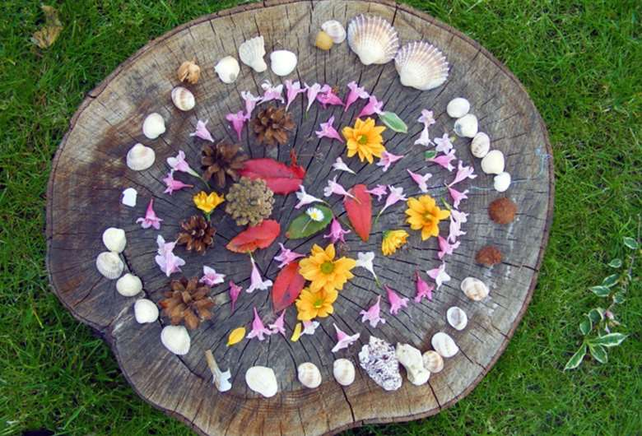
Collect natural materials and make a picture.

Cotton bud printing
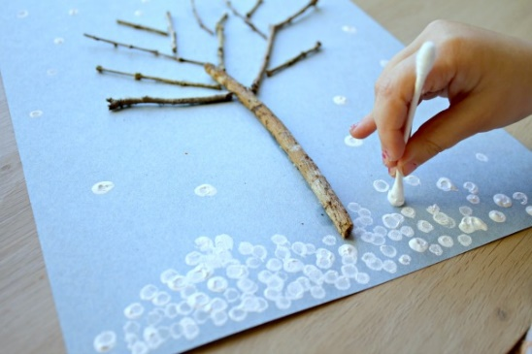
Use a cotton bud dipped in paint to create leaves, buds or snow to make seasonal pictures.

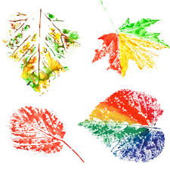
Leaf printing
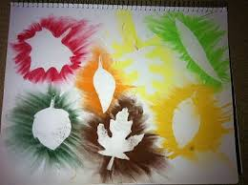
Paint onto leaves and print them onto paper.
Put leaves on paper and colour over them.

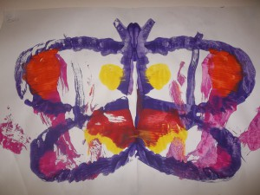
Butterfly printing
Paint one side of a butterfly onto a piece of paper. Fold it in half and undo it.

