Let’s get cooking!
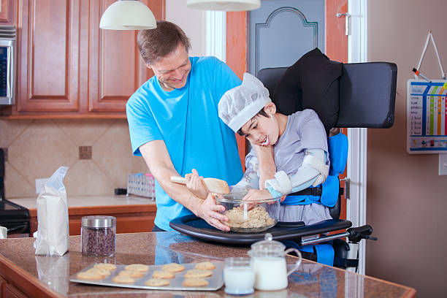

Here are some recipes which you can try at home together. Remember to wash your hands and have fun.

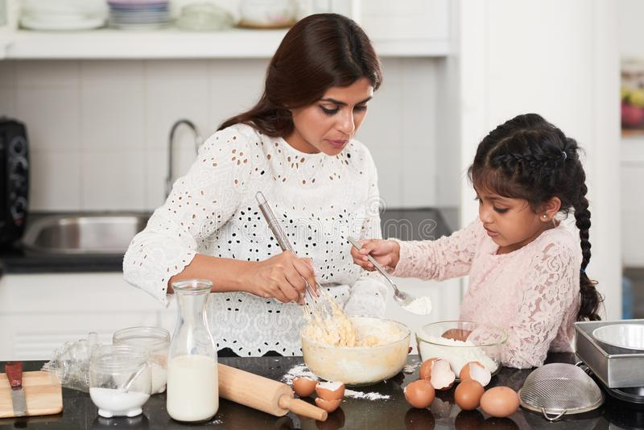

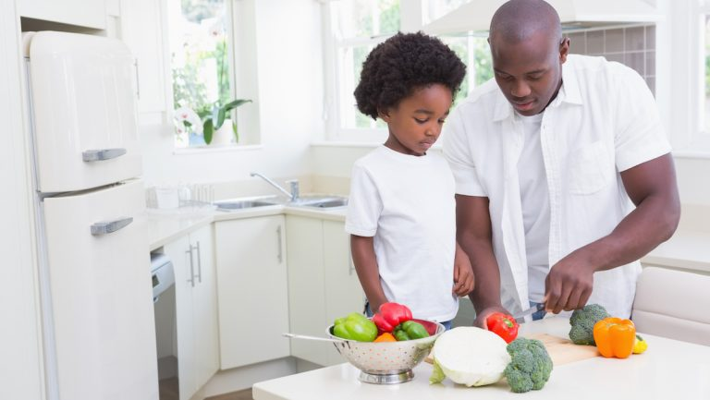

Flapjack ingredients:
- 250g oats
- 125g butter (plus extra for the tin)
- 125g brown sugar
- 2-3 tbsp golden syrup (depending on how gooey you want it)
- Raisins
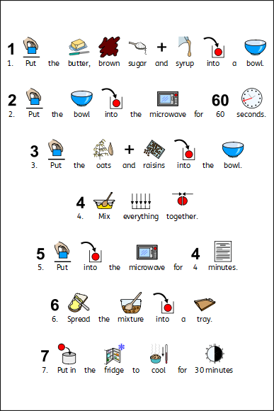

Cookies
- 225g butter
- 110g caster sugar
- 275g plain flour
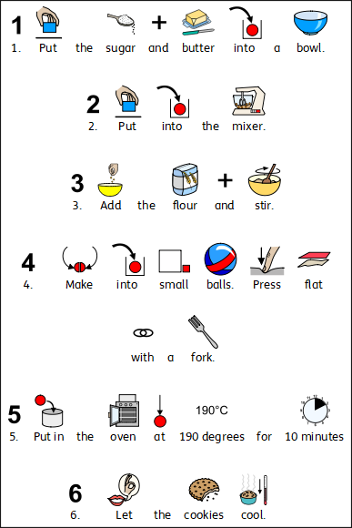

Chocolate cornflake cakes
- 50g butter
- 100g milk/dark chocolate broken into chunks
- 3 tbsp golden syrup
- 100g cornflakes
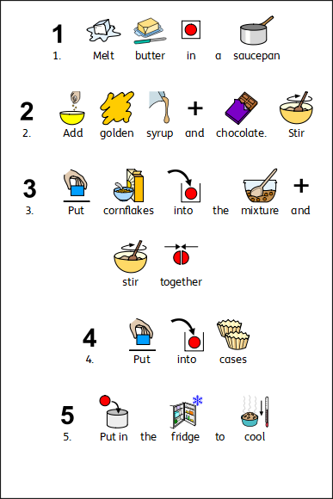
Make a sandwich
