‘Growth’ Stories
Week 1 and 2 Children
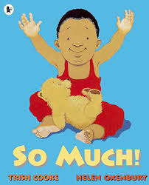
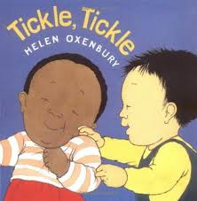
Tickle Tickle So Much
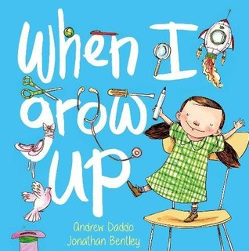
When I Grow Up

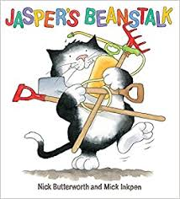
Week 3 Seeds
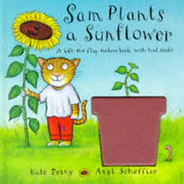

Jaspers Beanstalk Sam Plants a Sunflower

Week 4 Growing Tall
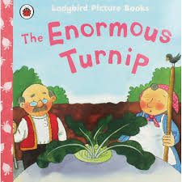
The Enormous Turnip

Week 5 Eggs and Life Cycles
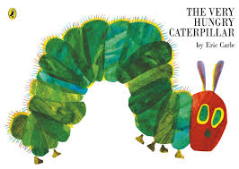
The Hungry Caterpillar
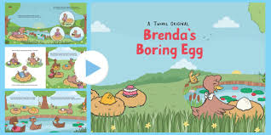
Brenda’s Boring Egg (link to the story on the website)

Week 6 Animal Babies
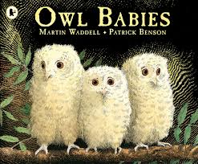
Owl Babies

