Home-learning activities for maths
Draw round soft toys/dolls and line them up by size, find pieces of grass/twigs/leaves and line up by size 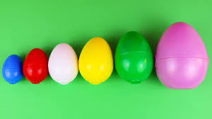 Cut up straws, paper strips, playdough etc. and find biggest and smallest.

Sequence pictures (parents can draw these) or sequence objects that were used, for three main things you have done that day e.g 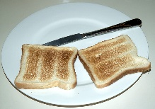 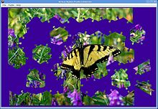 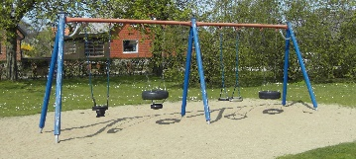

Create pictures with shapes – you can cut out different shapes from different coloured paper or from different types of paper such as newspaper, kitchen foil etc

Make 2 or 3 step repeating patterns with paint or with playdough. Make fruit skewers e.g. orange, apple, apple, orange, apple, apple. Make jewellery e.g. a necklace of different coloured pasta threaded on string. Ask your child to tell you what comes next. Do action repeating patterns e.g clap. stamp, jump, clap, stamp, jump 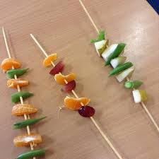
Copy patterns with shapes e.g.

Go on a shape hunt round the house looking for all the circles or all the squares or all the triangles
Make shapes with different sized sticks or with straws 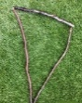
Do a jigsaw puzzle together

Count lots of things 10-20 - resources for an activity, bounces on a trampette, tins in the cupboard, spoons in a drawer, toy animals, toy cars, clothes in the washing etc. You could make it a game to find e.g. 10 toy animals round the house 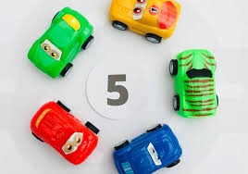

Roll two dice and add the two numbers then get that number of toys, pieces of cereal, bounces on the trampette etc, 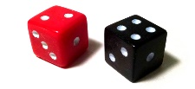

Have big numerals chalked on a path outside (if you have somewhere safe) or taped on the floor to colour/ drive toy cars on. Throw newspaper balls into particular numbered boxes (use numbers 10-20). 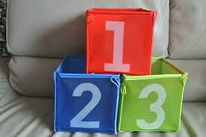

If you need to ring someone let your child try to find the numerals on your phone 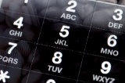

Make a big number line to 15 with pieces of paper and jump to the right number or throw a soft ball to the right number; peg large paper numbers on a ‘washing line’. 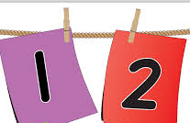

Thread and unthread beads/build or take down brick towers/park or unpark toy cars/ put in or take out toy animals from a field – recount each time as they add or take away some. You could help them write it as a sum. 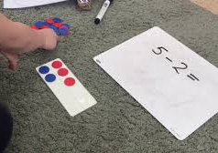
Use pairs of socks to start counting in two’s. 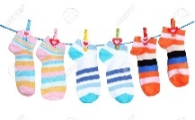

Put different numbers of items in a tin – shake the tin and guess how many are in there; guess how many pieces of paper are needed to cover a table; guess how many bricks are in a tower without counting. Measure small toys with cubes and guess how many cubes a new one will be.

Dice games- make a game where you collect things according to the number you roll on a dice, make a big track of pieces of paper for your child to move the number of steps they rolled, roll a dice and do that many jumps etc. You can have two dice and add the number to see how many to collect or how many steps to move. Play simple board games

Play dominoes 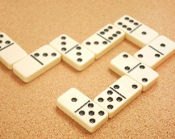

Do races with siblings, toy cars, take turns in a game – use ordinal numbers 1st 2nd 3rd
Give instructions to someone else to move and follow instructions to move – use left, right etc 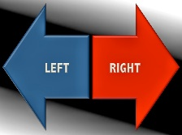

Talk about what day it is and what tomorrow will be and what yesterday was. Also what month it is. Make a simple calendar and draw pictures or write what you do each day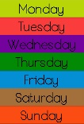

Help measure things in a jug or scales or with a ruler . You could do this when cooking (real cooking or just trying out measurements with different ingredients) You could measure toys with cubes or bricks to see how long they are and then try using a ruler to do the same thing.
Have 3, 4 or 5 of an object and group them in different ways to make different sums e.g 1+ 3 = 4, 2+2 =4 