Communication and Literacy
- Turn taking games e.g. rolling a ball, during daily routines such as mixing food for dinner.
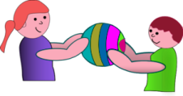
- Comment simply on what your child is doing to help them learn language
Washing dolly

- Look at books, try noisy books or tactile books
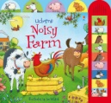
- Do ‘Ready steady go’ games e.g. pushing a toy car or letting a balloon go. Encourage your child to anticipate ‘Go’ and to vocalise for ‘go’ 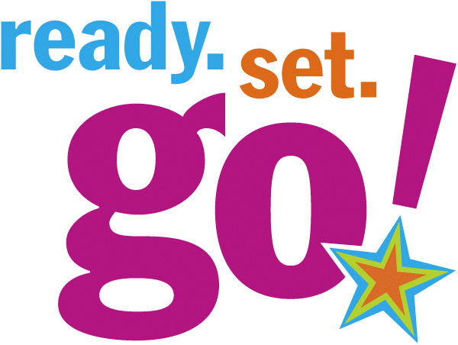

- Do an activity your child likes e.g. tickles, chase, pushing on a swing then stop and wait for them to vocalise or indicate they want more.
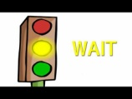
- Action songs and rhymes e.g. row your boat 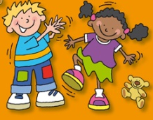

- Help with cooking, cleaning etc – turn taking and following simple instructions e.g. give me the dustpan, put the flour in the bowl. 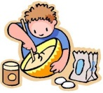
- ‘Painting’ outside with a brush and water 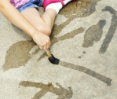

- Mark making in flour, sand 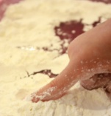

- Look at family photos and find particular people e.g. Where is Nanny?
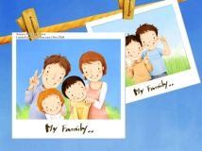
- Offer choices - cereal or toast, cars or balls etc Use objects, photos or symbols for your child to respond with e.g. 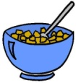OR 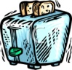

- Finding items on a picture shopping list at the shops or on a picture list of ingredients at home

- Taking an object to someone else or to another room e.g. give the cup to mummy , put the train in your bedroom

Maths
- Sorting washing into piles 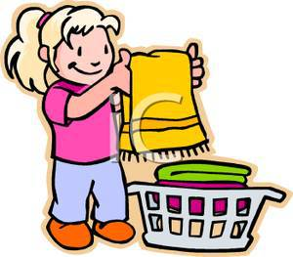
- Finding red/blue/yellow objects round the house
- Finding and counting toys 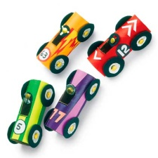
- Counting the stairs as you go up

- Finding matching shoes/socks 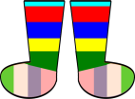
- Giving each person a spoon when laying the table 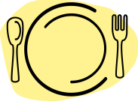

- Pouring drinks – who has more

- Finding the big bowl or small bowl/big shoe or small shoe
- Trying on parents’ clothes (these are too big) or a baby’s clothes (these are too small) 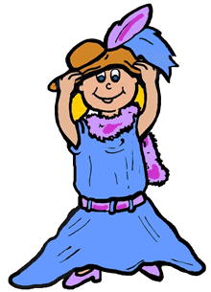
- Finding and hiding toys that are in/on/under something.
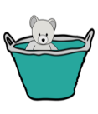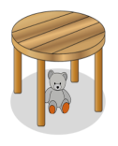
- Make shapes with play dough
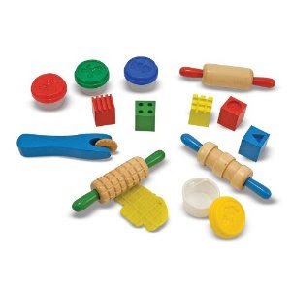
- Looking for shapes, numbers and colours when you are out. 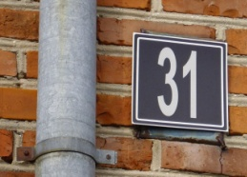

- Make a simple model with duplo and give your child the same bricks to copy it 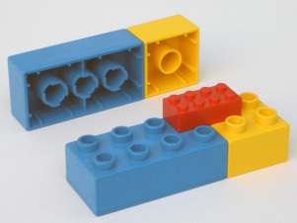

Other
- Pegging washing out (or pegging onto a box) 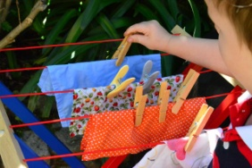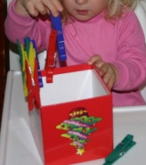

- Putting straws in a colander 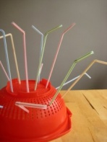

- Getting dressed 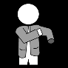

- Encourage your child to find the resources they need for an activity themselves e.g. pens, paper or clothes to go out, spoon and bowl
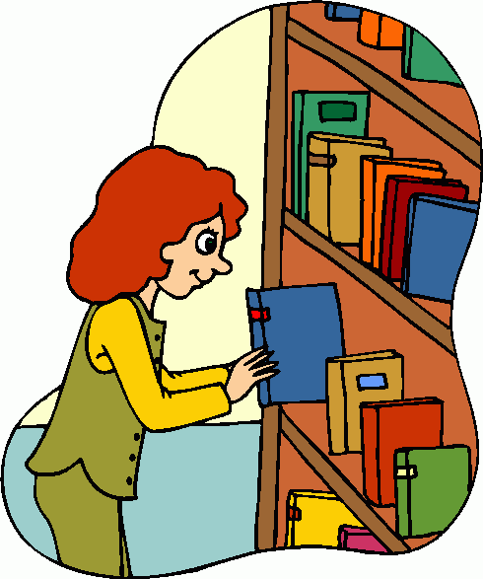

- Use wooden spoon on a saucepan as a drum to play fast and slow/loud and quiet
