The Jungle- Stories
These are some of the stories we will be sharing linked to our topic ‘The Jungle’
Rumble in the Jungle
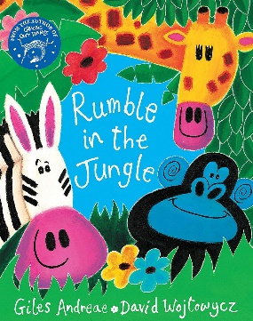 YouTube link: https://www.youtube.com/watch?v=fgdfofQegaM
The Tiger Who Came to Tea
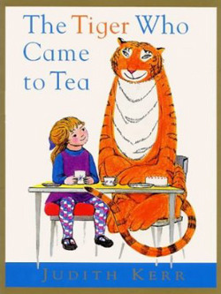 YouTube link: https://www.youtube.com/watch?v=p1_lnmdyR1s
Monkey Puzzle
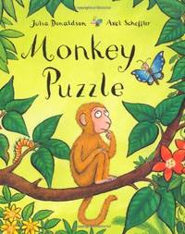 YouTube link: https://www.youtube.com/watch?v=JxpJnk3QO-8
Giraffes Can’t Dance
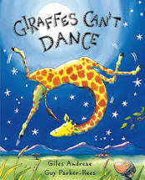 YouTube link: https://www.youtube.com/watch?v=aQMDaPRhA0I

Dear Zoo
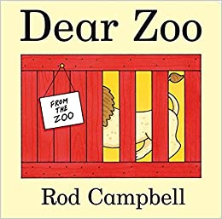 YouTube link: https://www.youtube.com/watch?v=A9Jr4jO0P9c

