**KS2- Home Learning February/March 2021**

**Our current topic is THE WEATHER. Here are some websites and activities which you can explore with your child.**

[**https://www.bbc.co.uk/games/embed/g7rh7b3d4q?exitGameUrl=https%3A%2F%2Fwww.bbc.co.uk%2Fcbeebies%2Fgames%2Fdown-on-the-farm-a-year-on-your-farm**](https://www.bbc.co.uk/games/embed/g7rh7b3d4q?exitGameUrl=https%3A%2F%2Fwww.bbc.co.uk%2Fcbeebies%2Fgames%2Fdown-on-the-farm-a-year-on-your-farm) **This is an interactive experience where you can explore how the weather affects the seasons.**

You can work together:

* take turns to press the buttons
* name the different animals on the farm
* talk about the weather you can see on the screen
* look at the words on the screen
* look at what is growing in your garden right now

[**https://www.bbc.co.uk/cbeebies/shows/nelly-and-nora**](https://www.bbc.co.uk/cbeebies/shows/nelly-and-nora) **Nelly and Nora – weather adventures. Nelly and Nora explore what you can do in different seasons.**

You can work together:

* choose which episode to watch
* find clothes to match Nelly and Nora for each season
* find and touch things that are warm and cold in your house
* use different things in your house to create wind (flap a book, piece of paper, open a door etc)
* go outside when it rains and see what happens to your clothes

<https://www.youtube.com/watch?v=tfAB4BXSHOA> This is a song about how the leaves change when its sunny, rainy, windy or snowy.

You can work together:

* moving to the music
* looking (naming) the colours you can see
* painting with leaves
* put leaves in the fridge and freezer, in water and on the radiator – what happens to them?

<https://www.youtube.com/watch?v=rD6FRDd9Hew> **This is a song your child probably already knows…**

You can work together:

* look outside at the weather
* vocalise to the song together
* make a box of things for when it’s sunny/cloudy/rainy/snowy. You can include clothes, toys etc that we associate with that weather.

**The following website is used by school with a subscription;**

<https://www.poissonrouge.com/members/bravenewfish>

For Poisson Rouge please use these log on details-

**login:** benhanremote

**password:** 1939wdch

You can also use Twinkl for free during the current lockdown. It has lots of resources which you can explore.

<https://www.twinkl.co.uk/>

Here are some links to activities which you can use:

**Colouring in weather scenes**

<https://www.twinkl.co.uk/resource/t-t-29371-weather-colouring-pages>

**Colouring in weather scenes (by number)**

<https://www.twinkl.co.uk/resource/t-t-26261-weather-colour-by-number-counting-activity-sheet>

**Scissor skills – cutting out pictures of the weather**

<https://www.twinkl.co.uk/resource/t-t-11747-weather-themed-cutting-skills-worksheet>

**Weather words for when you look outside**

<https://www.twinkl.co.uk/resource/t-t-5420-weather-words-display-posters>

**Sorting clothes activity (can be used with the songs linked above)**

<https://www.twinkl.co.uk/resource/t-t-5421-weather-clothes-sorting-activity>

Here are some PECS symbols which you can use with your child:

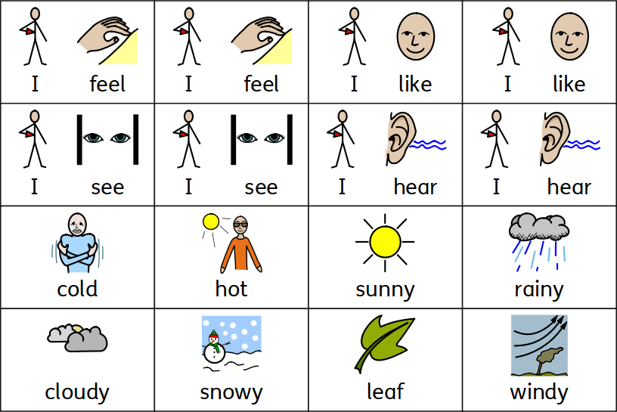

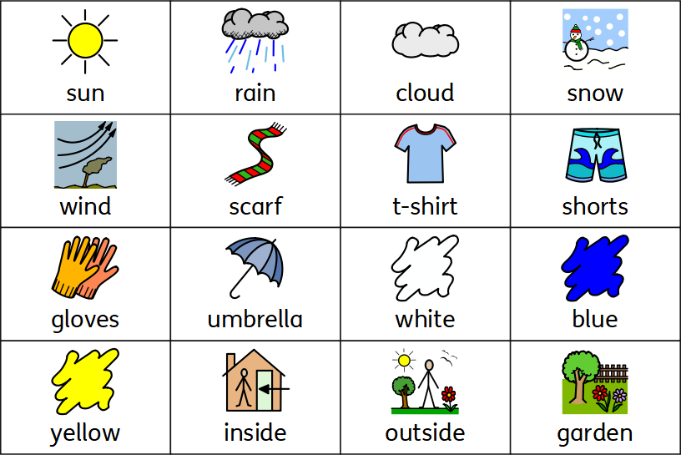

Here are some Makaton symbols for the weather:

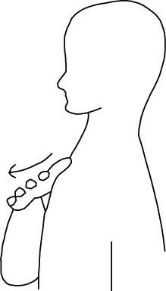

I want I like I hear I see

Weather

sun cloud wind

Sun cloud wind

stormsnow 0001 rain sky

Snow rain sky storm

rainbowfog frost

Fog frost rainbow