What to try for particular behaviours
Throwing things 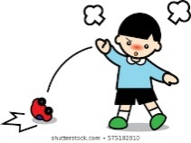
Give clear instructions to pick up any object your child has thrown and then put it away (but wait until they are calm to ask for this). Provide a box for your child to put things in when they have finished with them.
Give your child a chance to throw things and watch them fall e.g a ball in the garden or make a ramp and roll cars or balls down it
Spitting 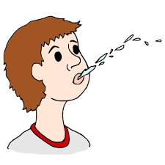
Try water play, get a water spray they can use or make a shaker from a plastic bottle with coloured water and e.g glitter (or cut up bits of silver foil) .
Biting or eating things they shouldn’t 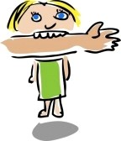
Try offering your child chewy tubes, cold or crunchy things to eat or a vibrating toothbrush etc (making sure they cannot swallow batteries).
If you are bitten try not to pull away as that will make the bite worse but try to distract your child so they let go.
Make snack and meal times clear and use plates/bowls etc. so your child starts to learn that what we eat is on a plate.

Hair pulling 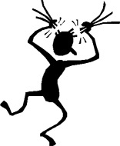

Give your child other ways to meet their sensory needs, e.g. a ‘row your boat’ game, tug of war, stretchy toys etc.
Try to avoid situations where hair pulling may occur e.g. don’t put your head down too low when tying your child’s shoelaces, keep long hair tied back
Try to appear calm and don’t pull away as that can make the hair pull worse.

Self-harm
If your child is banging their head: try brushing your child’s hair with a tactile brush, giving your child a vibrating toy, trying to help them to do something where their head is lower than their heart e.g laying on their front over a gym ball – try these things during the day not when they are already upset. Reduce demands for a time.
Try to get them to do something which means they can’t self harm e.g. a toy or tray of sensory materials (cereals, cornflour and water etc) so they are using their hands for something other than pinching themselves; or give them a chewy tube if they are biting themselves
Hitting, kicking, scratching 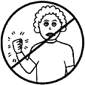
Try activities that match your child’s sensory need. For pinching/scratching behaviours, try e.g. pinching play-dough, using a squeezy toy, exploring textured materials.
For hitting, kicking behaviours, try e.g. clapping hands, singing a clapping song/rhyme, kicking a football, banging a drum.
If you are being scratched try having long sleeves or gloves to help you not to react to your child. If you are being hit to get your attention try to show your child another way to get your attention e.g giving you a symbol, high five etc
Screaming 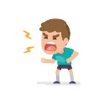
Say ‘I don’t understand screaming, show me/use words.’ Then if your child speaks/gives a symbol/leads you to something calmly, respond straight away. In this way we show that screaming does not help your child to get what they want,
Smearing/urinating in the wrong places 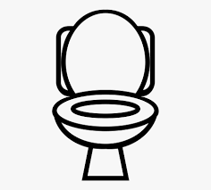
Try to meet any sensory needs by e.g play dough that is scented; finger painting; playing with silly soap.
Try using an all in one suit for your child if it doesn’t stop their toilet training. Give your child lots of praise for using the toilet and be calm if they urinate elsewhere. Take your child to the toilet calmly after they have urinated in an inappropriate place so they do not think they can just avoid going to the toilet by going elsewhere.

