Panthers:

Panthers are a busy class with many bubbly characters! They are enjoying learning about themselves this term. Our topic ‘All about me’ is offering many opportunities to take part in a range of relevant and exciting activities: From looking at our body to learning about our emotions and how to try to control them, developing our ability to play and work with our friends at school to sharing facts about our family and our home life, visiting the local community and developing our social skills to increasing our level of independence in any situation, and many more aspects of our life that we learn about throughout our school day.

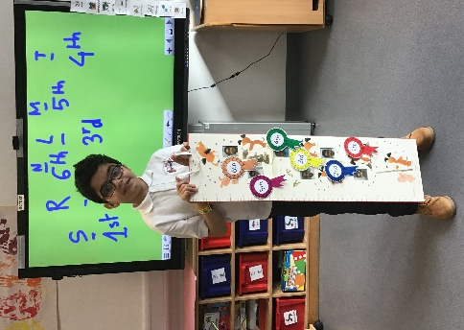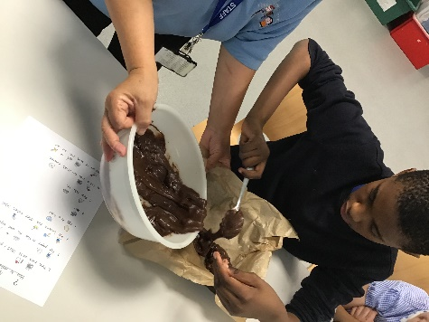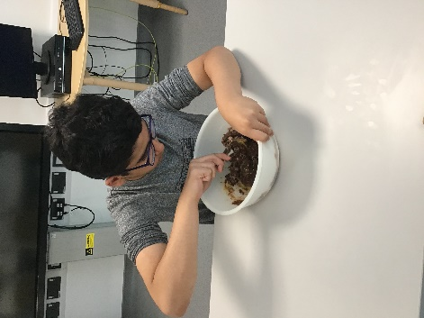
Independence
Measuring

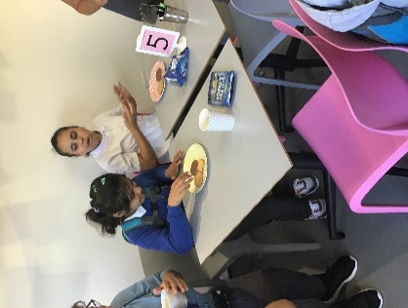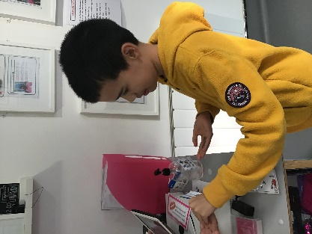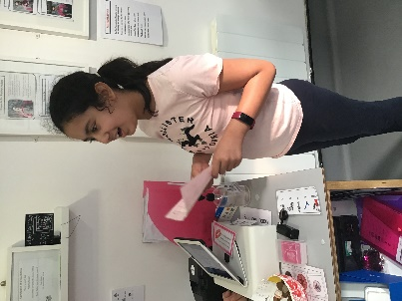
Paddocks School café visit

