Peacocks:
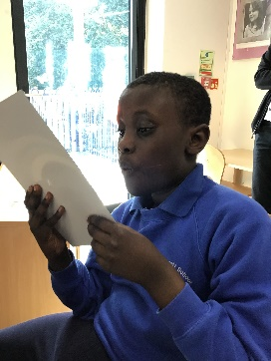
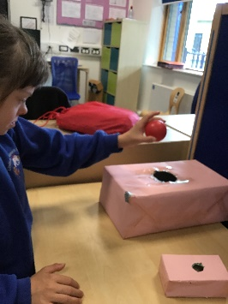
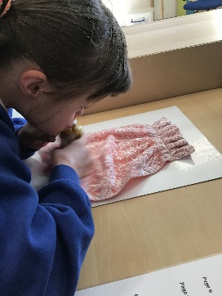
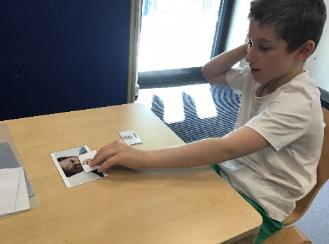
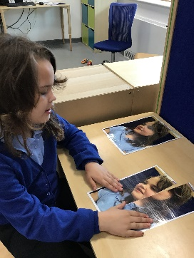
Peacocks Class have been very busy this half term learning about “All About Me”. Olivia has been enjoying mirror play and then completing puzzle pictures of herself. Bailey has been learning about different emotions, recognising these in pictures and labelling with symbols and Theo has been exploring different facial expressions. The pupils have also enjoyed exploring sensory stories with a focus on characters. Bella has been matching props to these sensory boards whilst, in maths, grouping items by size.

