In Tigers class the topic we are looking at this term is “All about me!”

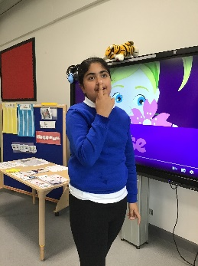
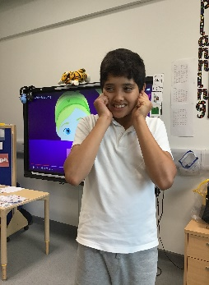
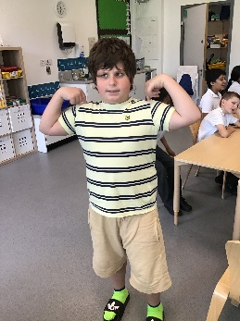
We have listened to the body song to learn about and find different body parts.

Daruish found his shoulders. Jatin found his ears. Gursimar found her nose
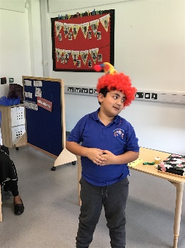
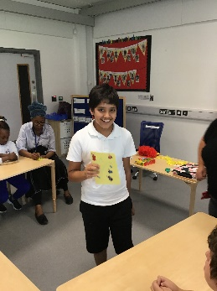
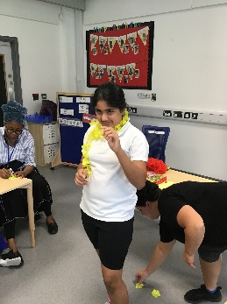
We have explored the favourite parts of our birthday

Gursimar likes decorations. Hussain likes party hats. Jatin likes Birthday cards
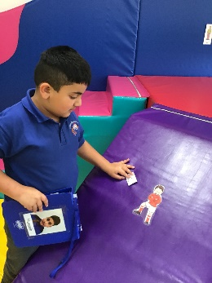
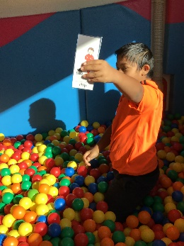
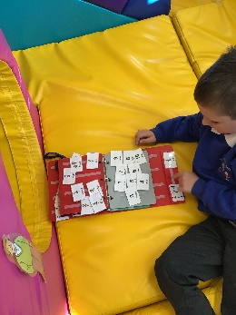
For our story we read “Biff & Chip’s family picnic”

Ian Found Dad. Hussain found Chip. Reyansh also found Chip

