Exploring Sounds at Home

Fill up cups and containers with rice, pasta or similar to make shakers. Children can use their hands to pick up and transfer to the containers or use different sized spoons to add challenge.
Use them to explore different sounds.

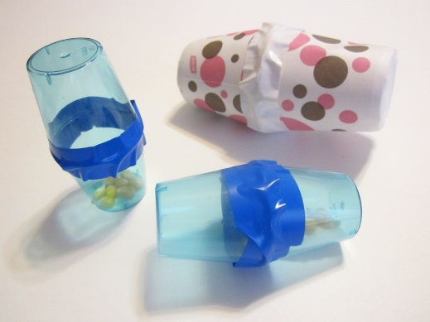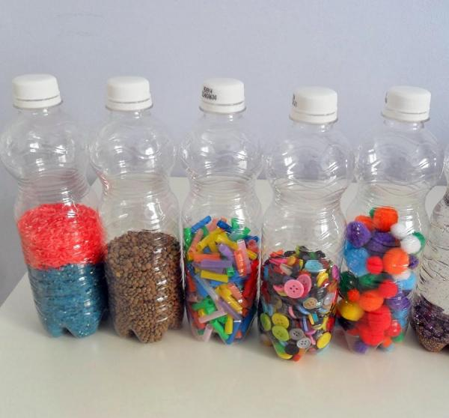

Use pots and pans to make a ‘drum kit’ with spoons/utensils/wooden spoons

