Helping in the Kitchen

Support your child to help with sorting out cutlery. Can they match different spoons- big and small, wooden spoons/serving spoons?
Explore 1:1 correspondence. Place a spoon in each bowl or cup. Has everyone got a cup?
Support your child to help to lay the table

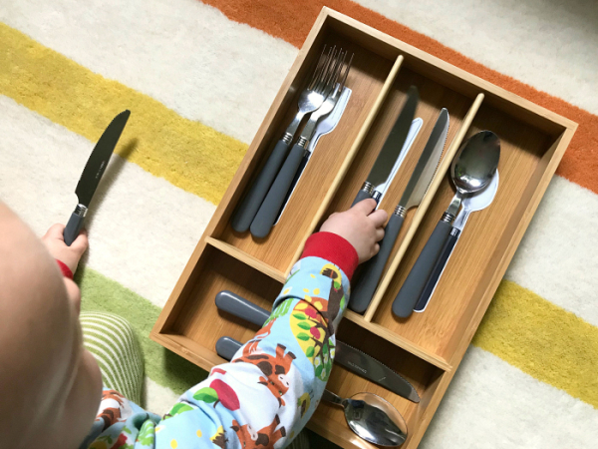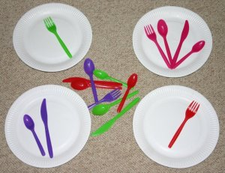

Sort the cutlery into coloured groups.
