KS1 Home learning activities

Making something from recycled materials at home? Can you make a car? Can you make a robot?
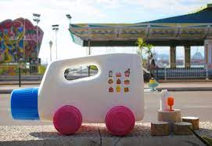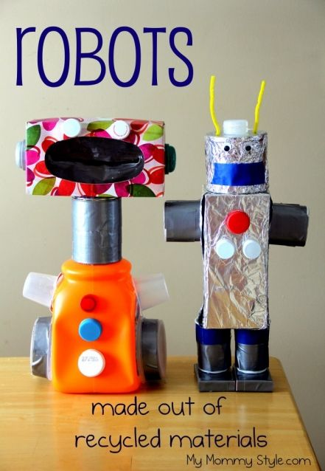

Papier-mâché activity
Can you make something from papier-mâché?
papier-mâché recipe:
https://www.bbcgoodfood.com/howto/guide/how-make-paper-mache

What you can make…
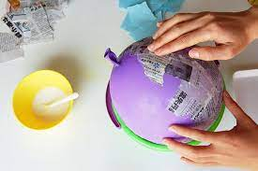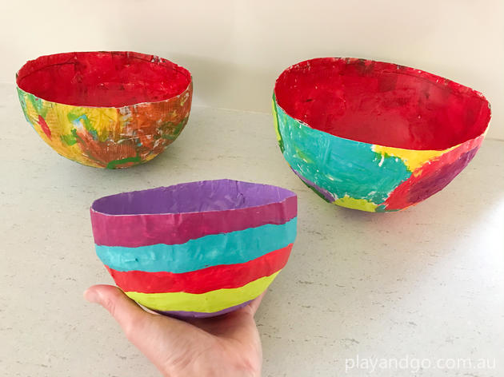

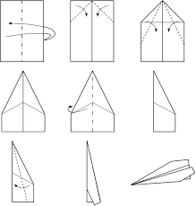
Folding paper –
Paper aeroplane making
Playing with shredded paper

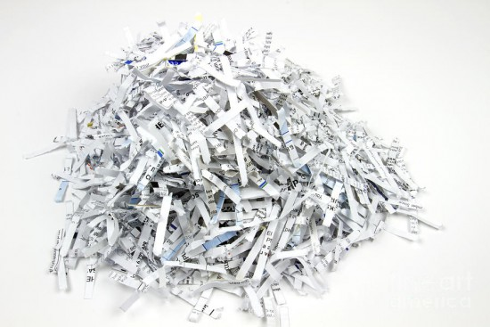

Sorting different types of paper/ recycling

