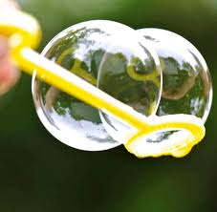
Water Play
Explore water in a variety of different ways.
Explore water play- using bowls, buckets or the bath!

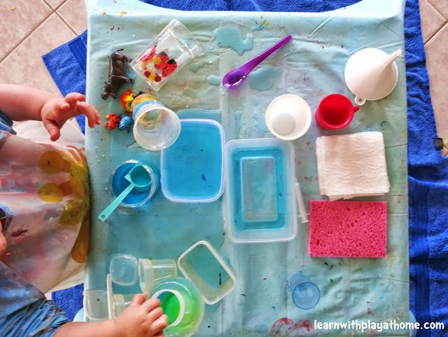
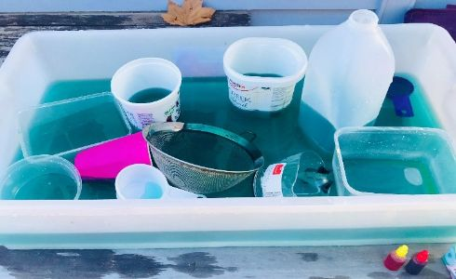

Fill the kitchen sink with safe, non-breakable kitchen equipment and bubbles. Give your child a sponge or cloth and let them ‘wash up!’
Children can manipulate objects using hands singly and together, such as squeezing water out of a sponge. Use toys and equipment in the water with increasing control in holding, using and pouring.
Add some bubbles to make water play different! Or try adding a few drops of food colouring.
Use the water to pour into cups, using different sized jugs or bottles

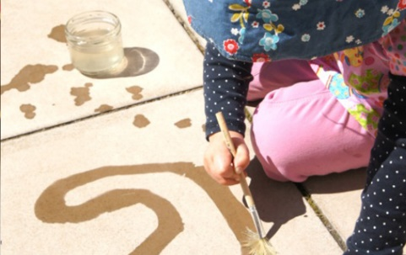
Outdoor water painting
(Use brushes/sticks/toothbrushes/sponges and cups or pots of water) on the ground or walls.

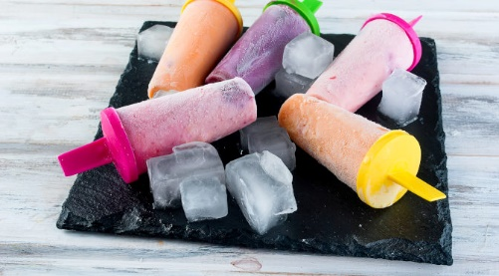
Make your own ice lollies or ice cubes
Add some juice or food colouring to change them. Observe how they change after being in the freezer! And enjoy

