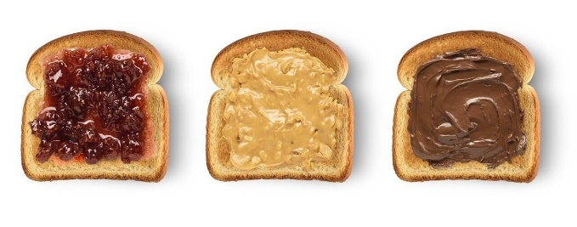
Making Toast!

Making toast is a great opportunity for your child to develop different skills.
Using the toaster with close adult supervision, allows them to observe how things work and to notice change. (Exploring cause and effect)
- Putting the bread into the toaster
- Pushing down the lever
- Watching the toast pop up- observing what has happened to the bread!
Afterwards, support your child to make a choice about what they would like on their toast.
Offer them a choice of 2 or 3 items, encourage a response by use of eye gaze, pointing, reaching for or using words/sighs/symbols. This supports their communication development.
Help your child to develop independence/self-help skills as they spread their choice onto their toast! This also helps to develop physical skills and hand-eye coordination.
Enjoy your toast!

