Easter nest cakes!
Easter Activities
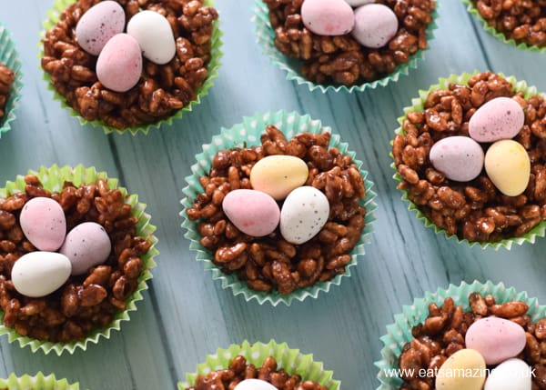

You will need: Cereal, chocolate, mini eggs, cupcake cases
Method: Mix the cereal with the melted chocolate. Place into the
Cupcake cases and decorate with mini Easter eggs!
Leave for a while in the fridge and enjoy!

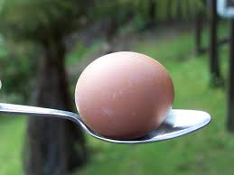
Egg and Spoon Race!

Balance some hard boiled eggs on some large spoons and balance!
You can extend this activity further by then moving whilst holding these!

Easter Egg Hunt!

Hide eggs (hard boiled, chocolate, printable egg shapes or eggs drawn on paper!) around the room or garden! Help your child find them and place them into a bag or basket. You can extend this with questioning to help them find a hidden egg or by counting out how many eggs they have found!

