Planting a Seed or Bean
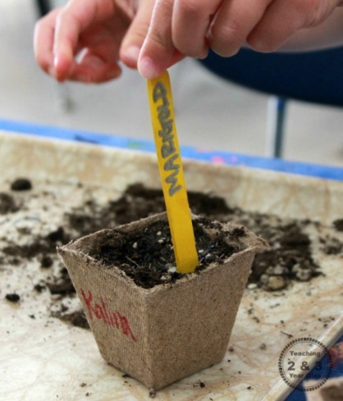
Plant a seed or a bean in some soil. If you don’t have a plant pot you could recycle a yoghurt pot!
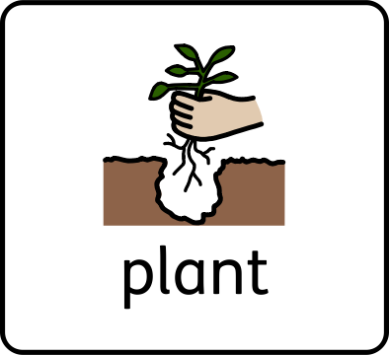
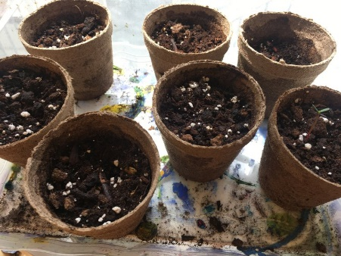

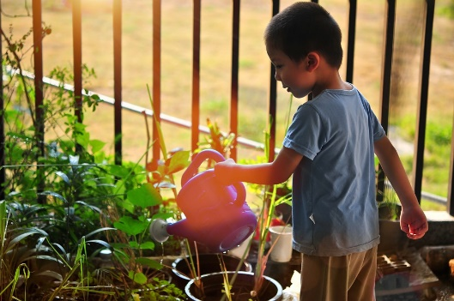
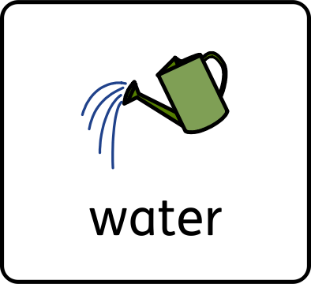
Children can help to water plants indoors or outdoors using watering cans, sprays or hoses.

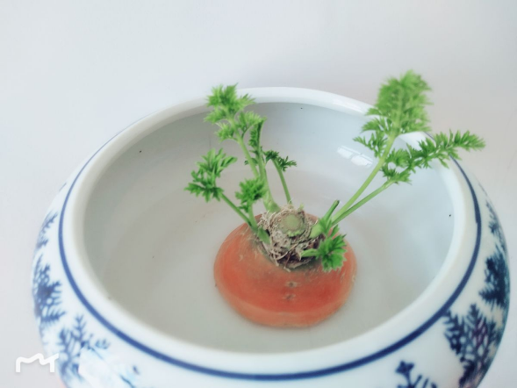

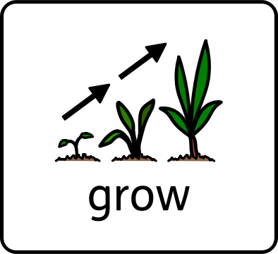
Carrot heads are very easy to sprout! After washing it and putting it in water, small shoots can grow in a few days.

