**Vegetable Exploration!**

***There are lots of different ways you can help your child to learn about different vegetables at home, following a sensory approach. Here are a few examples of easy to plan activities that can be carried out at home;***

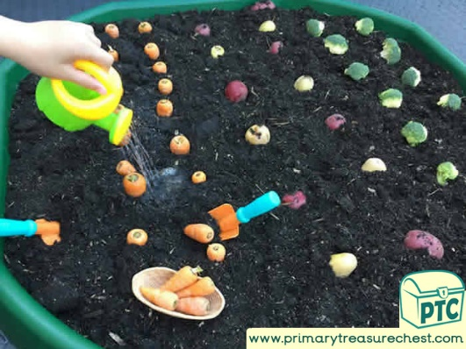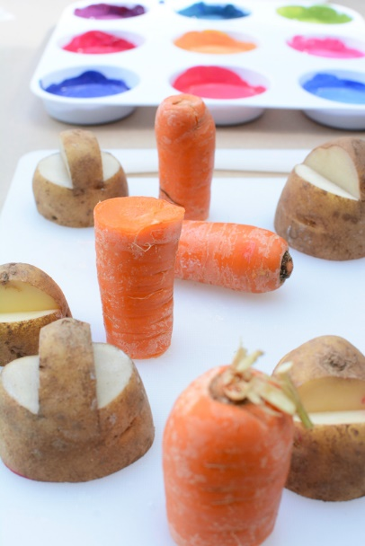

Printing with vegetables and paint.

Hiding vegetables in mud. Digging and watering.

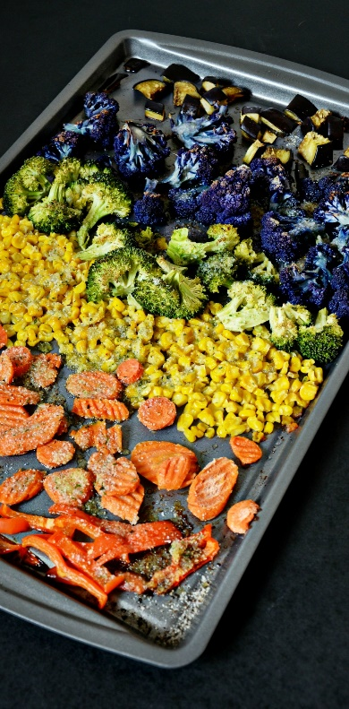

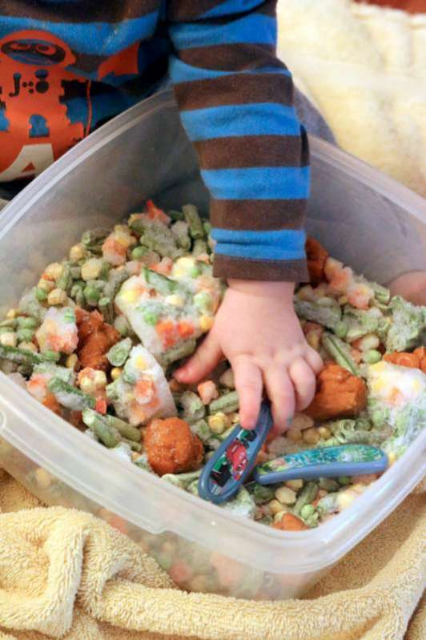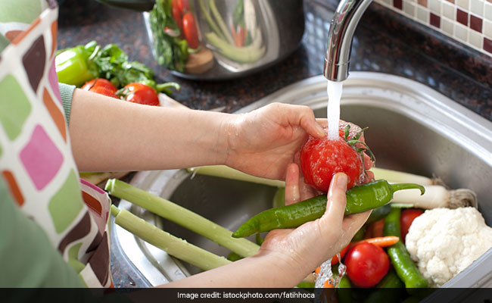

Helping to prepare vegetables. Washing, sorting, and helping to cut/chop/mix.

Sorting vegetables by colour. Counting the pieces.

Frozen veg sensory tray. Picking up small pieces with fingers and tools/cutlery.