Home learning KS2 – travel and transport 3
Our topic this half term is travel and transport. Please find below some activities that you can do with your child at home linked to the topic. There are different suggestions so please choose the ones that you think your child will enjoy. We would love to hear how they get on with these activities.
Water play
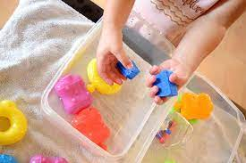
Fill a bowl with water and give your child different objects to see if they float or sink. They could then sort them into those that float and those that sink or make a mark on a piece of paper with pictures of ‘float’ and ‘sink’ on to show if each object floats or sinks
Count how many objects you can get in a tub before it sinks
Fill a bowl of water and have jugs, cups, plastic lids of different sizes (jam jar lids, milk container lids etc.) and allow your child to explore pouring, empty and full
Make and float a boat
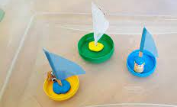
Use a big lid or small tub for a boat. Use a stick, twig or pencil stuck in playdough for the mast and a paper sail. Your child can cut out and colour the sail (they could choose different shape sails too) and choose which tub it goes in. Give your child verbal instructions for how to make the boat or let them follow written instructions with pictures.
Take it in turns to blow the boat on water (a bowl or the bath) Have races and see which boat is 1st or 2nd. Squirt a boat with a given number or colour on with a water spray
Ask your child to find the boat with a particular colour sail or the boat with a particular number on its sail.

Stormy seas
Make some little boats (see above) and put them on a sheet (or a towel). Hold the sheet with your child (and any others in your home) and encourage them to move it up and down slowly for the sea, then move it faster for a rough, stormy sea. Use the words ‘fast’ and ‘slow’ and ‘up’ and ‘down’. You could ask them which boat they think will fall off first

Row your boat
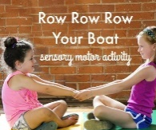
Sit opposite your child and do a pushing and pulling action and sing ‘Row row your boat’ . This can be quite calming as an action if done slowly and rhythmically.
Row, row, row your boat,
Gently down the stream,
Merrily, merrily, merrily, merrily
Life is but a dream.
Row, row, row your boat,
Gently down the stream,
If you see a crocodile,
Don’t forget to scream (Aaagh!)
There are lots of variations. Try one of the following:
Gently down the stream, if you see a crocodile don’t forget to scream
Gently down the river, if you see a polar bear don’t forget to shiver
Gently to the shore, if you see a lion don’t forget to roar
Gently down the lake, if you hear a hissing sound it’s probably a snake
Gently in the bath, if you see a spider don’t forget to laugh (tickle)

Story songs
Your child might be familiar with these songs and stories from school. Watch them with your child and encourage them to join in with sounds, actions or words. You could pause the songs and ask your child what they can see or where something is.
Port side Pirates https://www.youtube.com/watch?v=_qAngsMJD3I
10 little sailboats https://www.youtube.com/watch?v=cm-6n4ChZ78
Over the deep blue sea https://www.youtube.com/watch?v=lCPJhybHBkA

