Home learning KS2 – travel and transport 2
Our topic this half term is travel and transport. Please find below some activities that you can do with your child at home linked to the topic. There are different suggestions so please choose the ones that you think your child will enjoy. We would love to hear how they get on with these activities.
Action time
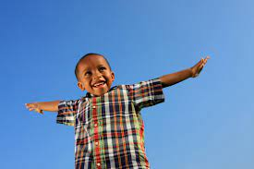
Can your child pretend to be an aeroplane e.g with arms outstretched, they make wing shapes. They could bend their knees to ‘fly’ lower or turn around on the spot to ‘circle’ in the sky. They could go fast or slow, forward or backwards, left or right, or to specific places. Encourage them to copy sounds e.g neow, whoosh, zoom
Packing to go on holiday
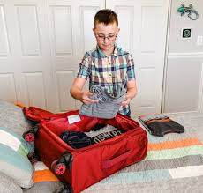
Give your child a list (of symbols, words or pictures) to find items and pack them in their suitcase
Or ask your child to find something for rainy or sunny or cold weather to pack
Make a kite
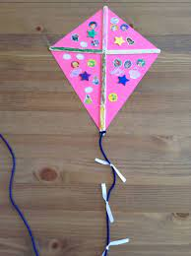
Give your child instructions to make a kite or you could write instructions with pictures of what to do or show them yourself and then let them have a go. Encourage them to do as much as possible – it doesn’t have to be perfect. They could cut out the kite shape then decorate it by painting, colouring or sticking. They could roll up paper to make the sticks to put on the kite. Then they can put on ribbons (paper or material ones) and the string. Have fun flying it – talk about the weather being windy

Shape plane
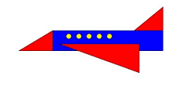
Cut some shapes out of paper or card and encourage your child to make pictures with them. You could show them first or give them an example to put their shapes on top of. Can your child find named shapes in their picture?

Track that plane
Move a toy plane around in front of your child and gradually move it further away and encourage them to watch it as it moves. You could also make plane sounds (or find some to play on your phone) and encourage your child to look at where the sound is coming from.

Airport role play
Make a passport – ask your child to draw a picture of themselves or stick a picture of them on it. They can stick or write their name or make their own mark for their name too. They could make some for their toys or other family members too. Then you can ask them who each one belongs too.
Weigh objects in scales or ask your child to pick up different bags and indicate which is heavy or light
Ask your child to wait and listen while you say different names and then stand up (Or acknowledge you in some other way) when you call their name (like listening for your flight to be called) You could give them a number instead to listen for
Put some cushions or chairs in a line like on a plane and put a number of each of them. Give your child a ‘plane ticket’ with a number on and sit on the seat with that number.
Story songs
Your child might be familiar with these songs and stories from school. Watch them with your child and encourage them to join in with sounds, actions or words. You could pause the songs and ask your child what they can see or where something is.
Up, up, up https://www.youtube.com/watch?v=Lrd0TiER_J0&t=20s

