Home learning KS2 – travel and transport 1
Our topic this half term is travel and transport. Please find below some activities that you can do with your child at home linked to the topic. There are different suggestions so please choose the ones that you think your child will enjoy. We would love to hear how they get on with these activities.
Trains and tickets
Help your child to make a train out of one or two boxes (any size) . They can decorate the boxes and stick on some circles for wheels. Then put some toys in the train
Then you can make ‘tickets’ of different colours (Your child could colour these)and give each toy a different colour ticket. Then ask your child to push the train to an object that is red, blue etc and find the toy with the same colour ticket and get them out there.
You could try the same with ‘tickets’ that have the name and picture of an object in the house e.g. TV, sofa, door
Ready steady go
Make a slope for some toy cars and take it in turns to push a car down the slope on ‘Go’ in ‘Ready, steady, go’ You could ask your child which car went the furthest or have the cars fall into a tin to make a sound
Cars, cars, cars
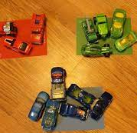
If you have toy cars then you could help your child sort them into colour groups. You also could ask them to count how many of each colour and put the right number by the group
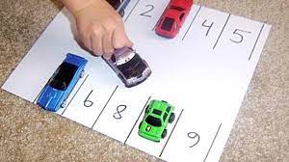
You could draw a car park and ask your child to put the cars in specific numbered parking spaces.
Car tracks
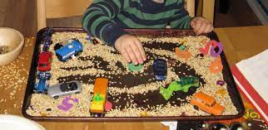
Your child could push a toy car around in a tray of oats, icing sugar etc and see the marks it makes.
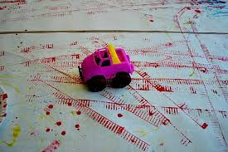
You could dip a toy car in paint and let your child drive it over some big paper to make tracks.

Story songs
Your child might be familiar with these songs and stories from school. Watch them with your child and encourage them to join in with sounds, actions or words. You could pause the songs and ask your child what they can see or where something is.
The wheels on the bus https://www.youtube.com/watch?v=9siyDPch-6c
We all go travelling by https://www.youtube.com/watch?v=cSw50Jw0H34&t=15s
The journey home from Grandpas’s https://www.youtube.com/watch?v=wKcrsv_t8Ko&list=PL0maGUp7cdUkPJgFg9PL0CAqzSDsWo2UR&index=11
Driving my tractor https://www.youtube.com/watch?v=i7l9ts5rijs
Makaton Wheels on the Bus https://www.youtube.com/watch?v=0peZ5AN5vs8

