Recycling Weeks 3 and 4 cardboard and plastic

Recycling boxes week 3

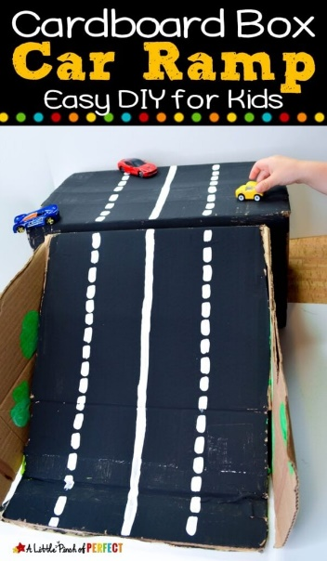
Activities
Making ramps with recycled cardboard to push cars up and down, can children make them go fast/slow?
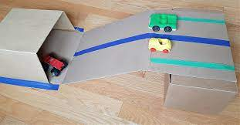

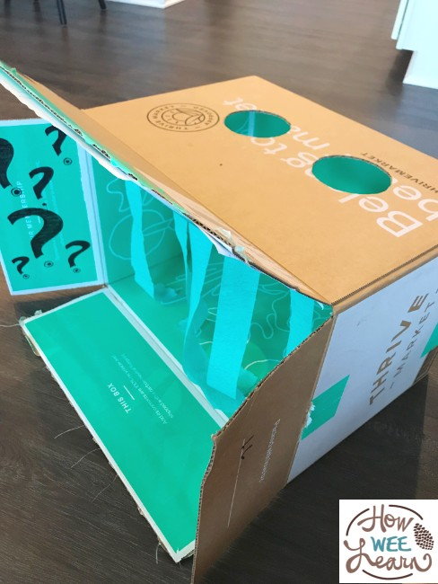
Making a mystery box. Can children feel objects in the mystery box? Try using different objects and textures.
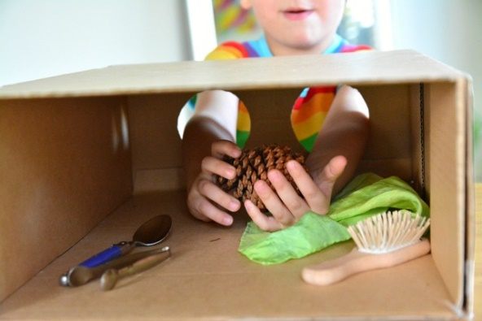

Stacking boxes to build a tower. How big can children build a tower, it’s fun to knock it over!
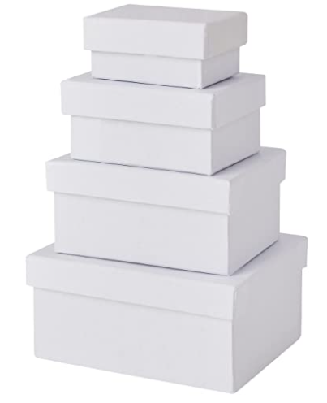
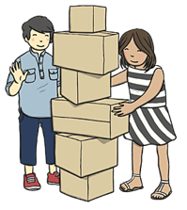
Videos
Number 1 Newtons Adventure
https://www.bbc.co.uk/iplayer/episode/m000zp36/number-1-newton-avenue-series-1-17-prickly-problem

Recycling plastic week 4
Stories
The life of a little plastic bottle https://www.youtube.com/watch?v=5GtegfEvzDo
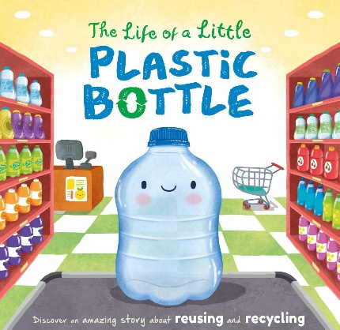
The adventures of a little plastic bottle https://www.youtube.com/watch?v=aAOgZ7ew7VM
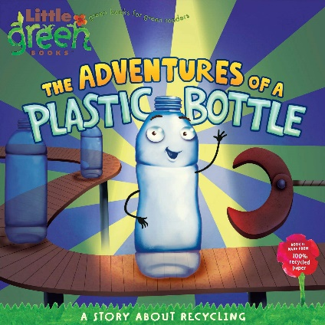

Songs
No more single use plastic- Pink fong https://www.youtube.com/watch?v=zNtaarHS5UA

Yes, yes save the earth- Cocomelon https://www.youtube.com/watch?v=xqkGPgtFHR4

Activities
Plastic bottle bowling. How many can the children knock down? Can they help count them? Children could help decorate these before bowling, using paint or help pour a little bit of water into the bottom of the bottles.

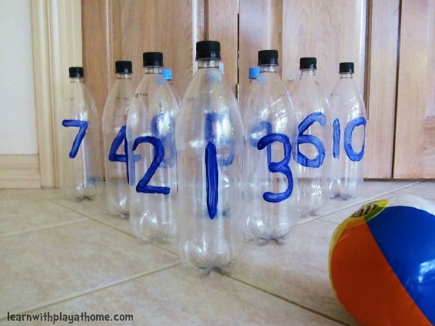
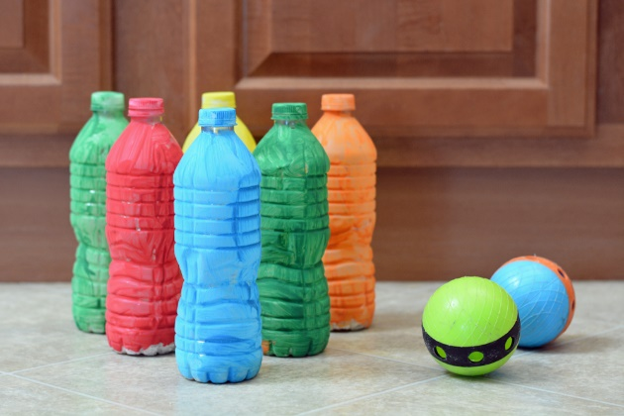

Making sensory bottles https://www.youtube.com/watch?v=D7zp7KbxbKY
Children can help with pouring and chose materials, colours and objects to put into their bottles.
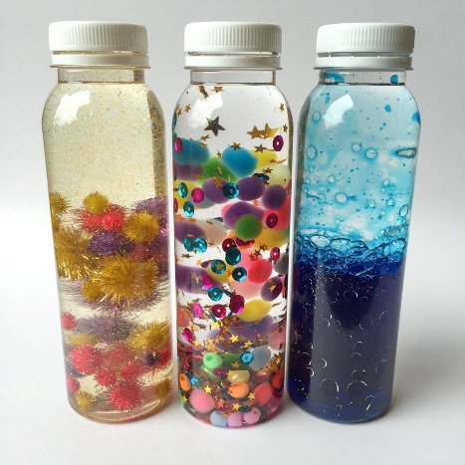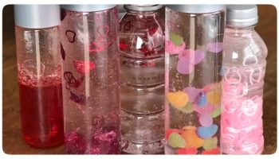

Yogurt pot cress. Can children help plant the cress and watch it grow each day? When it is ready they can try it.

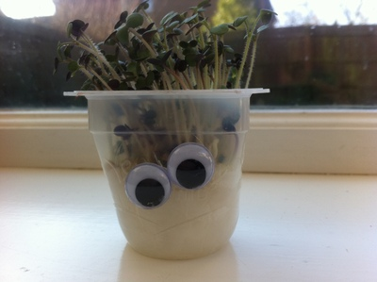
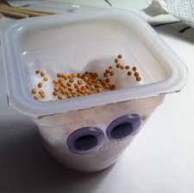

Videos
Kit and Pup- Plastic
https://www.bbc.co.uk/iplayer/episode/b0bppydw/kit-pup-series-1-37-plastic

