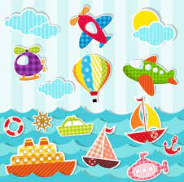
https://m.youtube.com/watch?v=2c68qD_NExQ
Transportation song

https://m.youtube.com/watch?v=oAWNJ6x-oyw
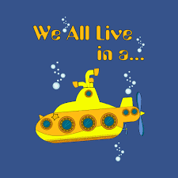
Yellow submarine

https://m.youtube.com/watch?v=FfhFieHXTNU
Water transportation

