Exercise 1 – Movement to music - ambulant children
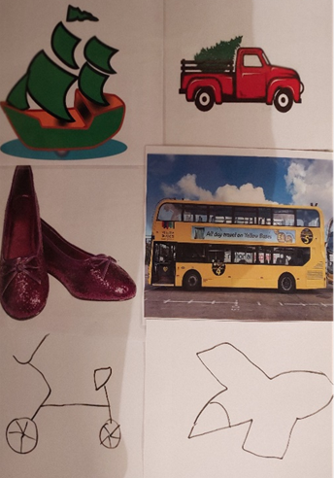
1. Draw / print pictures of:
yellow bus turn/spin
red truck jump
blue train march
pink bike jog
green boat swimming/splashing arms
white plane flying arms
orange car run around fast
purple shoes stomp

2. Ask child to colour the drawn pictures or cut out the objects (if appropriate)
3. Place the pictures around the room on floor
4. Play the song and move around transport objects mentioned in the song
https://www.youtube.com/watch?v=cSw50Jw0H34
5. Move around each picture in a different way (suggested above)

Exercise 2 – orienteering
1. Put pictures on the walls around the room
2. Sit down with crossed legs
3. Shout chosen vehicle and run to its picture as fast as you can

Exercise 3 – sorting
1. Put pictures on the floor
2. Ask child to collect any red, yellow, purple, green, white, orange, blue object
3. Child to match an object to the corresponding coloured vehicle from the picture

