Exercise 1 * Sensory song * non-ambulant children
- Print pictures of transport vehicles (see colours below)

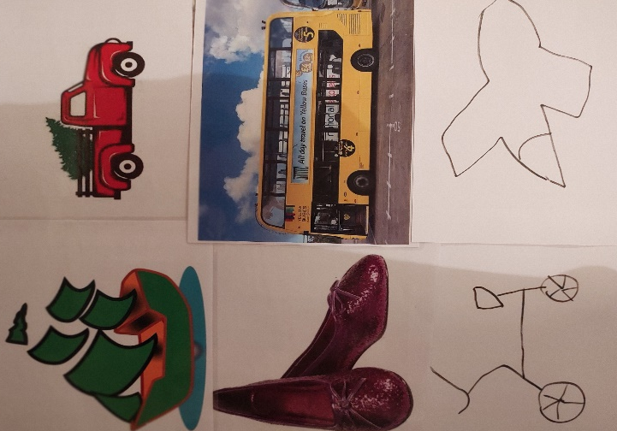
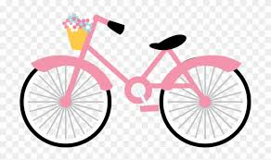
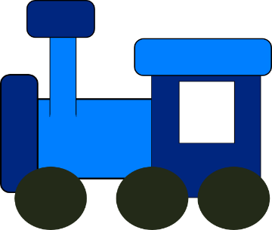

2. Get different coloured socks, gloves, balloons, sacks to be filled with things
yellow bus - yellow fabric filled with a ball, orange…
red truck - red fabric filled with plastic bags
blue train - blue fabric filled with something soft
pink bike - pink fabric filled with something noisy
green boat - green fabric filled with something hard
white plane - white fabric filled with for eg. Building blocks, toys
orange car - orange fabric filled with keys, rattles…
purple shoes - purple fabric filled with a plastic cup
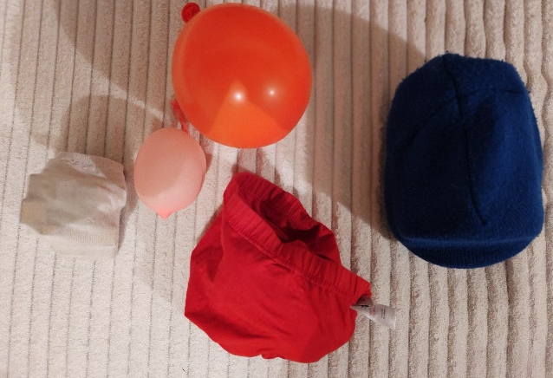

3. Place the pictures on floor in front of your child
4. Play the song. Point at transport objects mentioned in the song
https://www.youtube.com/watch?v=cSw50Jw0H34
5. Play the song. Child to pick an object, manipulate it and place on the corresponding travel vehicle being sang

Exercise 2 – stretching/ fine motor skills
1. Place sensory objects/fabrics from exercise 1 around your child:
behind/aside, on top of a chair, in front of the child, inside a box, underneath a box, in a bag, behind a pillow…
2. Ask your child to reach and collect all the objects
3. Child to manipulate the objects - to shake, squeeze, drop, throw, pass between hands…

Exercise 3 – sorting
1. Put pictures on the floor
2. Collect any red, yellow, purple, green, white, orange, blue object from the house
3. Child to match an object to the corresponding vehicle from the picture

