Recycling Weeks 5 and 6 Clothes and Toys

Recycling clothes week 3
Stories
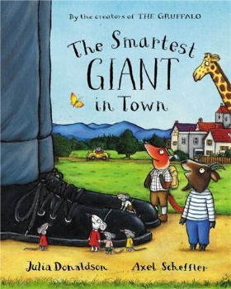
The Smartest Giant in Town https://www.youtube.com/watch?v=6gw-wfxFrfA

Bear Gets Dressed https://www.youtube.com/watch?v=qqXzjHdyvlA
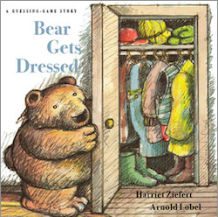
Songs
Put on your shoes- Super Simple Songs
https://www.youtube.com/watch?v=-jBfb33_KHU

Getting dressed for the day- The Singing Walrus
https://www.youtube.com/watch?v=KDE6i_ZZkFU

Videos
Hey Duggee- Fashion badge
https://www.bbc.co.uk/iplayer/episode/b0bb2ffl/hey-duggee-series-2-51-the-fashion-badge

Topsy and Tim- New clothes
https://www.bbc.co.uk/iplayer/episode/b03hy7p2/topsy-and-tim-series-1-4-new-clothes

Activities
Children can make tie dye t-shirts or sock puppets
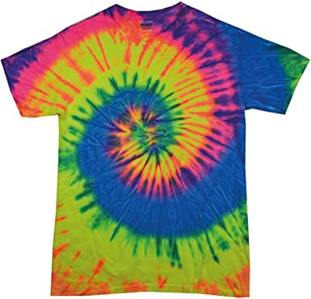
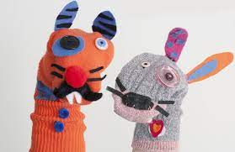

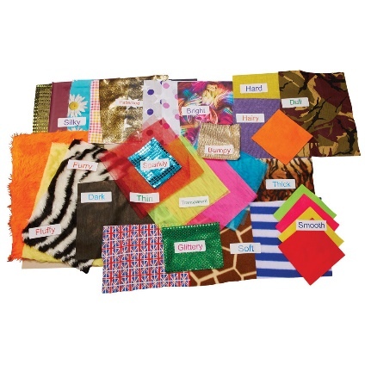

Can children feel different textures of clothes, which do they like?

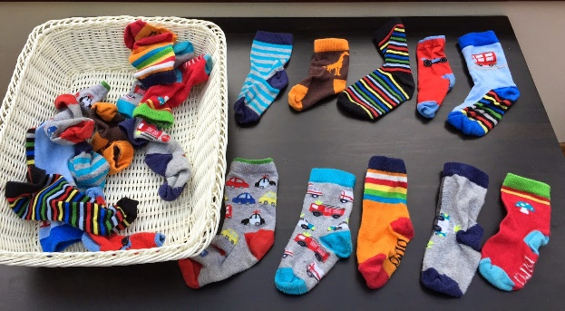

Can children find matching socks, sort big and small socks or colours?

Recycling Toys week 4
Stories
This is the bear https://www.youtube.com/watch?v=kfiYIxJ2FhA
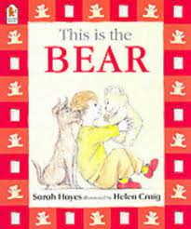
Toys in Space https://www.youtube.com/watch?v=jEotPSwntaM
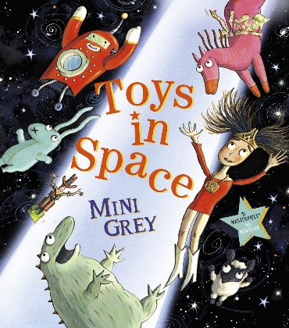
Songs
I can’t let you throw yourself away- Toy Story 4
https://www.youtube.com/watch?v=fgKpDyM_1y0

Videos
Topsy and Tim- Old toys
https://www.bbc.co.uk/iplayer/episode/b03x15xs/topsy-and-tim-series-1-20-old-toys

Timmy Time- Old tins
https://www.bbc.co.uk/iplayer/episode/b00sqjdn/timmy-time-series-2-16-timmys-tins

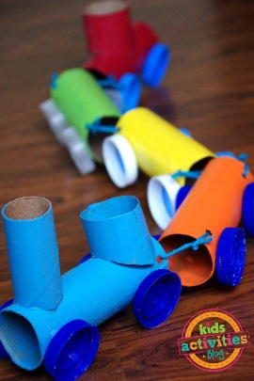
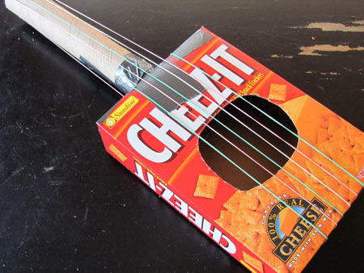
Activities
Making toys out of recycled materials

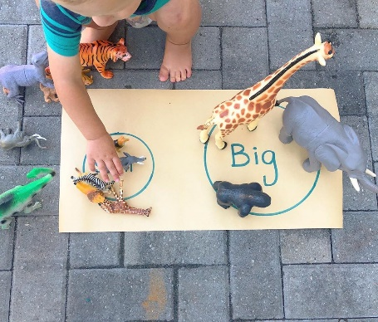

Ordering toys by size or sorting colours

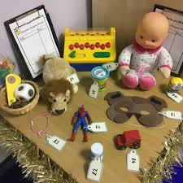

Role-play toy shop

