Toys Weeks 1 Favourite Toys and 2 Construction Toys

Toys- 1 favourite toys

Activities
Children can have a toy party or picnic
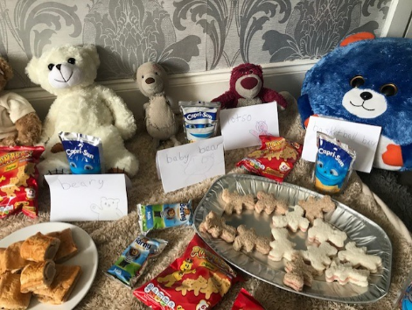
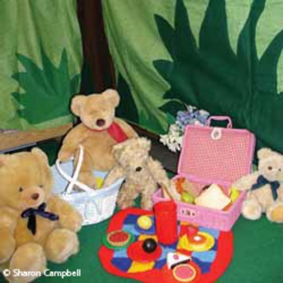

Can you give one item to each toy?
Can you share with the toys or family?

Sorting difffernt toys
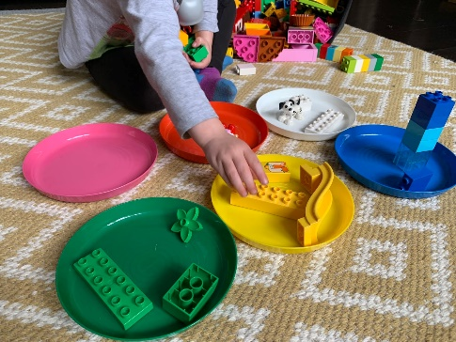
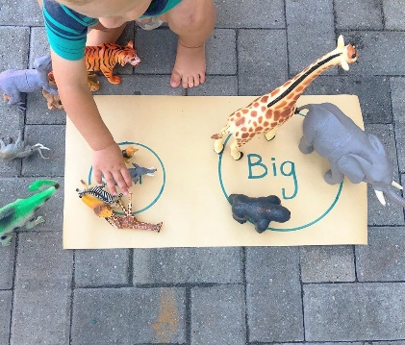

Can they sort them by colour or size?

Toys 2-Consrtuction toys

Activities
Children can use icing sugar as cement for building or stacking biscuits

Children can construct toys using items found at home

