Toys Week 3 Moving Toys and Week 4 Puppets and Role-Play

Toys- 3 Moving Toys

Activities
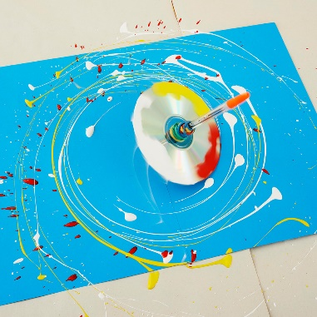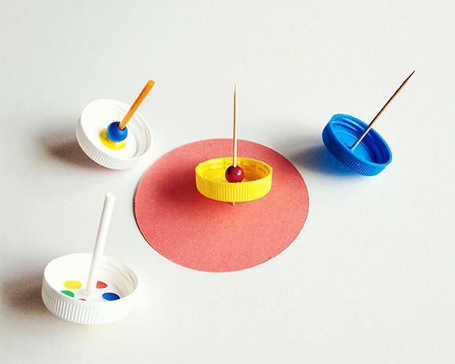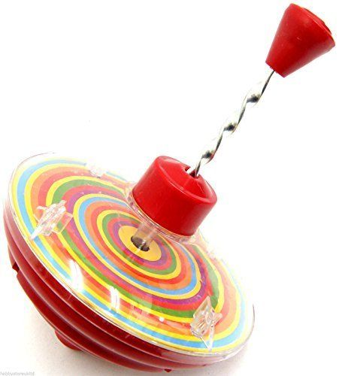
Making or playing with spinning toys
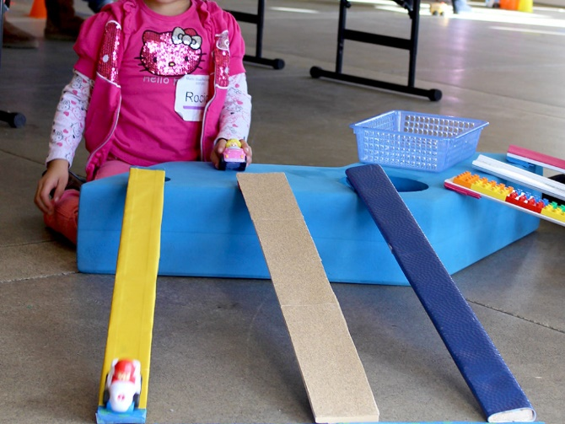
Making ramps to push cars down. Can different textures effect the speed of the car. Can they identify fast and slow or you can model the vocabulary when they push the cars.

Toys 4- Puppets and Role-play

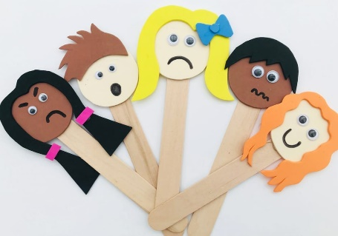
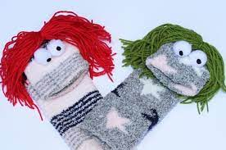
Activities
Making puppets

Stick puppets Sock puppets

