Toys Week 5 Teddy Bears Picnic and Week 6 Easter

Toys- 5 Teddy Bears Picnic
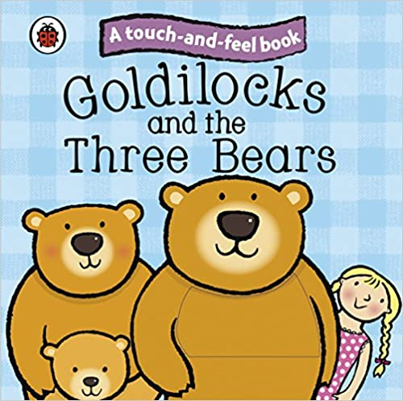
Stories

Goldilocks and the Three Bears Touch and Feel Story

Activities
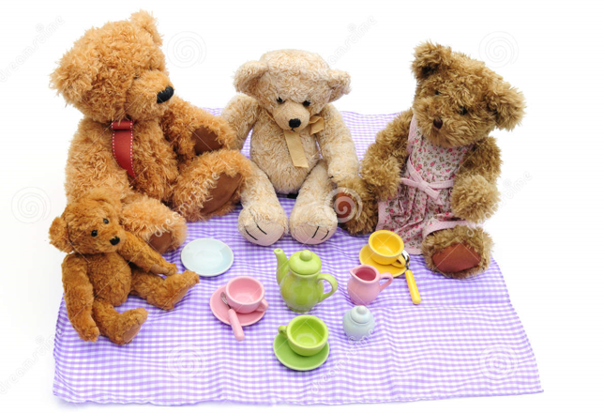
Have a teddy bears picnic.
Can they place one cup on each saucer?
Can they match the colours?
Can they order the bears by size?

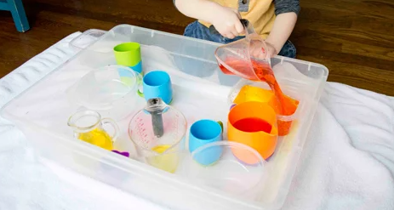
Filling and pouring
Can they explore filling and pouring?
Can they fill and pour with control?
Can they identify full and empty?

6-Easter
Stories
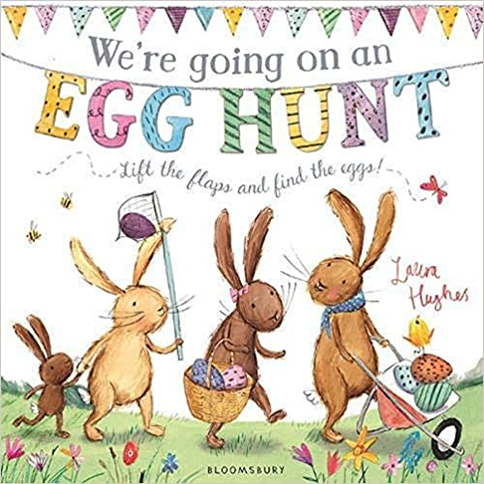

We’re going on an egg hunt

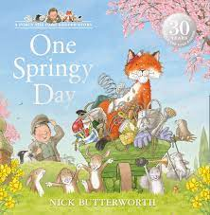

One Spring Day

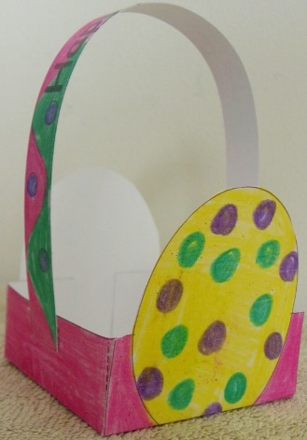
Activities

Making or decorating an Easter basket

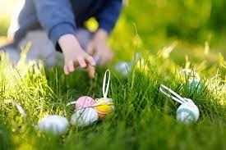
and go on an Easter egg hunt!

