Minibeasts/Small Animals

Videos
Dog Loves Books- dog loves minibeasts
https://www.bbc.co.uk/iplayer/episode/m000j5tc/dog-loves-books-series-1-17-dog-loves-mini-beasts
Mr Tumble- Wetlands centre
https://www.bbc.co.uk/iplayer/episode/b03ybw6c/something-special-were-all-friends-series-9-25-wetlands-centre?seriesId=b03qvnmp

Activities
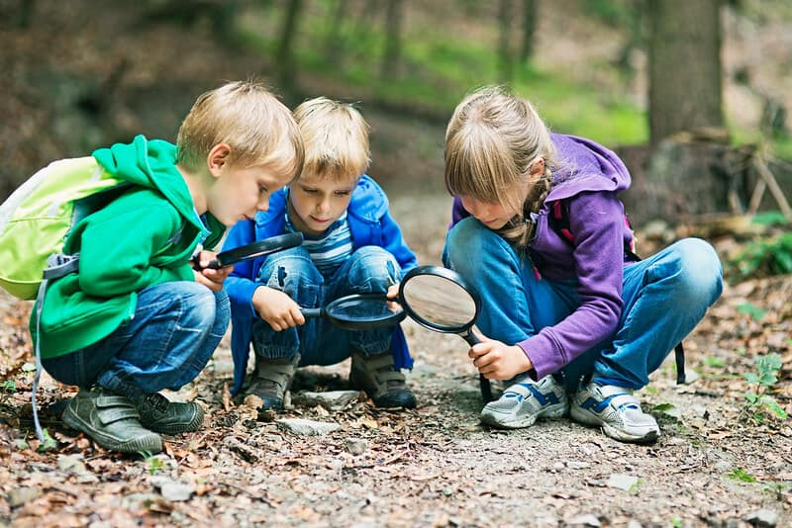
Going for a walk and looking for minibeasts

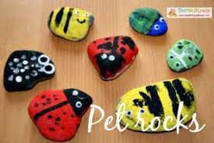

Collecting rocks on the walk to paint

Pets/Baby Animals

Videos
Mr Tumble- Woof
https://www.bbc.co.uk/iplayer/episode/m000fjf3/something-special-were-all-friends-series-12-12-woof?seriesId=m000f39p

Topsy and Tim- Pet sitters
https://www.bbc.co.uk/iplayer/episode/b03jpg8b/topsy-and-tim-series-1-10-pet-sitters

Activities

Take a visit to a pet shop if you can

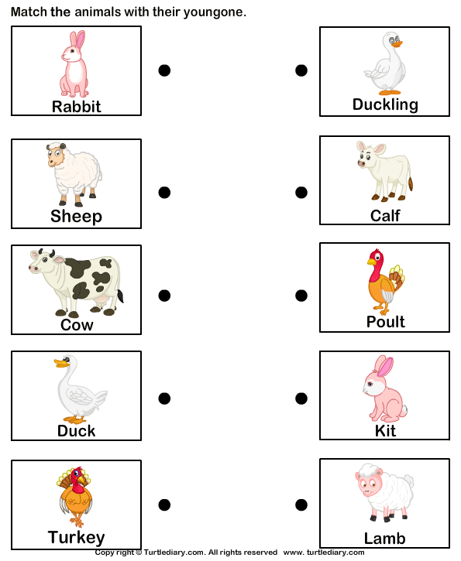
Matching animals to their babies

Farm Animals/UK Animals

Videos
Mr Tumble- Down on the farm
https://www.bbc.co.uk/iplayer/episode/m000f4bt/something-special-were-all-friends-series-12-4-down-on-the-farm
Topsy and Tim at the farm
https://www.youtube.com/watch?v=xRaGEElZaUs

Activities
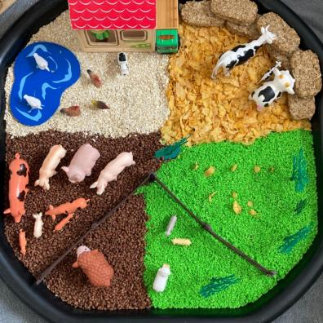
Role-Play
Making a farm sensory tray with different material for toy animals.
Can children role-play with the animals?
Can they identify them?
Can they match/group them?
Can the make/identify animal sounds?

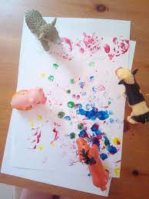
Mark making
Printing with toy animal feet

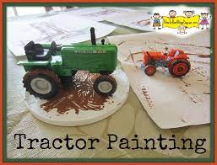

Using tractors to mark make

Rainforest/Birds

Videos
Go Jetters- Rainforest of Sumatra, Indonesia
https://www.bbc.co.uk/iplayer/episode/b095tf9l/go-jetters-series-2-4-rainforests-of-sumatra-indonesia
Andy’s Wild Workouts- Rainforests
https://www.bbc.co.uk/iplayer/episode/p06tmrxr/andys-wild-workouts-series-1-6-rainforests

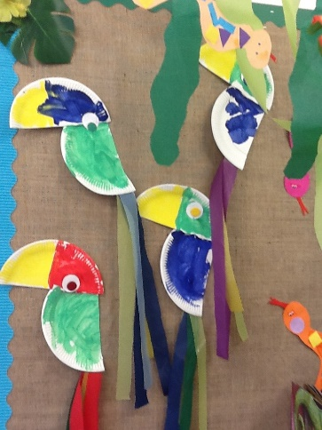
Activities

Making paper plate birds

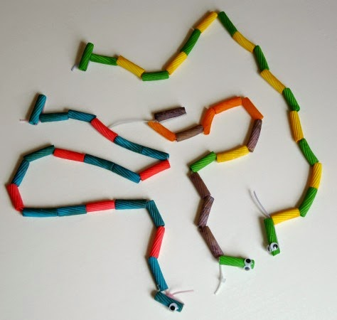

Threading pasta to make snakes

Jungle/Big Animals

Videos
Tish Tash- Jungle Shoes
https://www.bbc.co.uk/iplayer/episode/m0015h1l/tish-tash-series-1-45-jungle-shoes

Raa Raa the noisy lion- Jungle journey
https://www.bbc.co.uk/iplayer/episode/b09nyklj/raa-raa-the-noisy-lion-series-3-22-raa-raa-and-the-jungle-journey

Activities
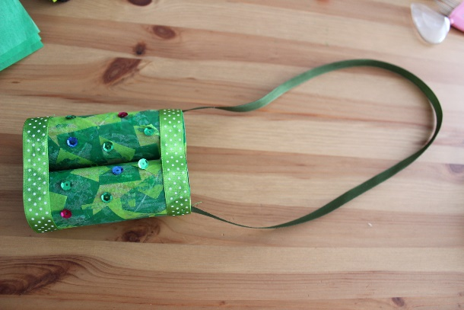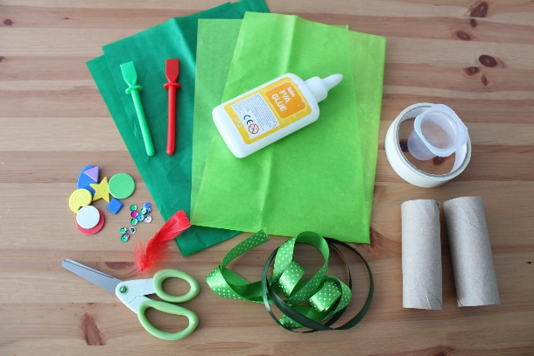

Making bonoculars and using the to look for toy jungle animals

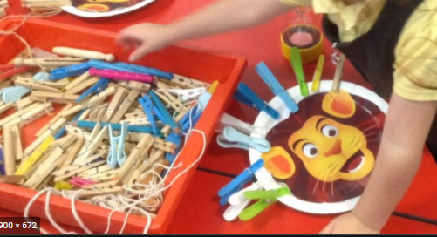
Practicing fine motor skills using pegs.

Arctic Animals

Videos
Andy’s wild workouts- Arctic
https://www.bbc.co.uk/iplayer/episode/p06tmrxh/andys-wild-workouts-series-1-10-arctic
Andy’s wild adventures- Polar bears
https://www.bbc.co.uk/iplayer/episode/b01kvmbk/andys-wild-adventures-series-2-10-polar-bears

Activities
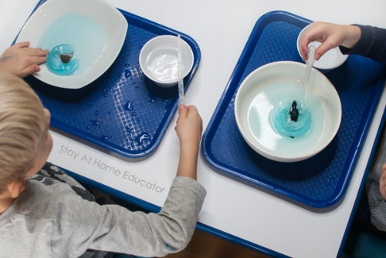

Freezing animals in ice and helping get them out
