Home learning KS2 –sport and leisure
Our topic this half term is sport and leisure. Please find below some activities that you can do with your child at home linked to the topic. There are different suggestions so please choose the ones that you think your child will enjoy. We would love to hear how they get on with these activities.

Musical afternoon
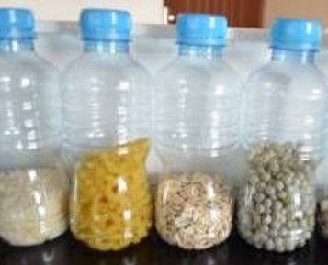
Listen to different kinds of music – how do they make you feel (show your child happy and sad faces to choose from), which one do you like? Can you make it loud or quiet – controlling the technology ?
Play music on your own instruments you have made (e.g. wooden spoon and saucepan, plastic bottle with some rice in as a shaker. Play along with some other music or keep a rhythm or copy a pattern of sounds. Can your child find where the sound is coming from? Can they find the same instrument as the one they can hear?
Dance along to music or have material or paper streamers to wave. Can your child copy movements or make their own? Can they stop when the music stops?

Gardening
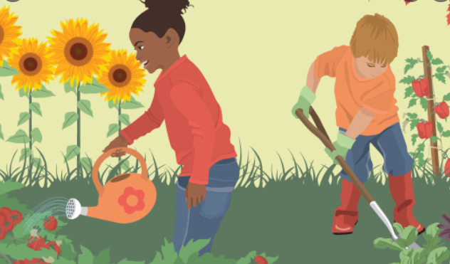
Let your child dig, plant and water plants or seeds. They can follow instructions to count out seeds, plant them where you say or water a particular plant or colour plant
If you haven’t got a garden you could plant some seeds in a pot or trying growing cress on damp kitchen roll. You could take photos of how the seed and plant look on different days and see if your child can order them.
Look for twigs, leaves etc in the garden or at the park and count them, sort them into groups, make pictures with them and explore them
Mark make in the soil with a stick - can your child copy your marks or draw a given shape.

Have a picnic
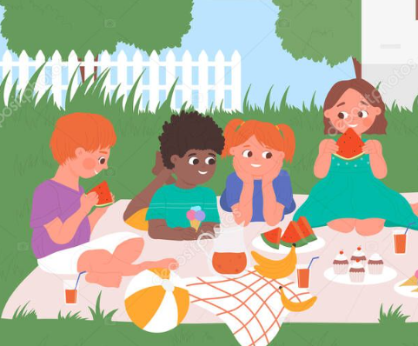
Link back to last term’s work on shopping and let your child make a list of picnic food they want (use pictures you have drawn or empty packets). Your child could come with you to buy the things on the list or you could set up a role play shop for them to buy it from you at home.
Choose somewhere for a picnic (in your home or garden or a park) and set it up. Can your child put out one plate, one cup etc for each person?
Look at different foods and talk about which is healthy/good for us and which isn’t. Let your child sort them into groups. Try cooking and tasting some new healthy food

Technology time
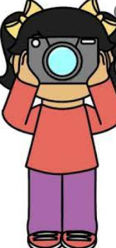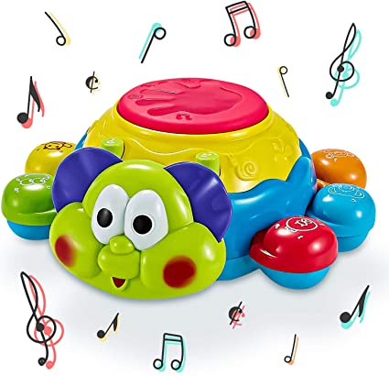
Ask your child to take photos of different things – can they find them and then get them in the shot? Or they could look for and photograph things that are e.g. green
Play with cause and effect toys such as sound or music or pop up toys or simple apps on your phone or a tablet. Does your child know what they have done? Will they persist until it works? You could give your child problems to solve e.g. by not switching it on so they need to work out how to switch it on or to get you to help them.

Books, books, books
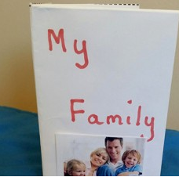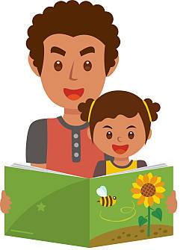
Read a book with your child. Ask them questions about it – where is the dog, where is the bus etc. Ask them to turn the pages, get the book the right way round and find the words and the pictures etc.
Let your child choose a book or find the one about a particular character or topic from looking at the cover.

Try a noisy book or a tactile book

Make photo books of your child and your family. Cut pictures out of magazines or catalogues to make simple word books. Make a colour book by having fun with crayons or paints

Keeping fit and sports
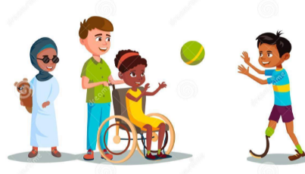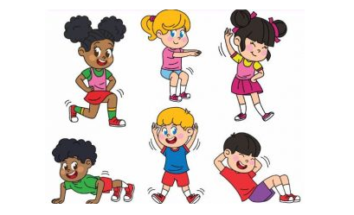
Have races in your garden or the park. Who is first? Who is last?

Throw a ball or bean bag or jump and see who goes furthest. You could try measuring the distance e.g. how many spoons, how many sticks long?

Use a visual timer on your phone to see how long it takes your child to do something. Can they do it faster? How fast can you do it? Can they stop or go when you give the instructions?
Do some keep fit . e.g. Walk like a penguin, hop like a frog etc., . Sit facing each other and hold hands. rock back and forth and sing the song "Row, row, row your boat." Sit on the ground and let your child step over your legs, or make a bridge with your body and let your child crawl under. Play follow the leader. Do physio stretches if your child has these to do. Do some of the sensory activities if your child has an OT programme e.g. roll over a gym ball
Play catch with a ball – or roll it to each other or kick it to each other or to a target.

Go to the park. Help your child take turns or develop their climbing/balancing skills on the equipment.

Pamper Day

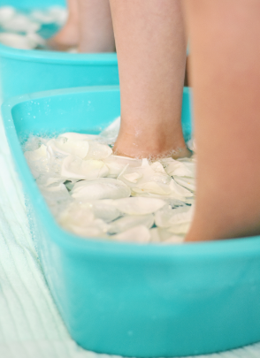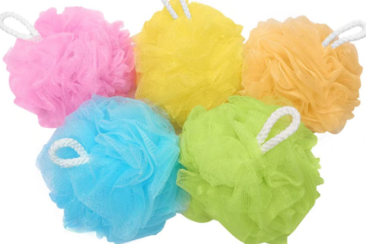

Use a foot spa or just feet in a bowl of scented water and bubbles. Blow bubbles and encourage your child to blow them.

Let your child feel different sponges etc, - they can indicate which body part they want the sponge on or which one they want?

Smell and choose different scents – flower petals, bubble baths. Help your child to pour just a little and stop.

Make jewellery – thread pasta tubes on wool or string

Games and toys

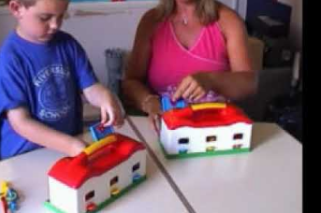
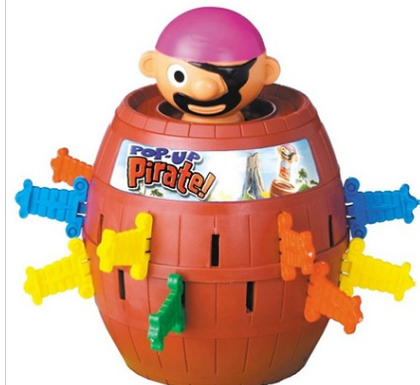
Play simple games. Help your child to take turns

Show your child how to play with toys. You can have a set of toys e.g toy train and track or some animals and a pot of pretend food, and your chlld have the same toys and then they can copy what you do with them

Play games such as peekaboo or hiding toys. Does your child know the hidden thing is still there and do they anticipate it appearing? Help your child to look for hidden toys following instructions using the words on/in/under.

