Home learning KS2– sport and leisure song and video links
Songs
- You can watch these songs with your child.
- You could pause them and ask them to point to particular things they can see.
- You could have the real things they buy in the songs and ask your child to find the same as on the screen.

https://www.youtube.com/watch?v=WCYTlVF-djw Sports song – Do you like sports?
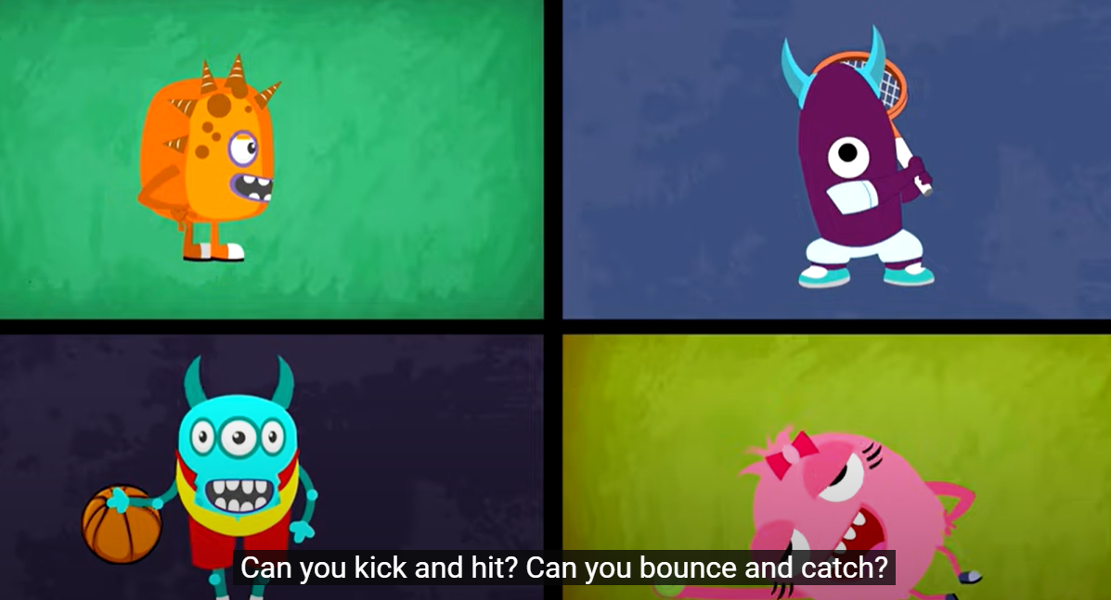

https://www.youtube.com/watch?v=9I09BSaGLSs Sports ABC
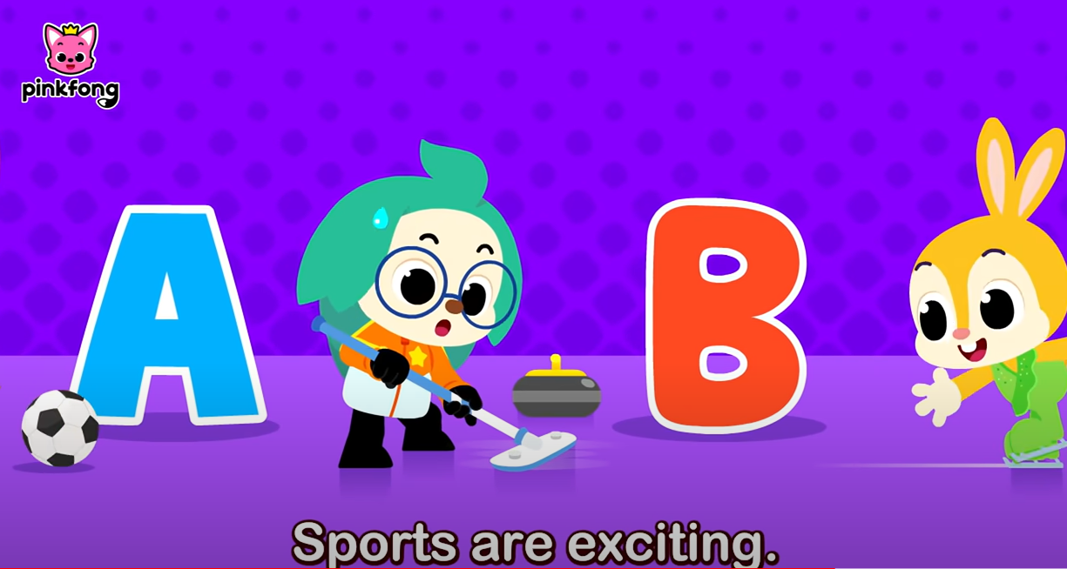
https://www.youtube.com/watch?v=uzAl5gHD5-I I can move my body like anything
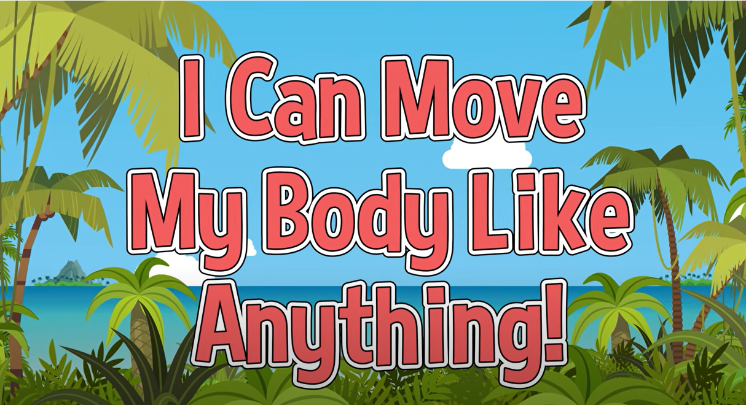
Videos
- You could watch these and ask your child to find things on the screen when you pause them
- You could encourage your child to watch the signs and try them if they use Makaton

https://www.bbc.co.uk/iplayer/episode/b09trnsv/something-special-were-all-friends-series-11-20-getting-sporty?seriesId=b09jvg91 Something special - getting sporty
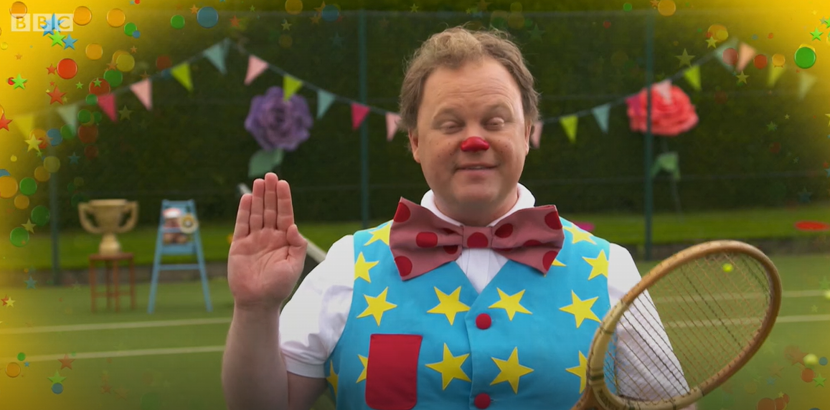

https://www.bbc.co.uk/iplayer/episode/b09vf23b/something-special-were-all-friends-series-11-22-music-stars?seriesId=b09jvg91 Something special – Music stars
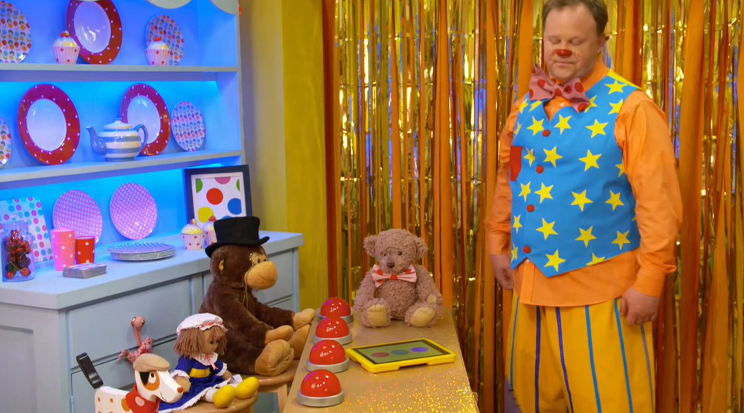

https://www.bbc.co.uk/iplayer/episode/b09syqqv/something-special-were-all-friends-series-11-11-library?seriesId=b09jvg91 Something special – library
