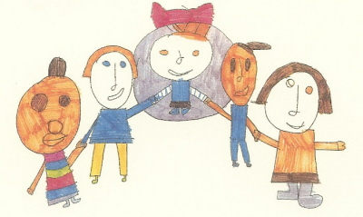

Our Mission for communication at Lindon Bennet School.
We work together to maximise every child’s ability, enabling pupils to reach their full potential in the key skills of Communication.
Intent
At Lindon Bennett School, we believe in giving every child opportunities to express themselves, to communicate and listen in a range of situations. Communication is a priority throughout the school and development of language skills is planned jointly with the Speech and Language Therapist.
At Lindon Bennett School, we aim to provide a happy, stimulating and safe learning environment where children are encouraged to engage in their communication skills with appropriate and consistent support provided by skilled staff to ensure progress.

Implementation
Children have access to a variety of methods of communication such as Makaton (sign language), use of high and low tech modes, Picture Exchange Communication Symbols (PECS), sensory cues and touch cues. We ensure a consistent approach is used across the whole school. Staff are trained in using modes of communication and work in close partnership with multi- professional teams.

Impact
All our children reach their full potential whatever that may be for each individual. Children are able to communicate their individual needs and wants in a way, which is tailored to their individual needs, learning styles and interests. Giving children a voice reduces the need to communicate through behaviour that is challenging'

Reviewed Autumn 22

